**Table 8.** The parameters settings of Stanford Classifier used in our reproduced NLP approach



**Table 9.** The parameters settings of our reproduced CNN approach



Table 6. Summary of the 20 projects in our study



**Table 12.** The performance comparison based on Dataset-M and Dataset-G under the MTO scenario:

Pattern vs. MAT



**Table 13.** The performance comparison based on Dataset-M and Dataset-G under the MTO scenario:

NLP vs. MAT



**Table 14.** The performance comparison based on Dataset-M and Dataset-G under the MTO scenario:

TM vs. MAT

**Table 15.** The performance comparison based on Dataset-M and Dataset-G under the MTO scenario:

Easy vs. MAT



**Table 16.** The performance comparison based on Dataset-M under the MTO scenario: CNN vs. MAT



**Table 18.** The performance comparison based on Dataset-M and Dataset-G under the OTO scenario:

NLP vs. MAT



**Table 19.** The performance comparison based on Dataset-M and Dataset-G under the OTO scenario:

TM vs. MAT



**Table 20.** The performance comparison based on Dataset-M and Dataset-G under the OTO scenario:

Easy vs. MAT



**Table 21.** The performance comparison based on Dataset-M under the OTO scenario: CNN vs. MAT



**Table 27.** Performance comparisons between strict and fuzzy matching strategies



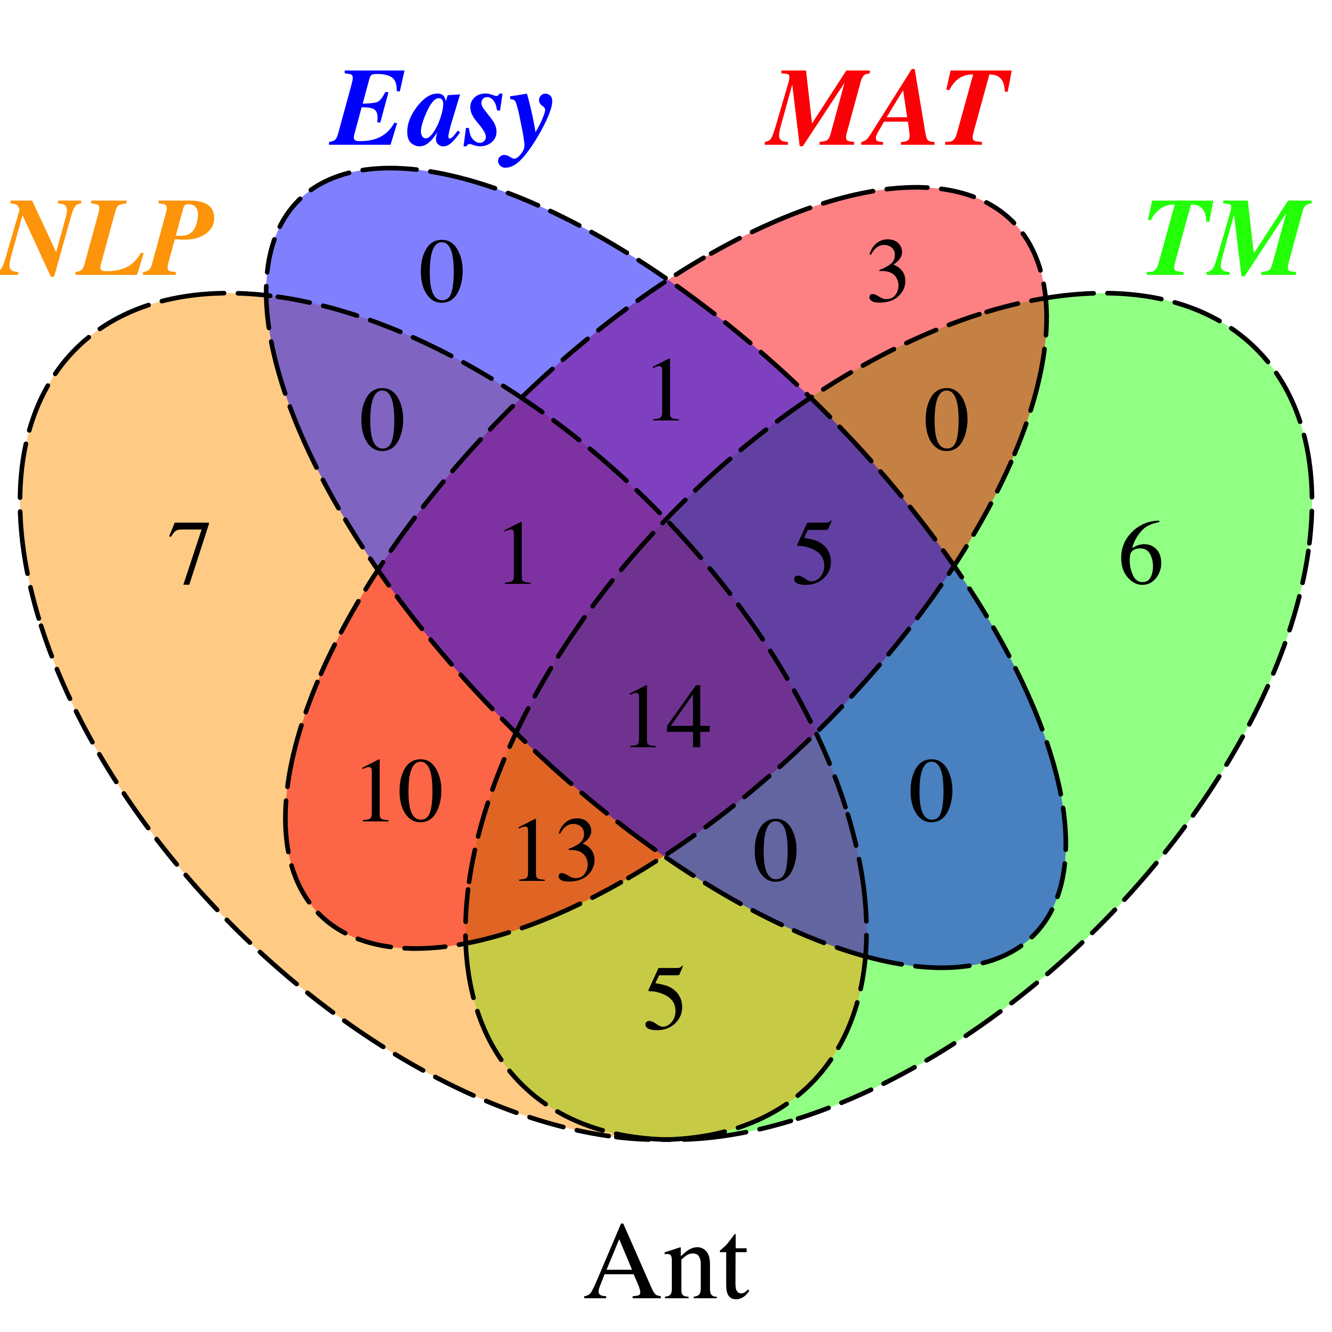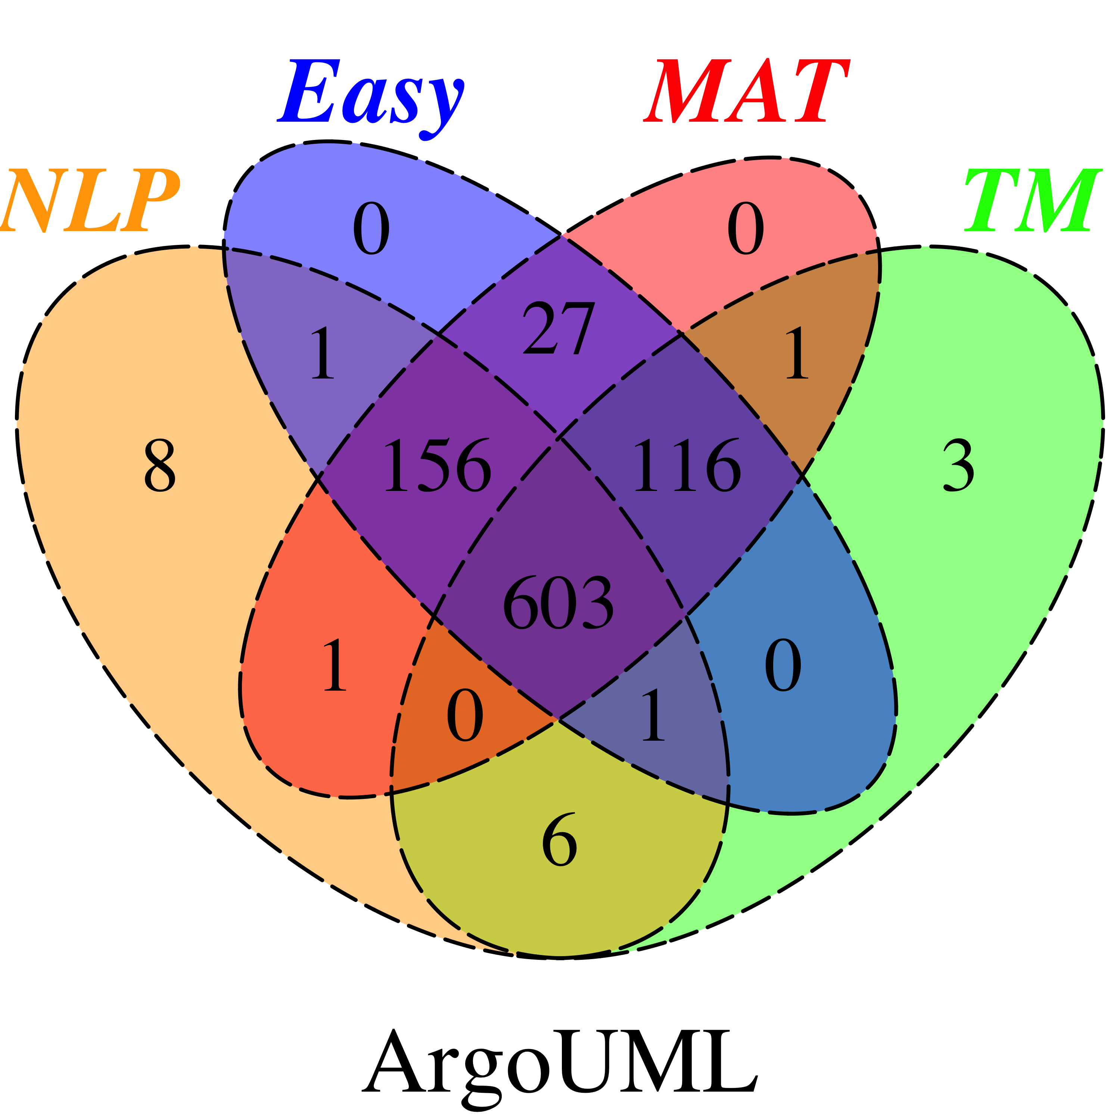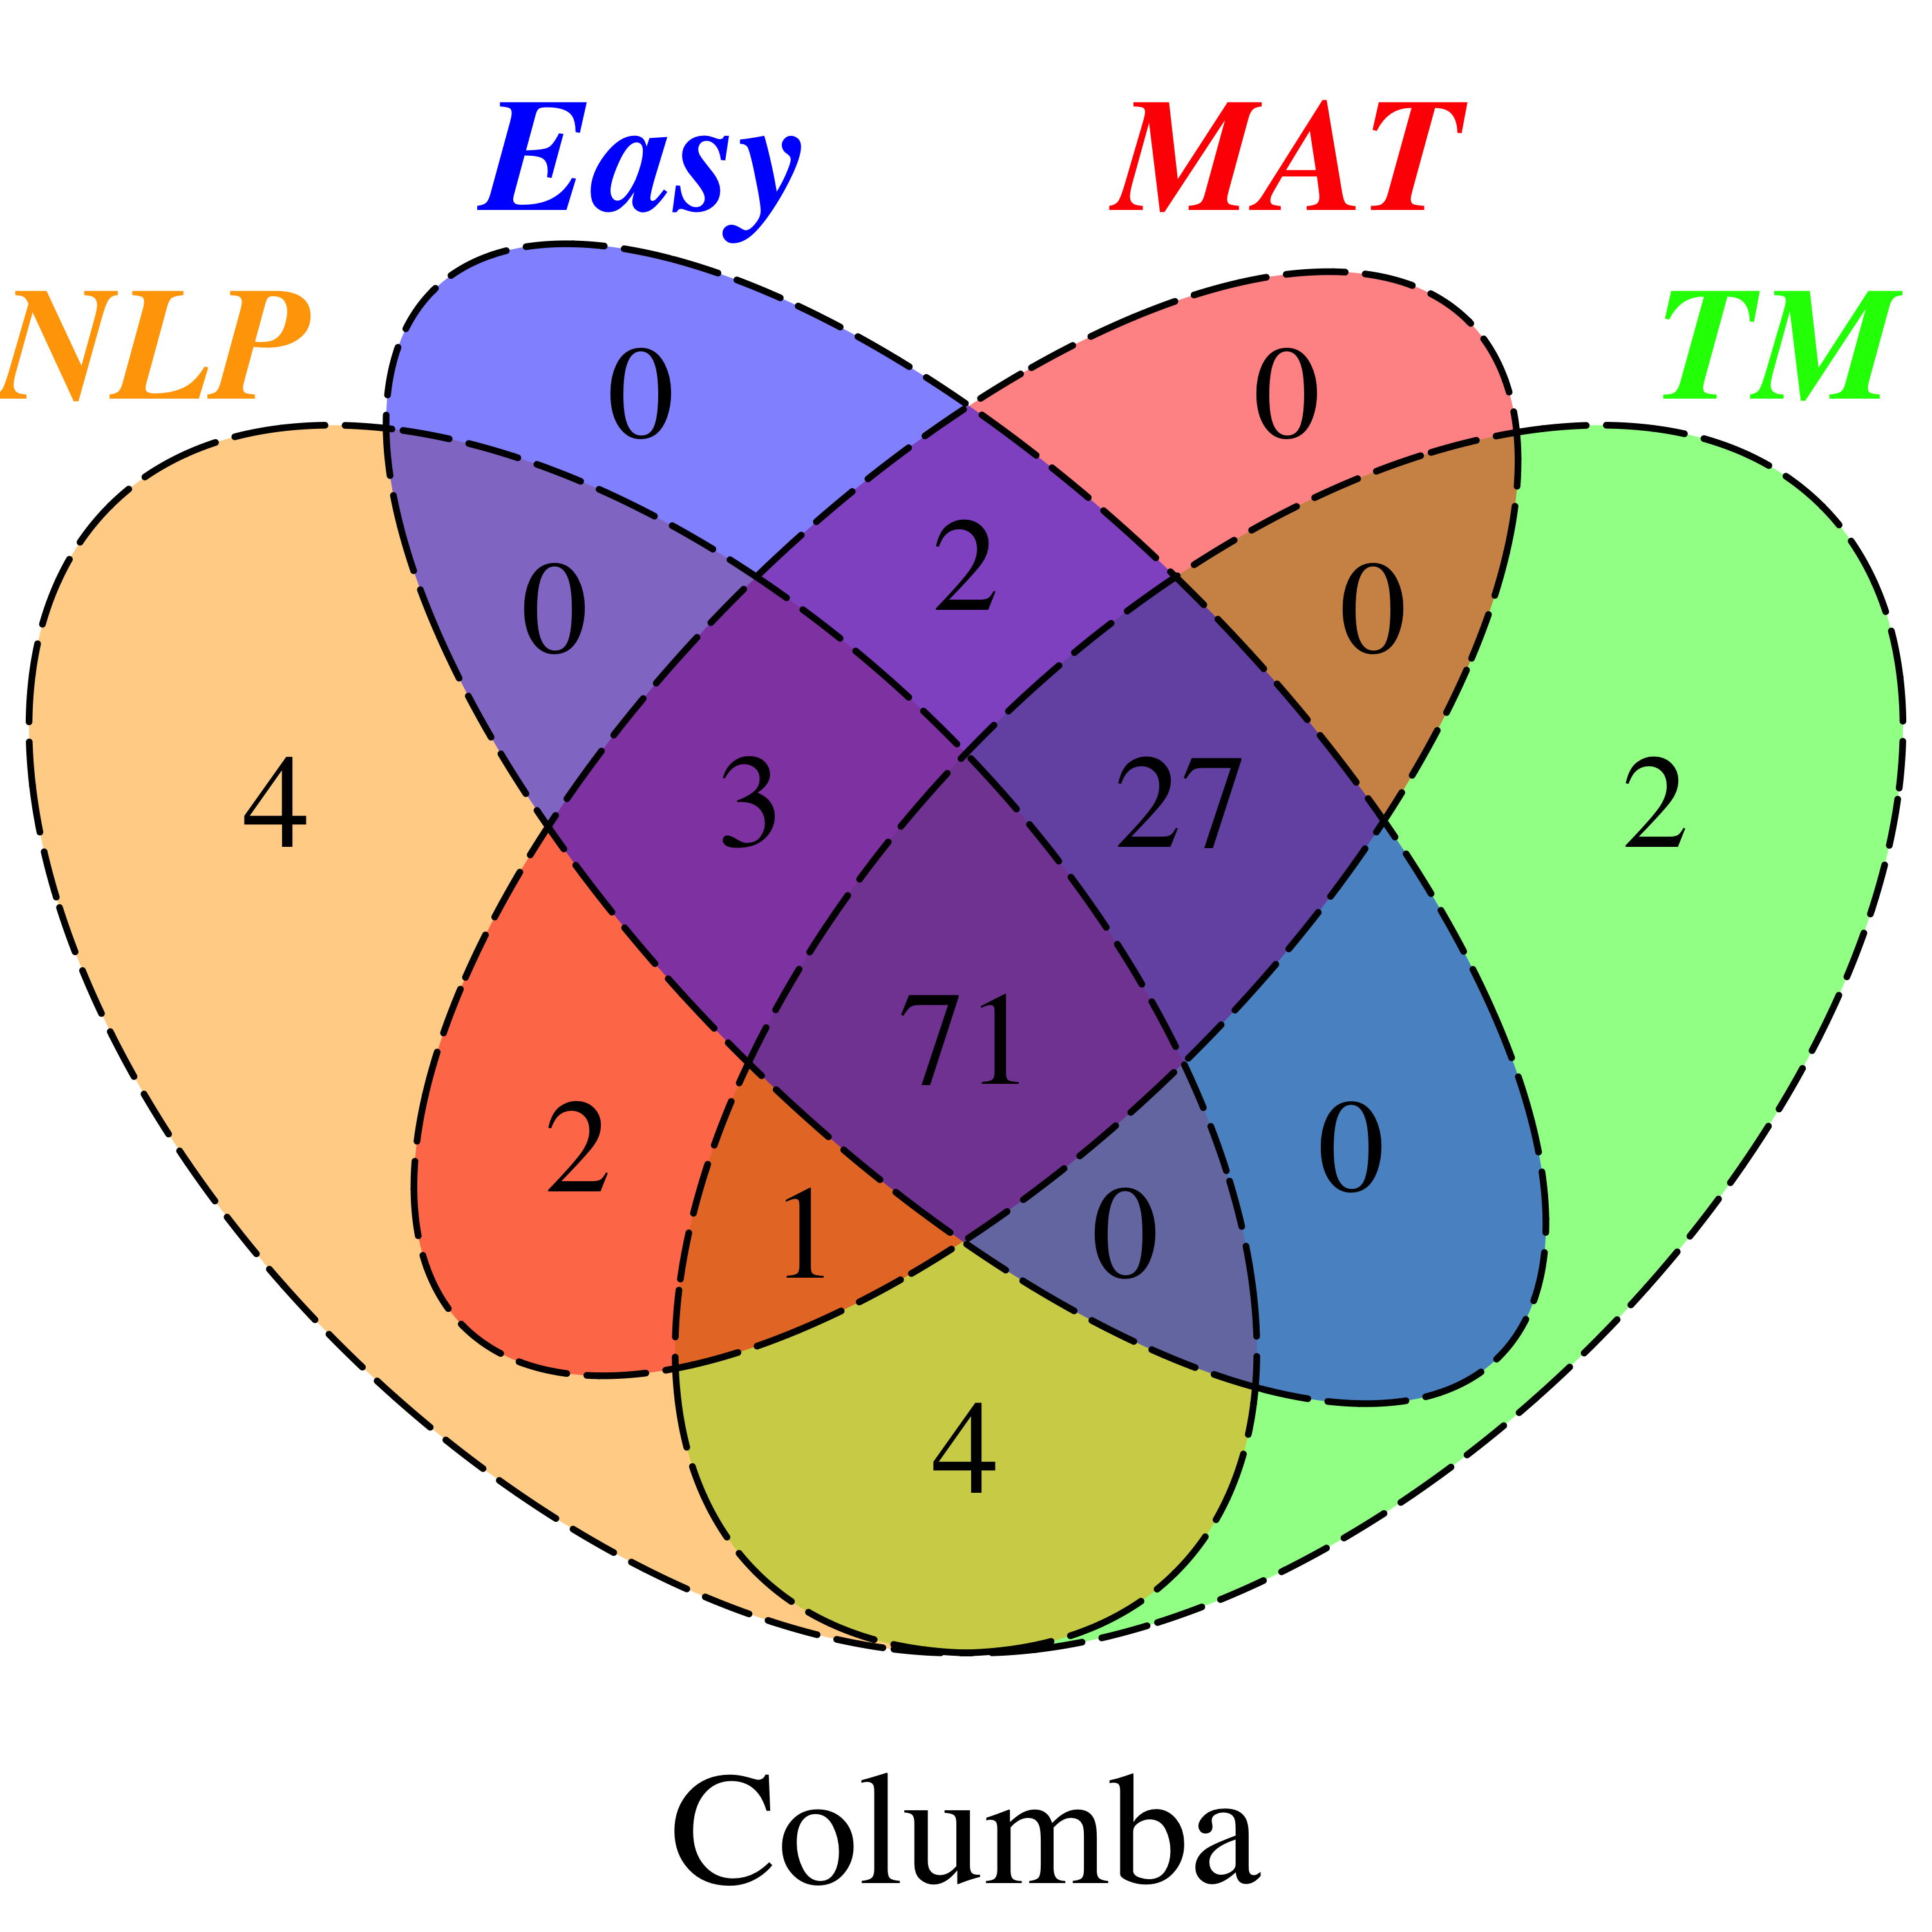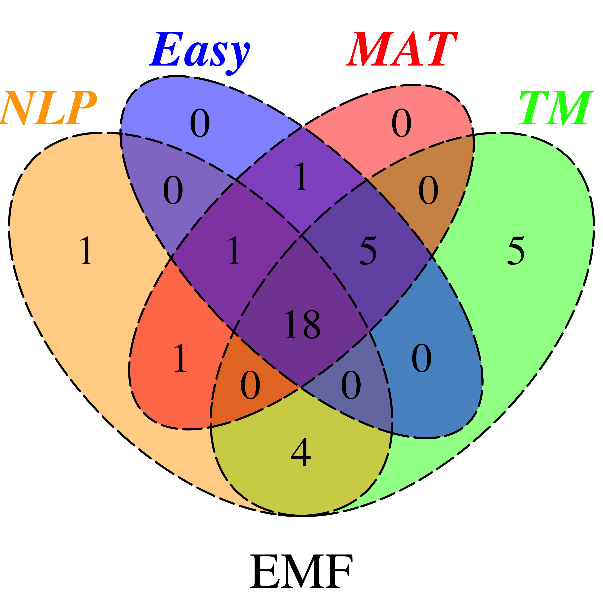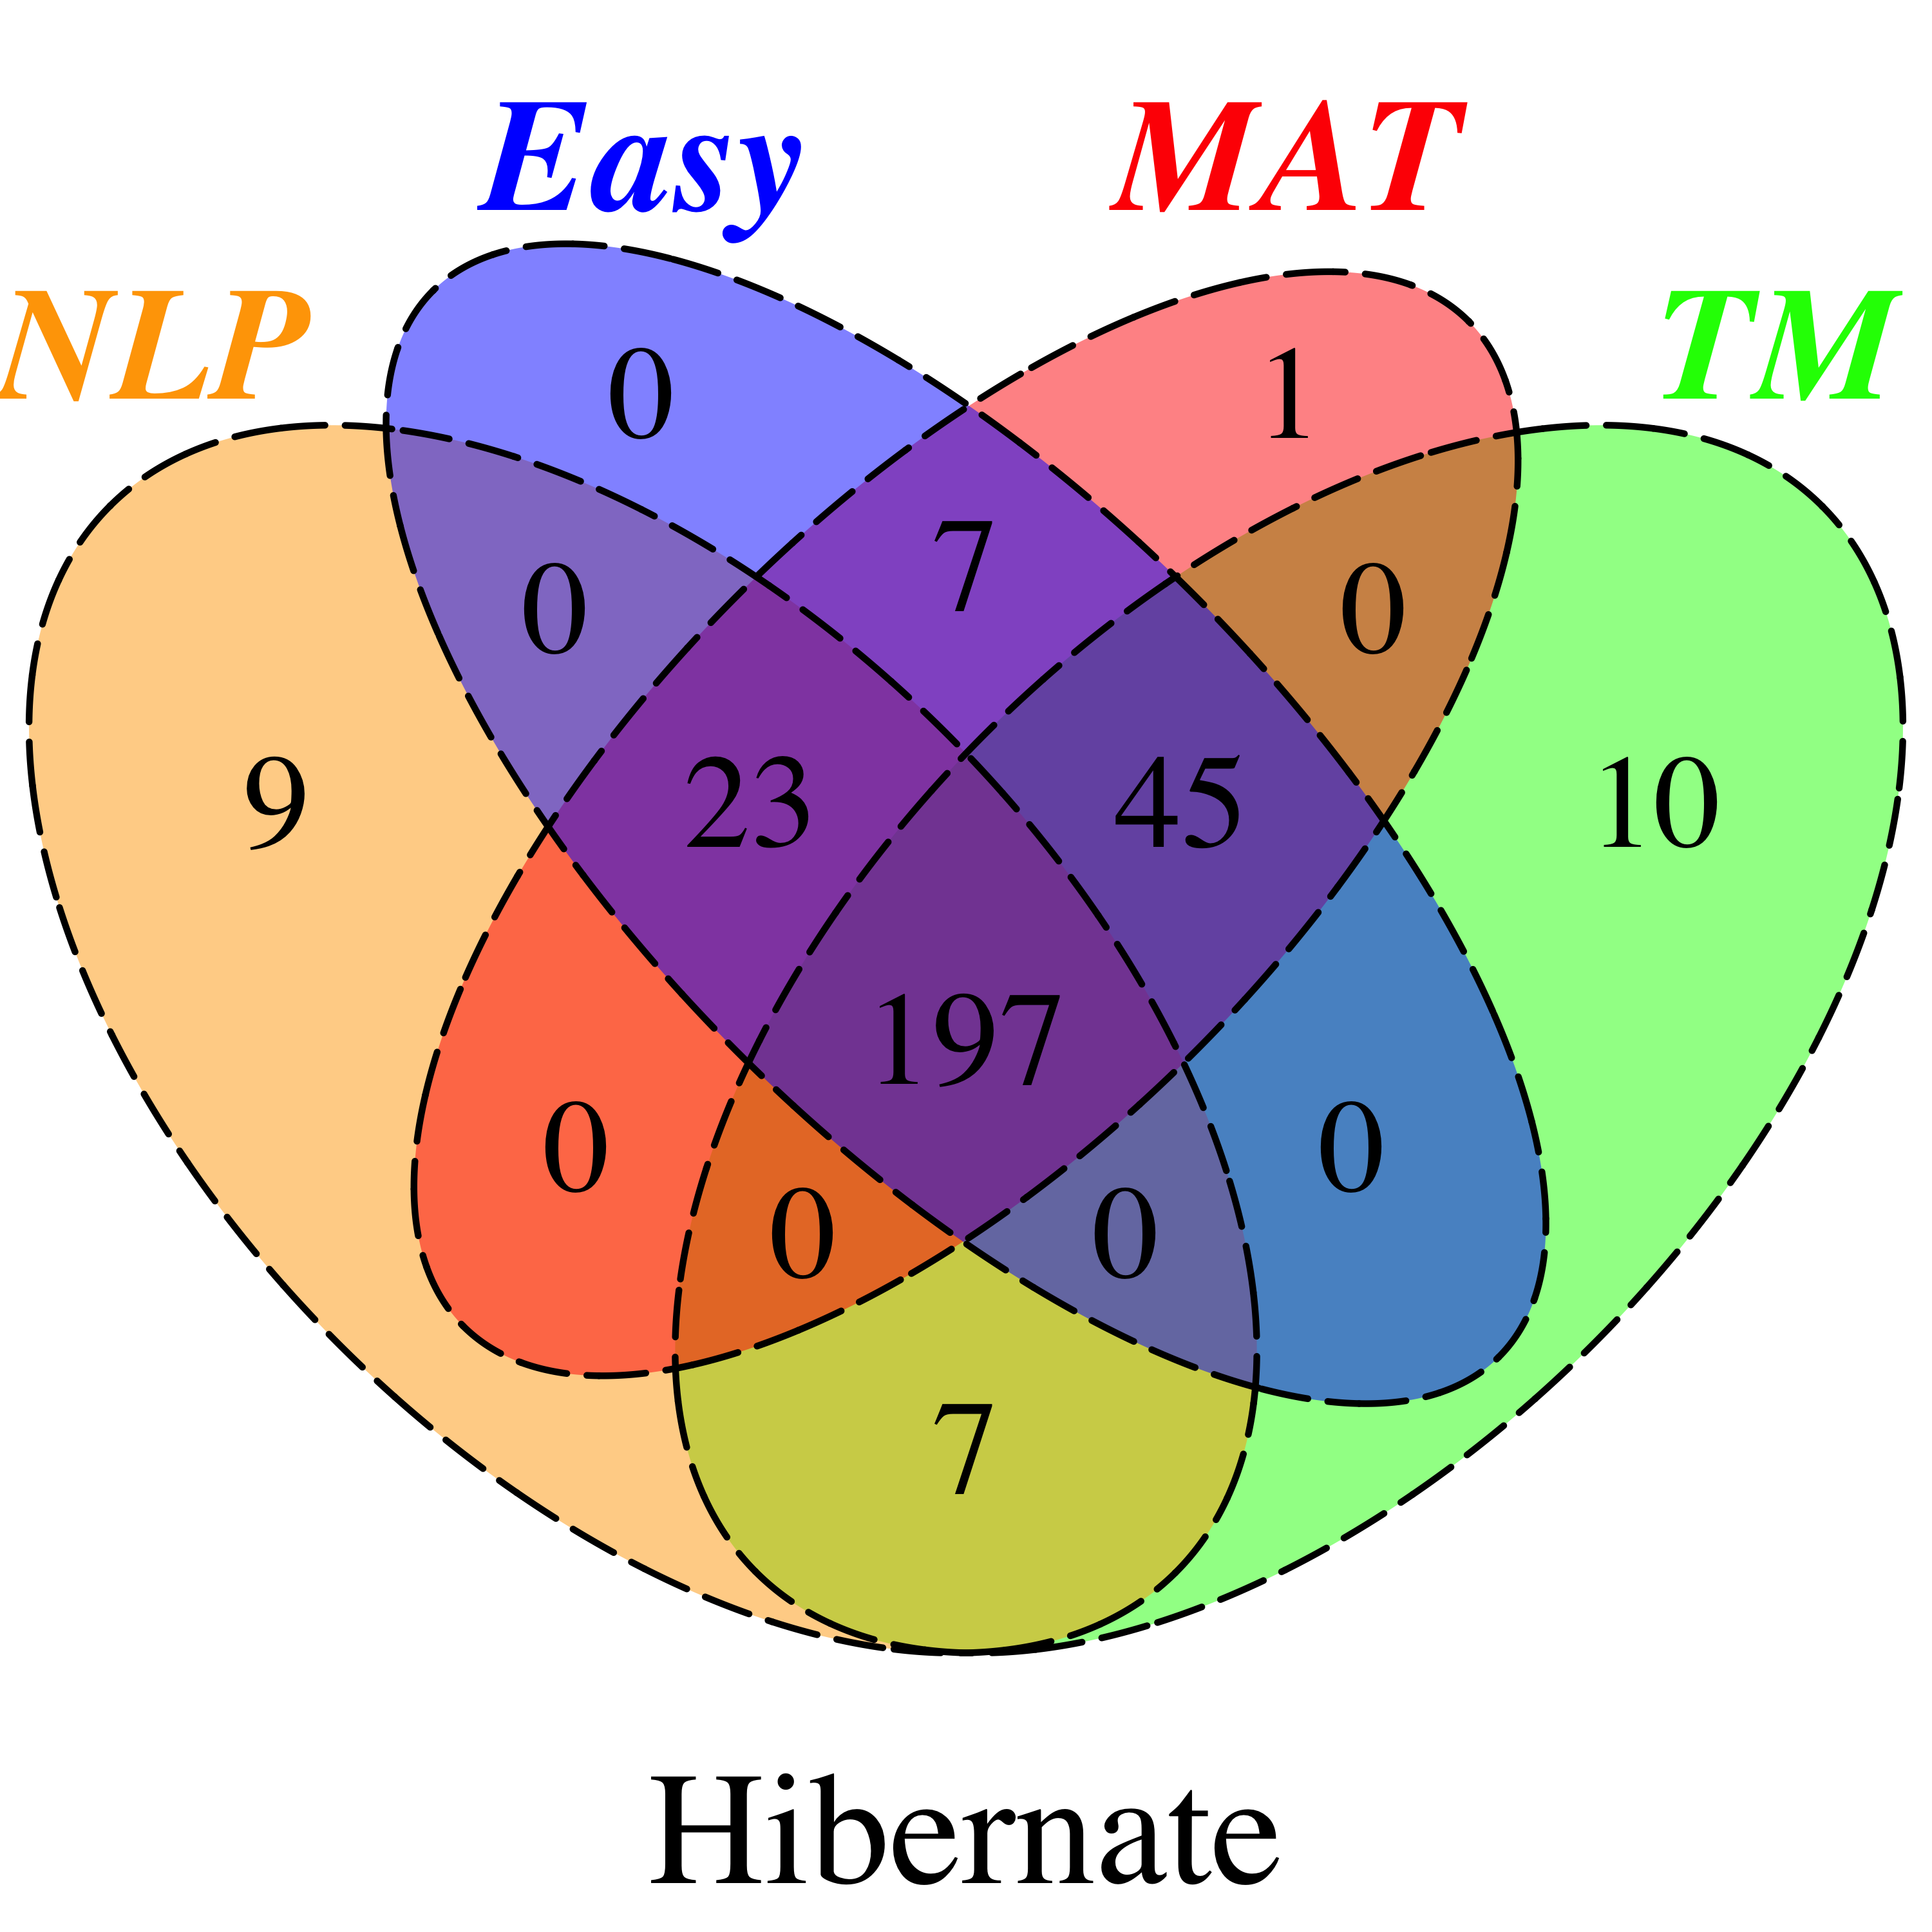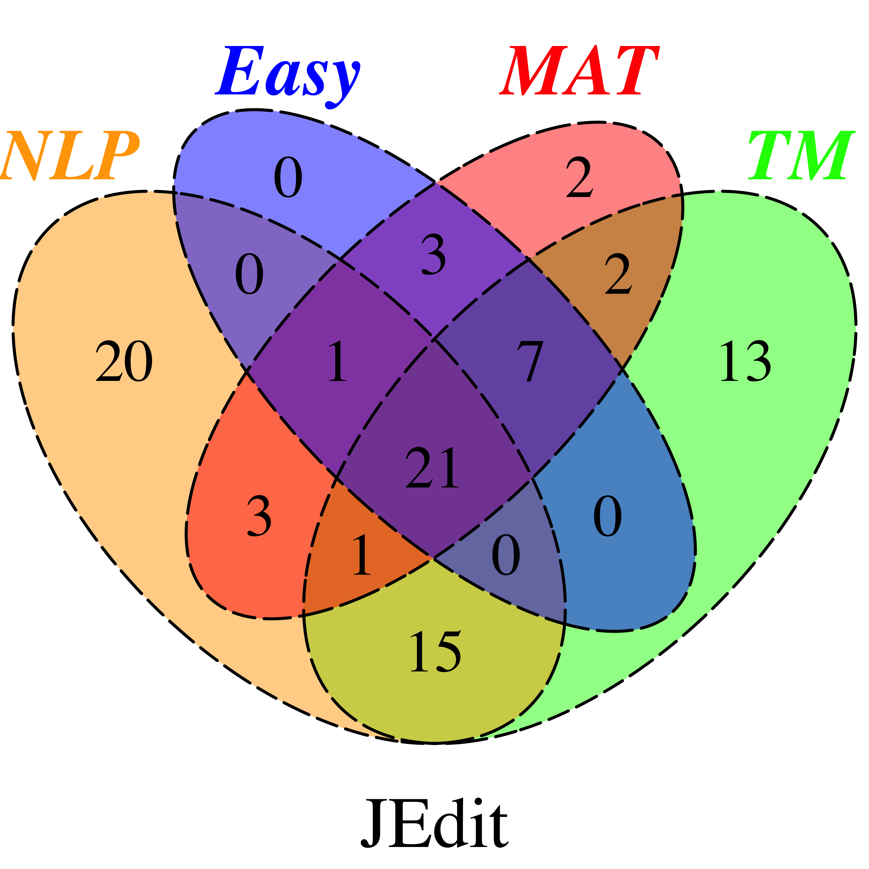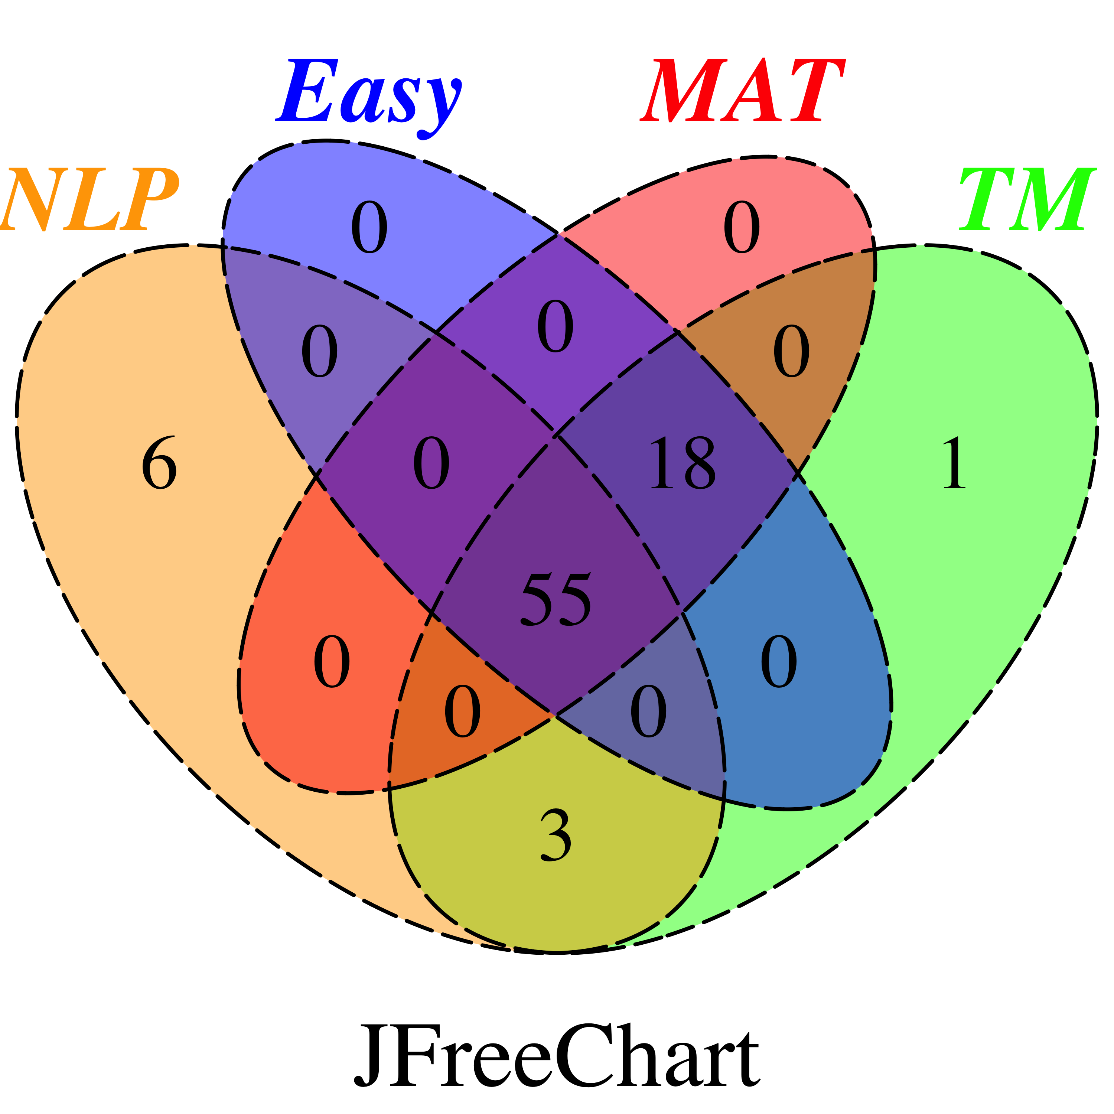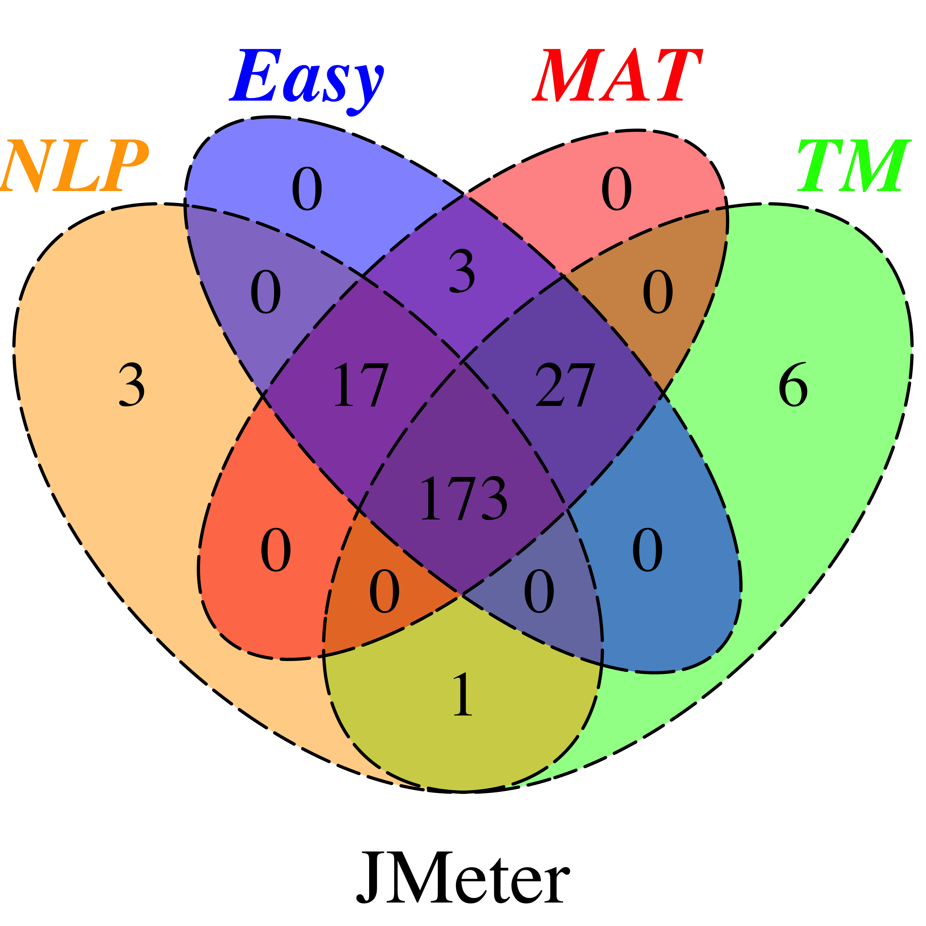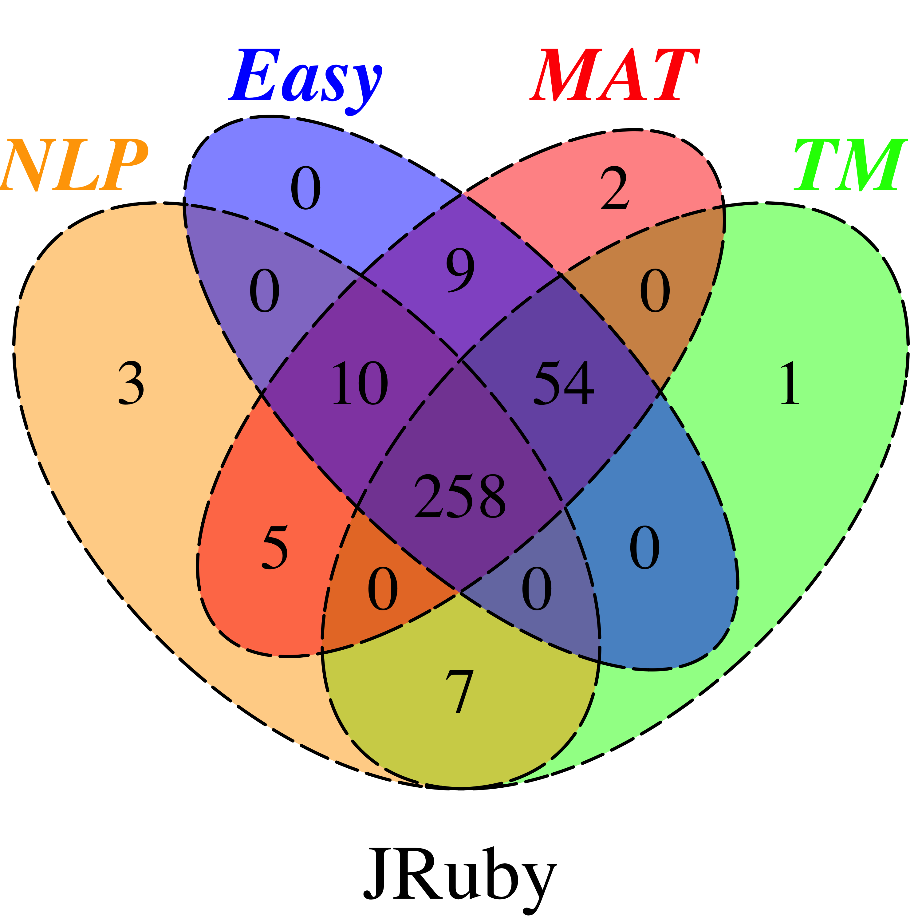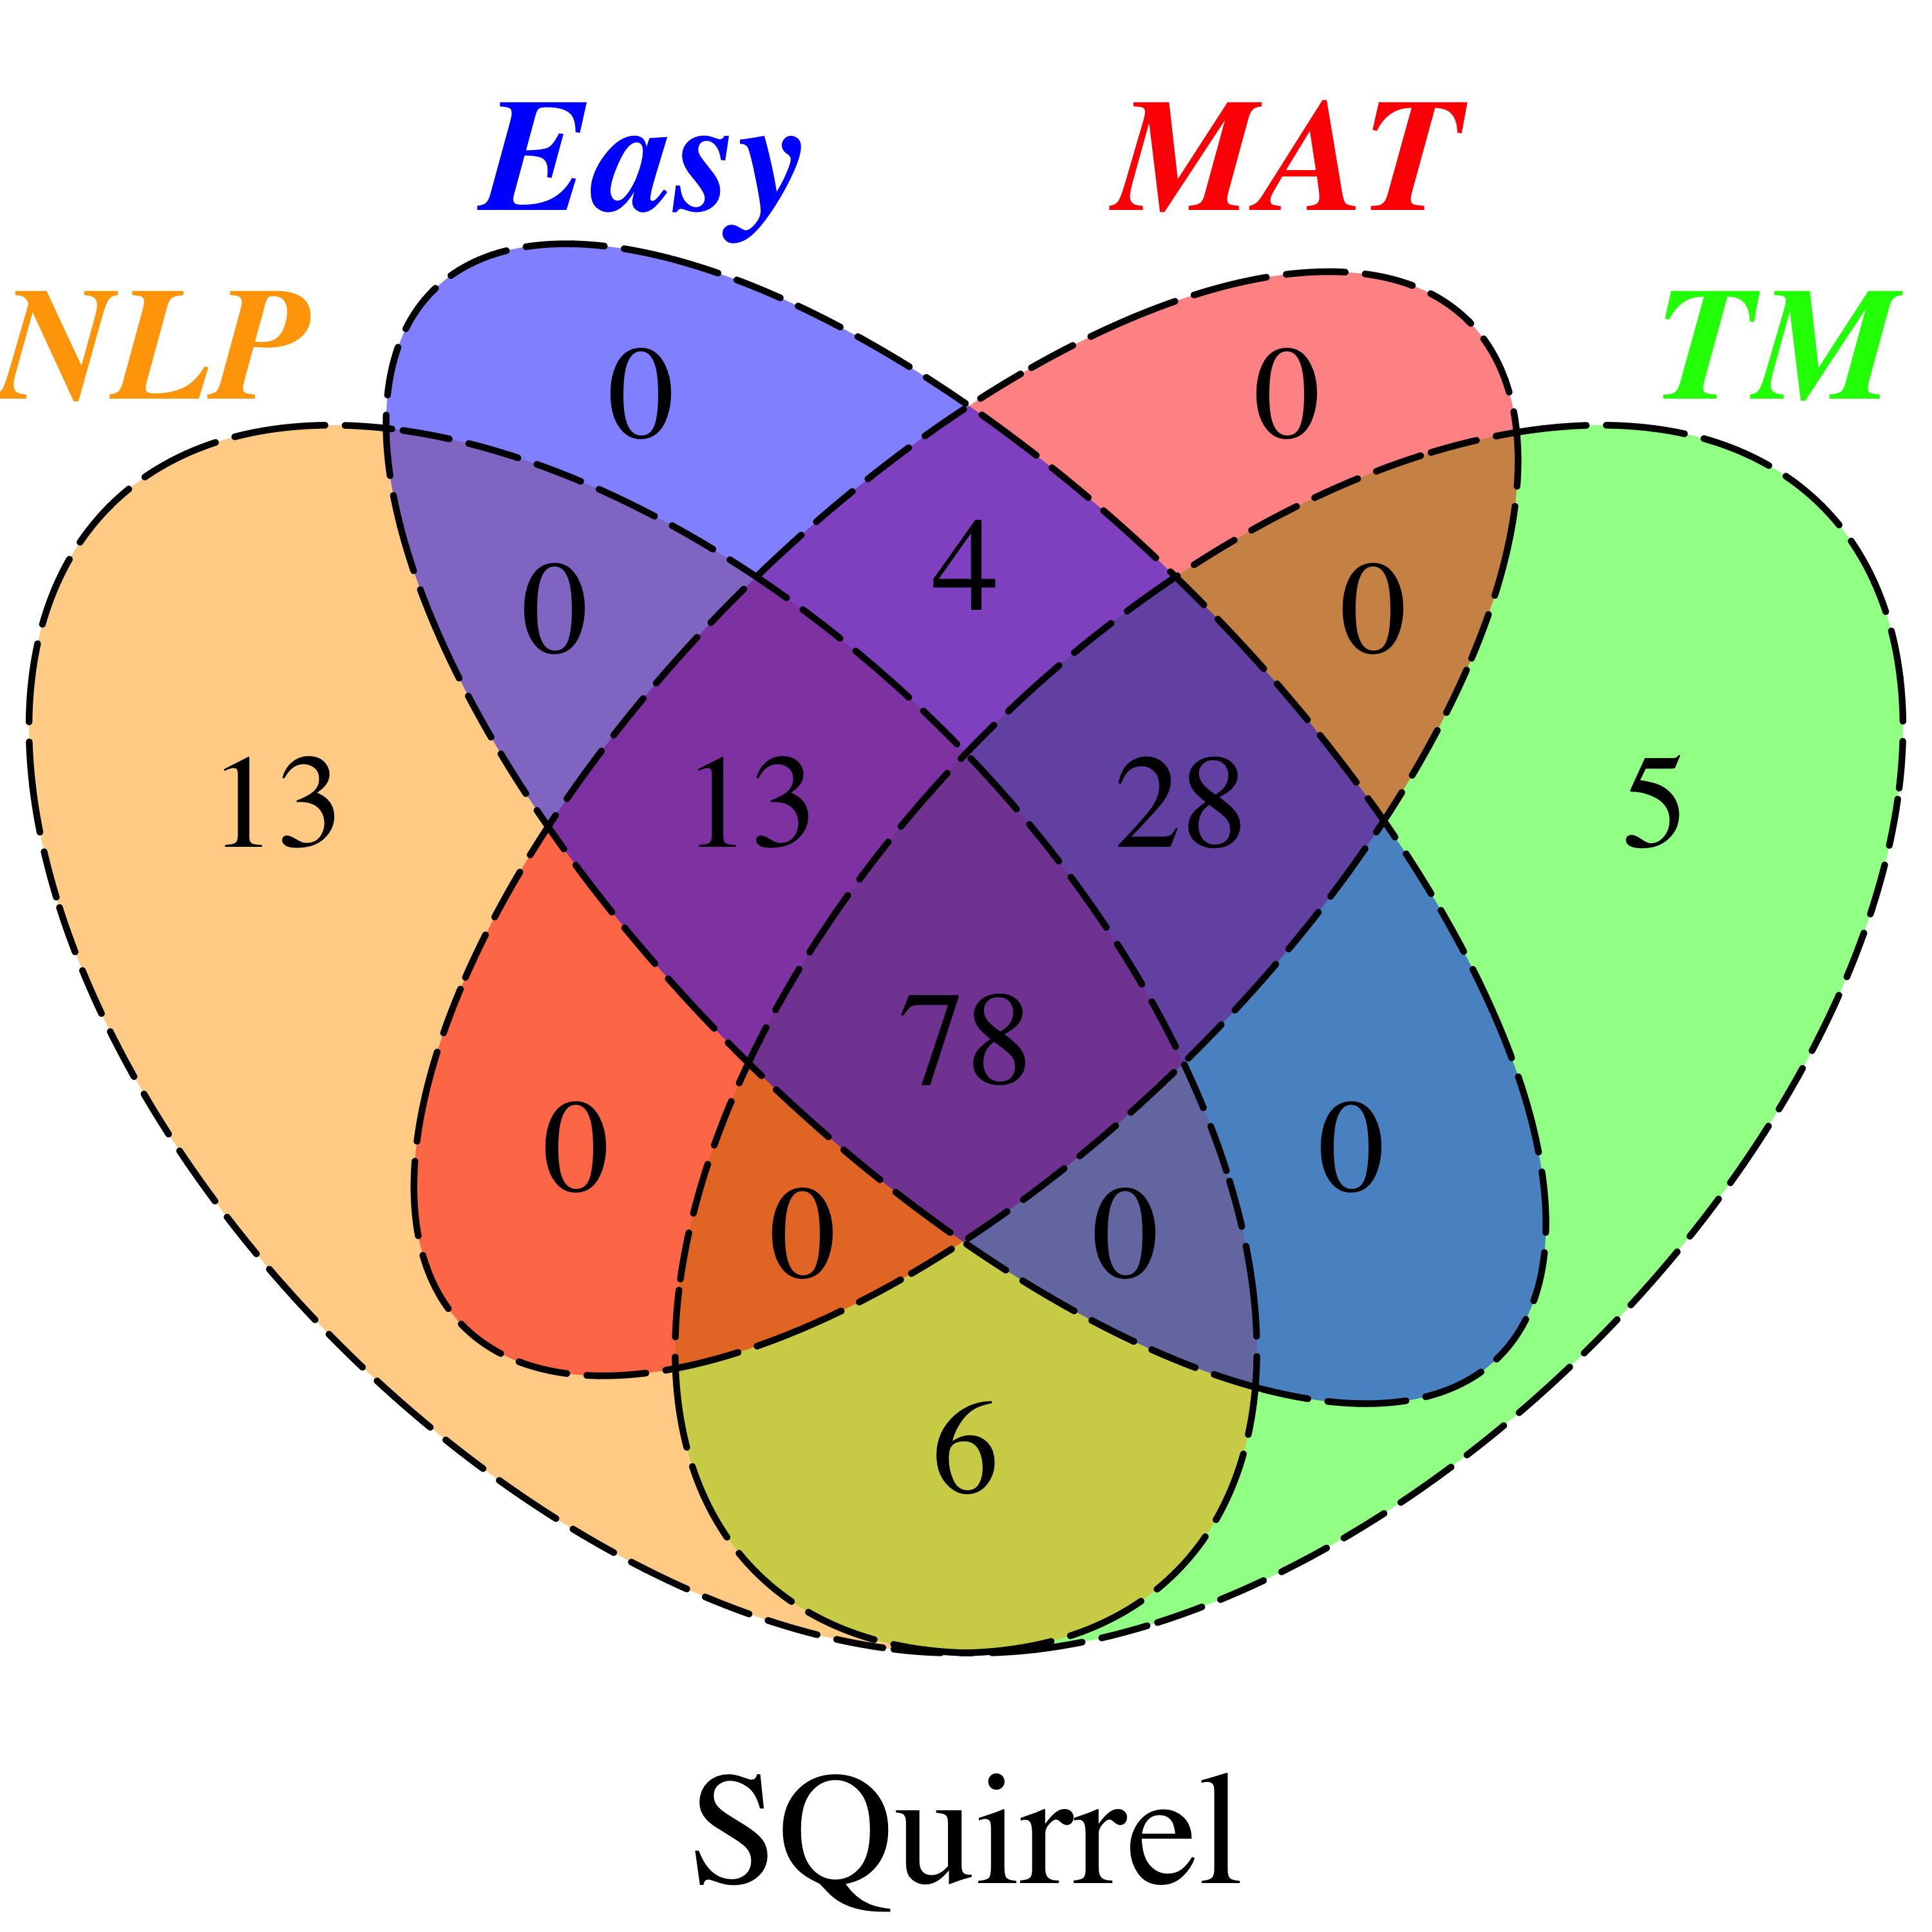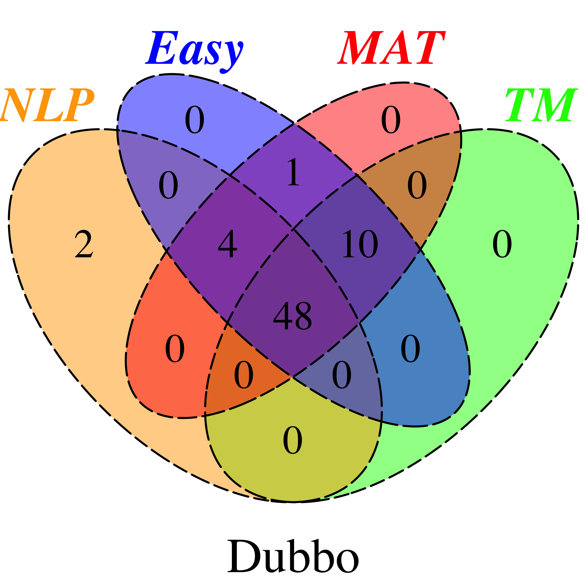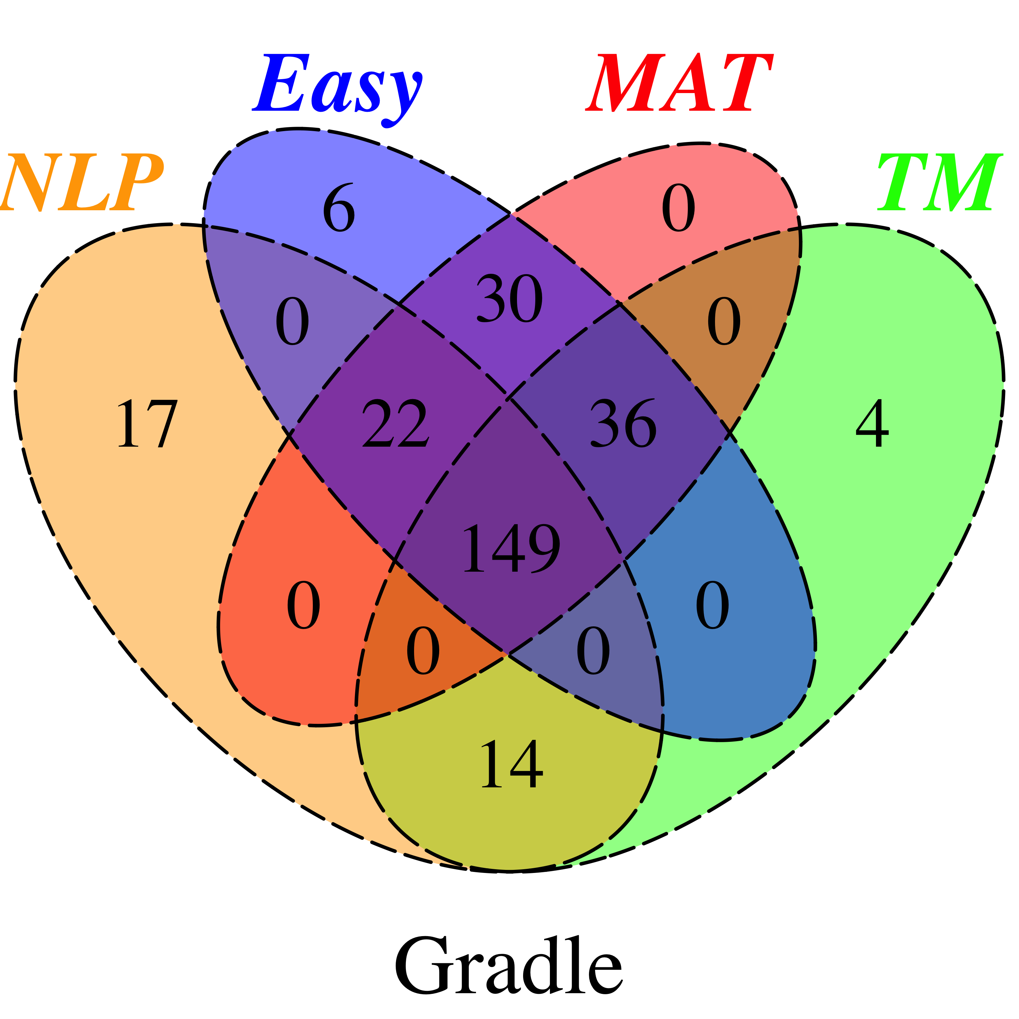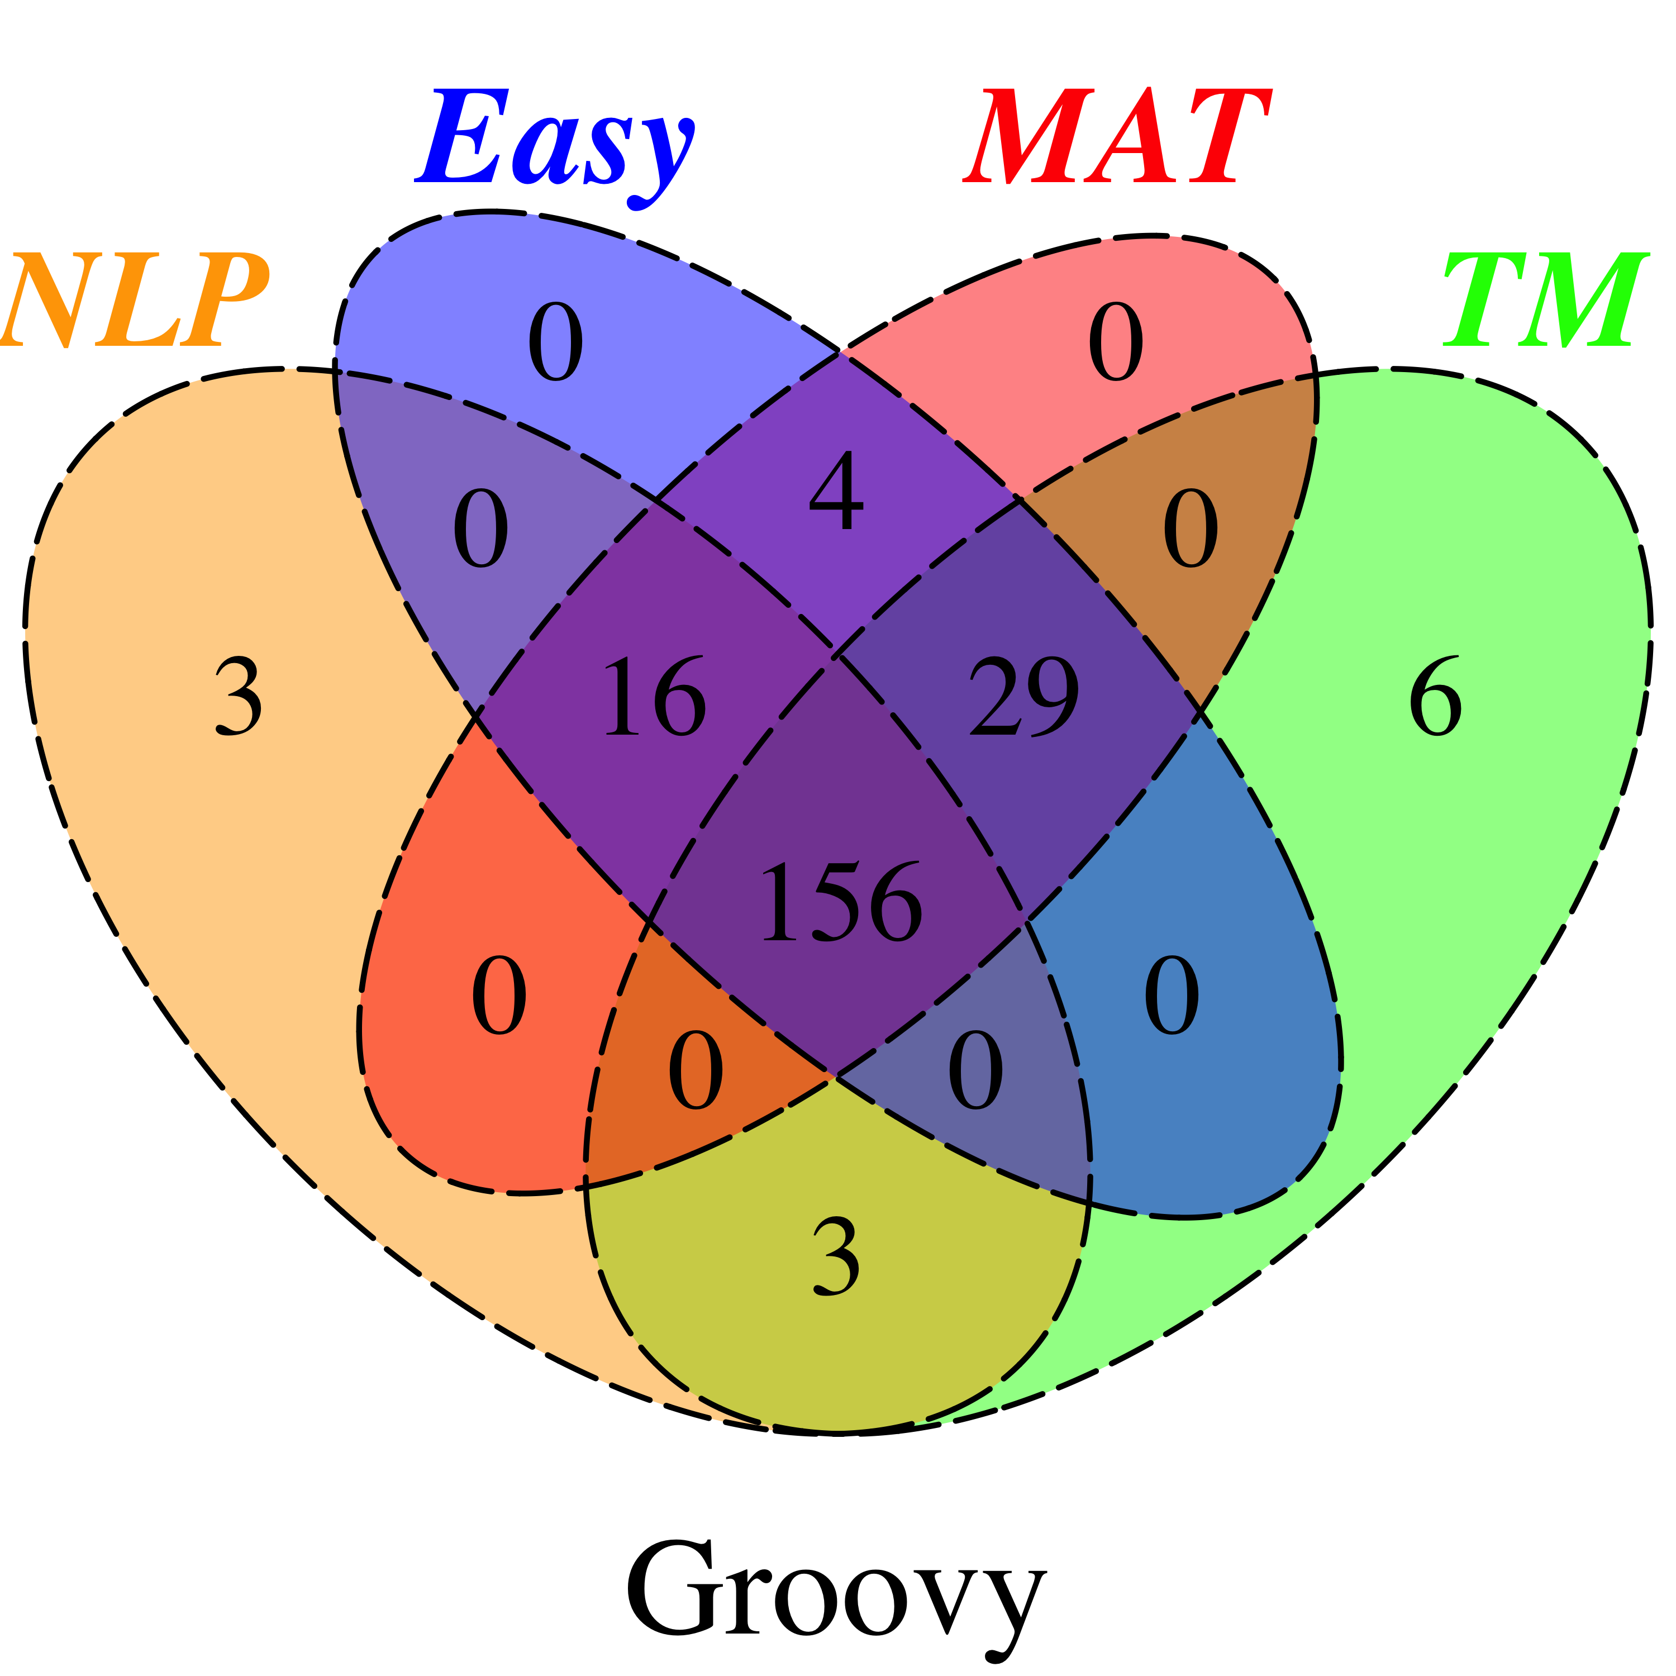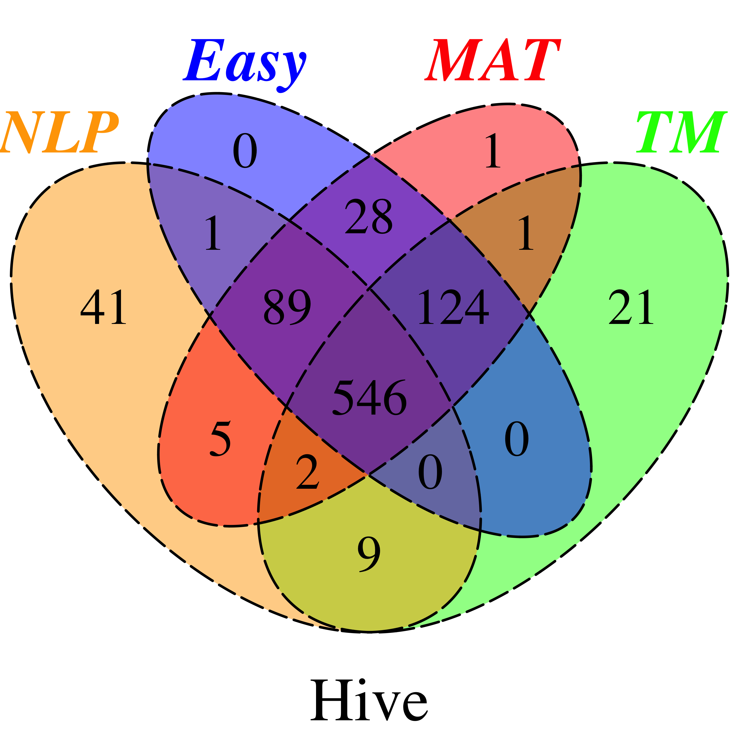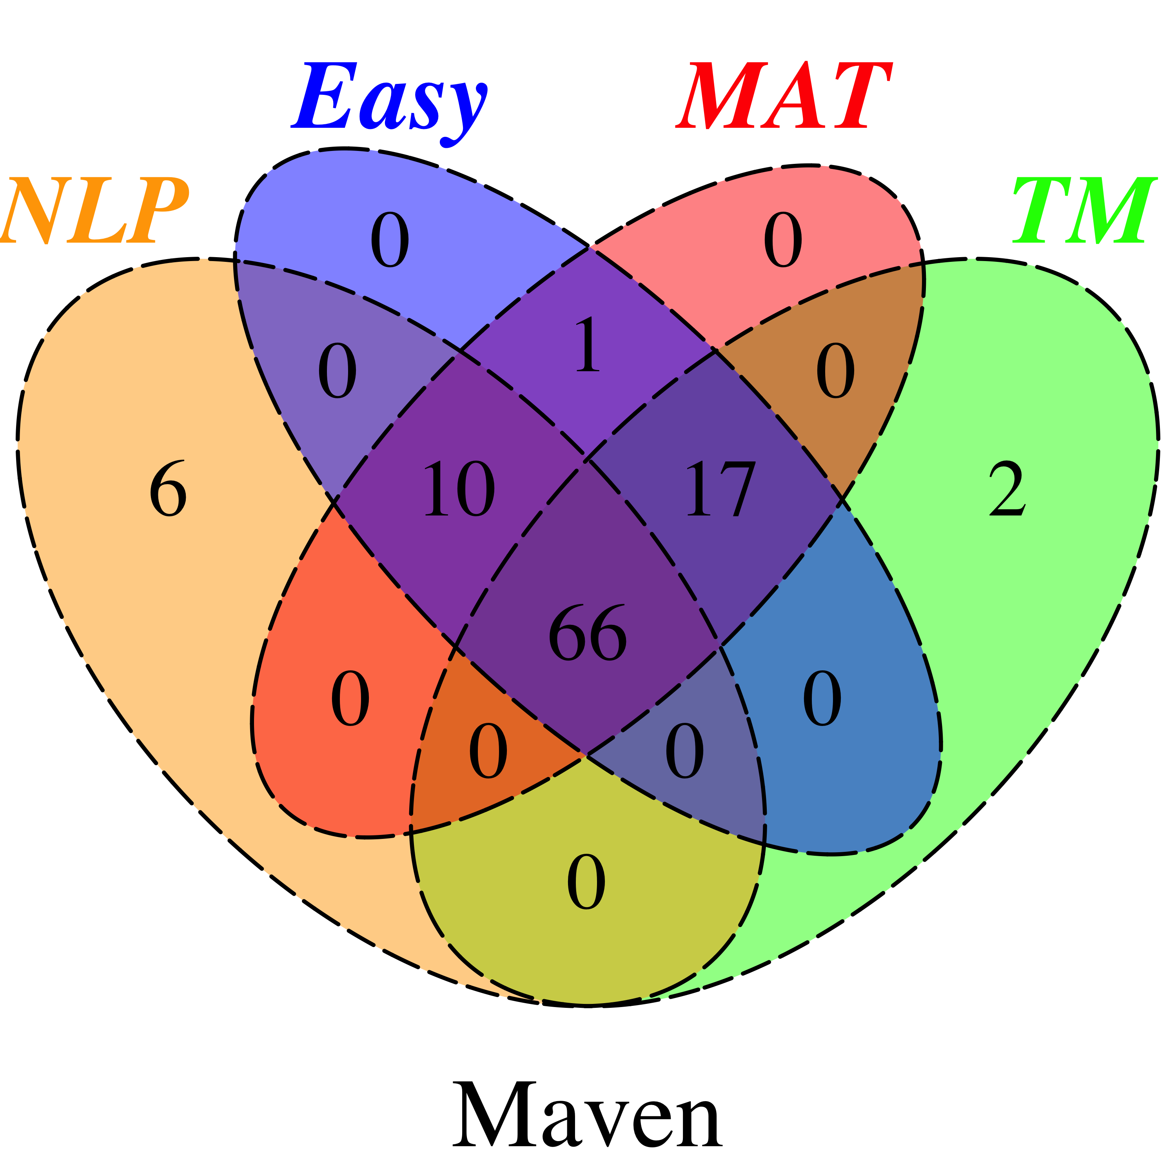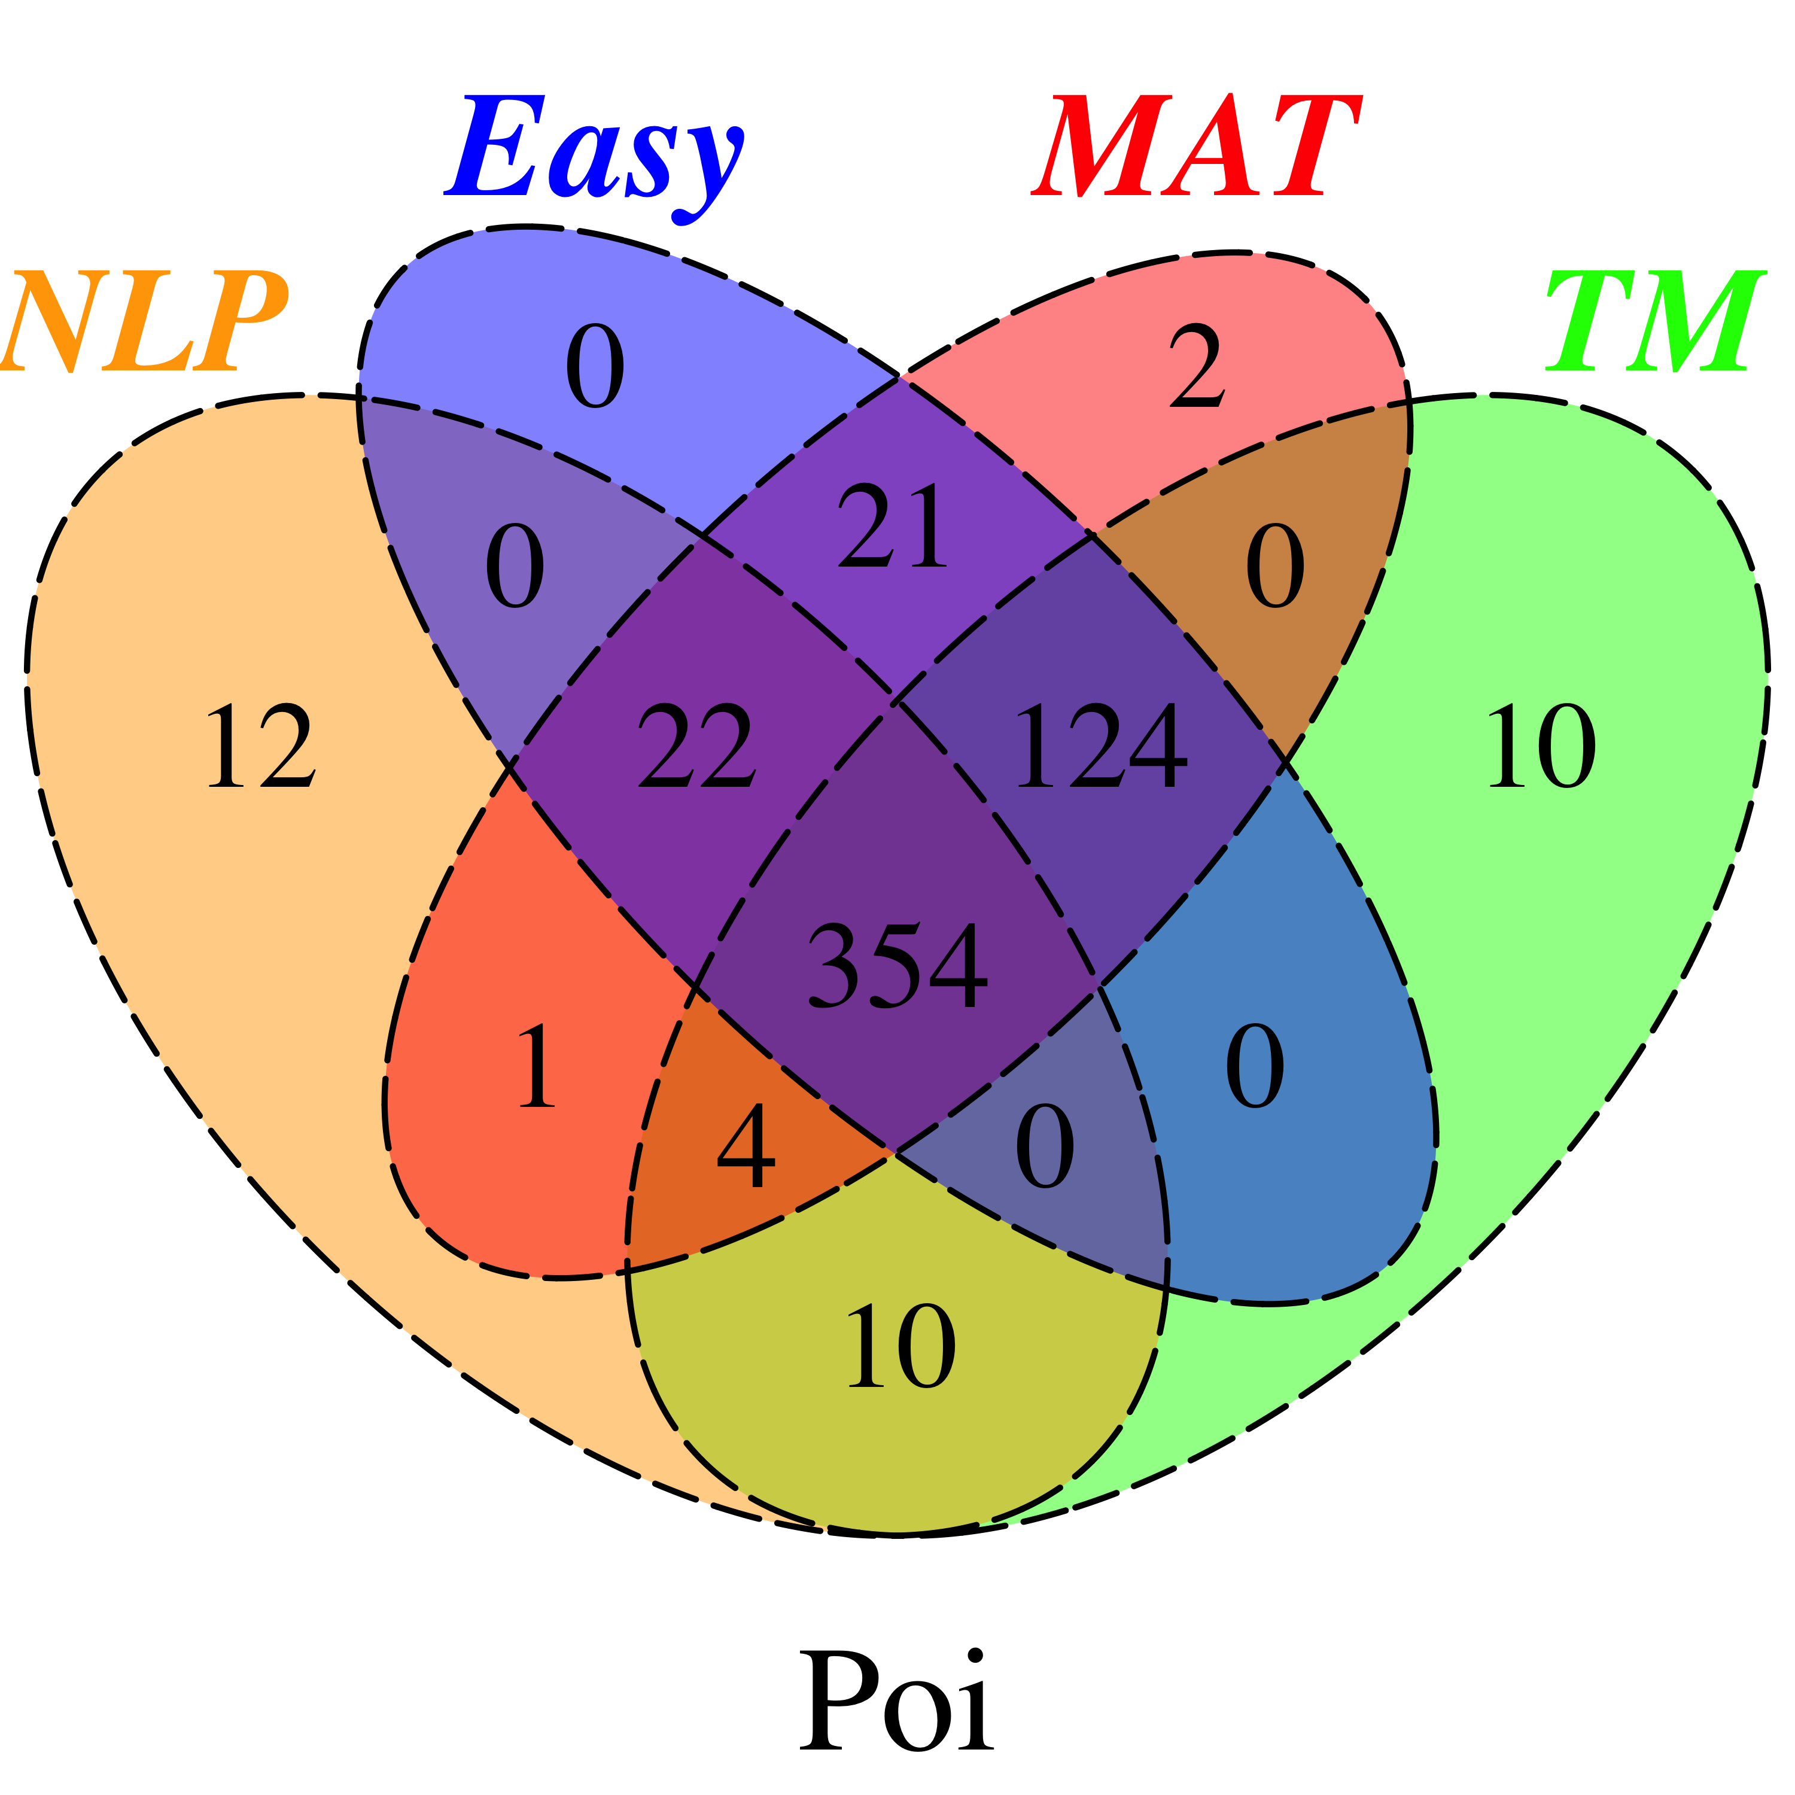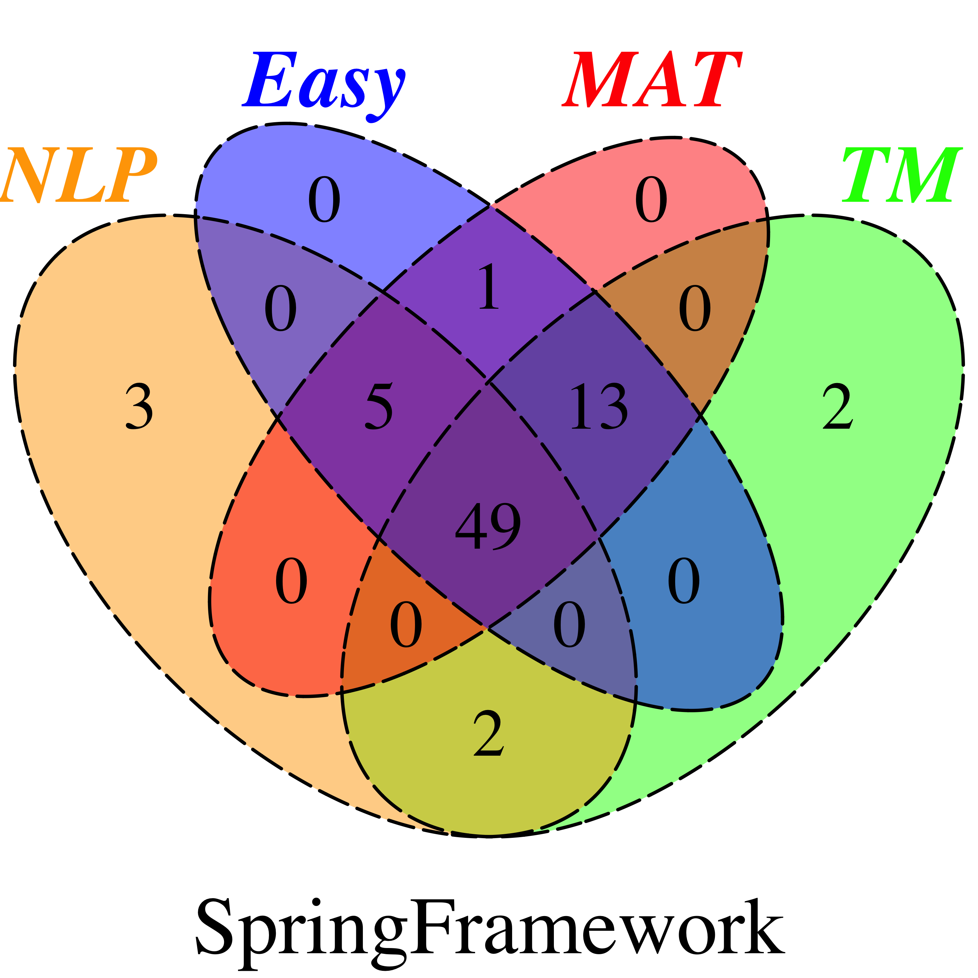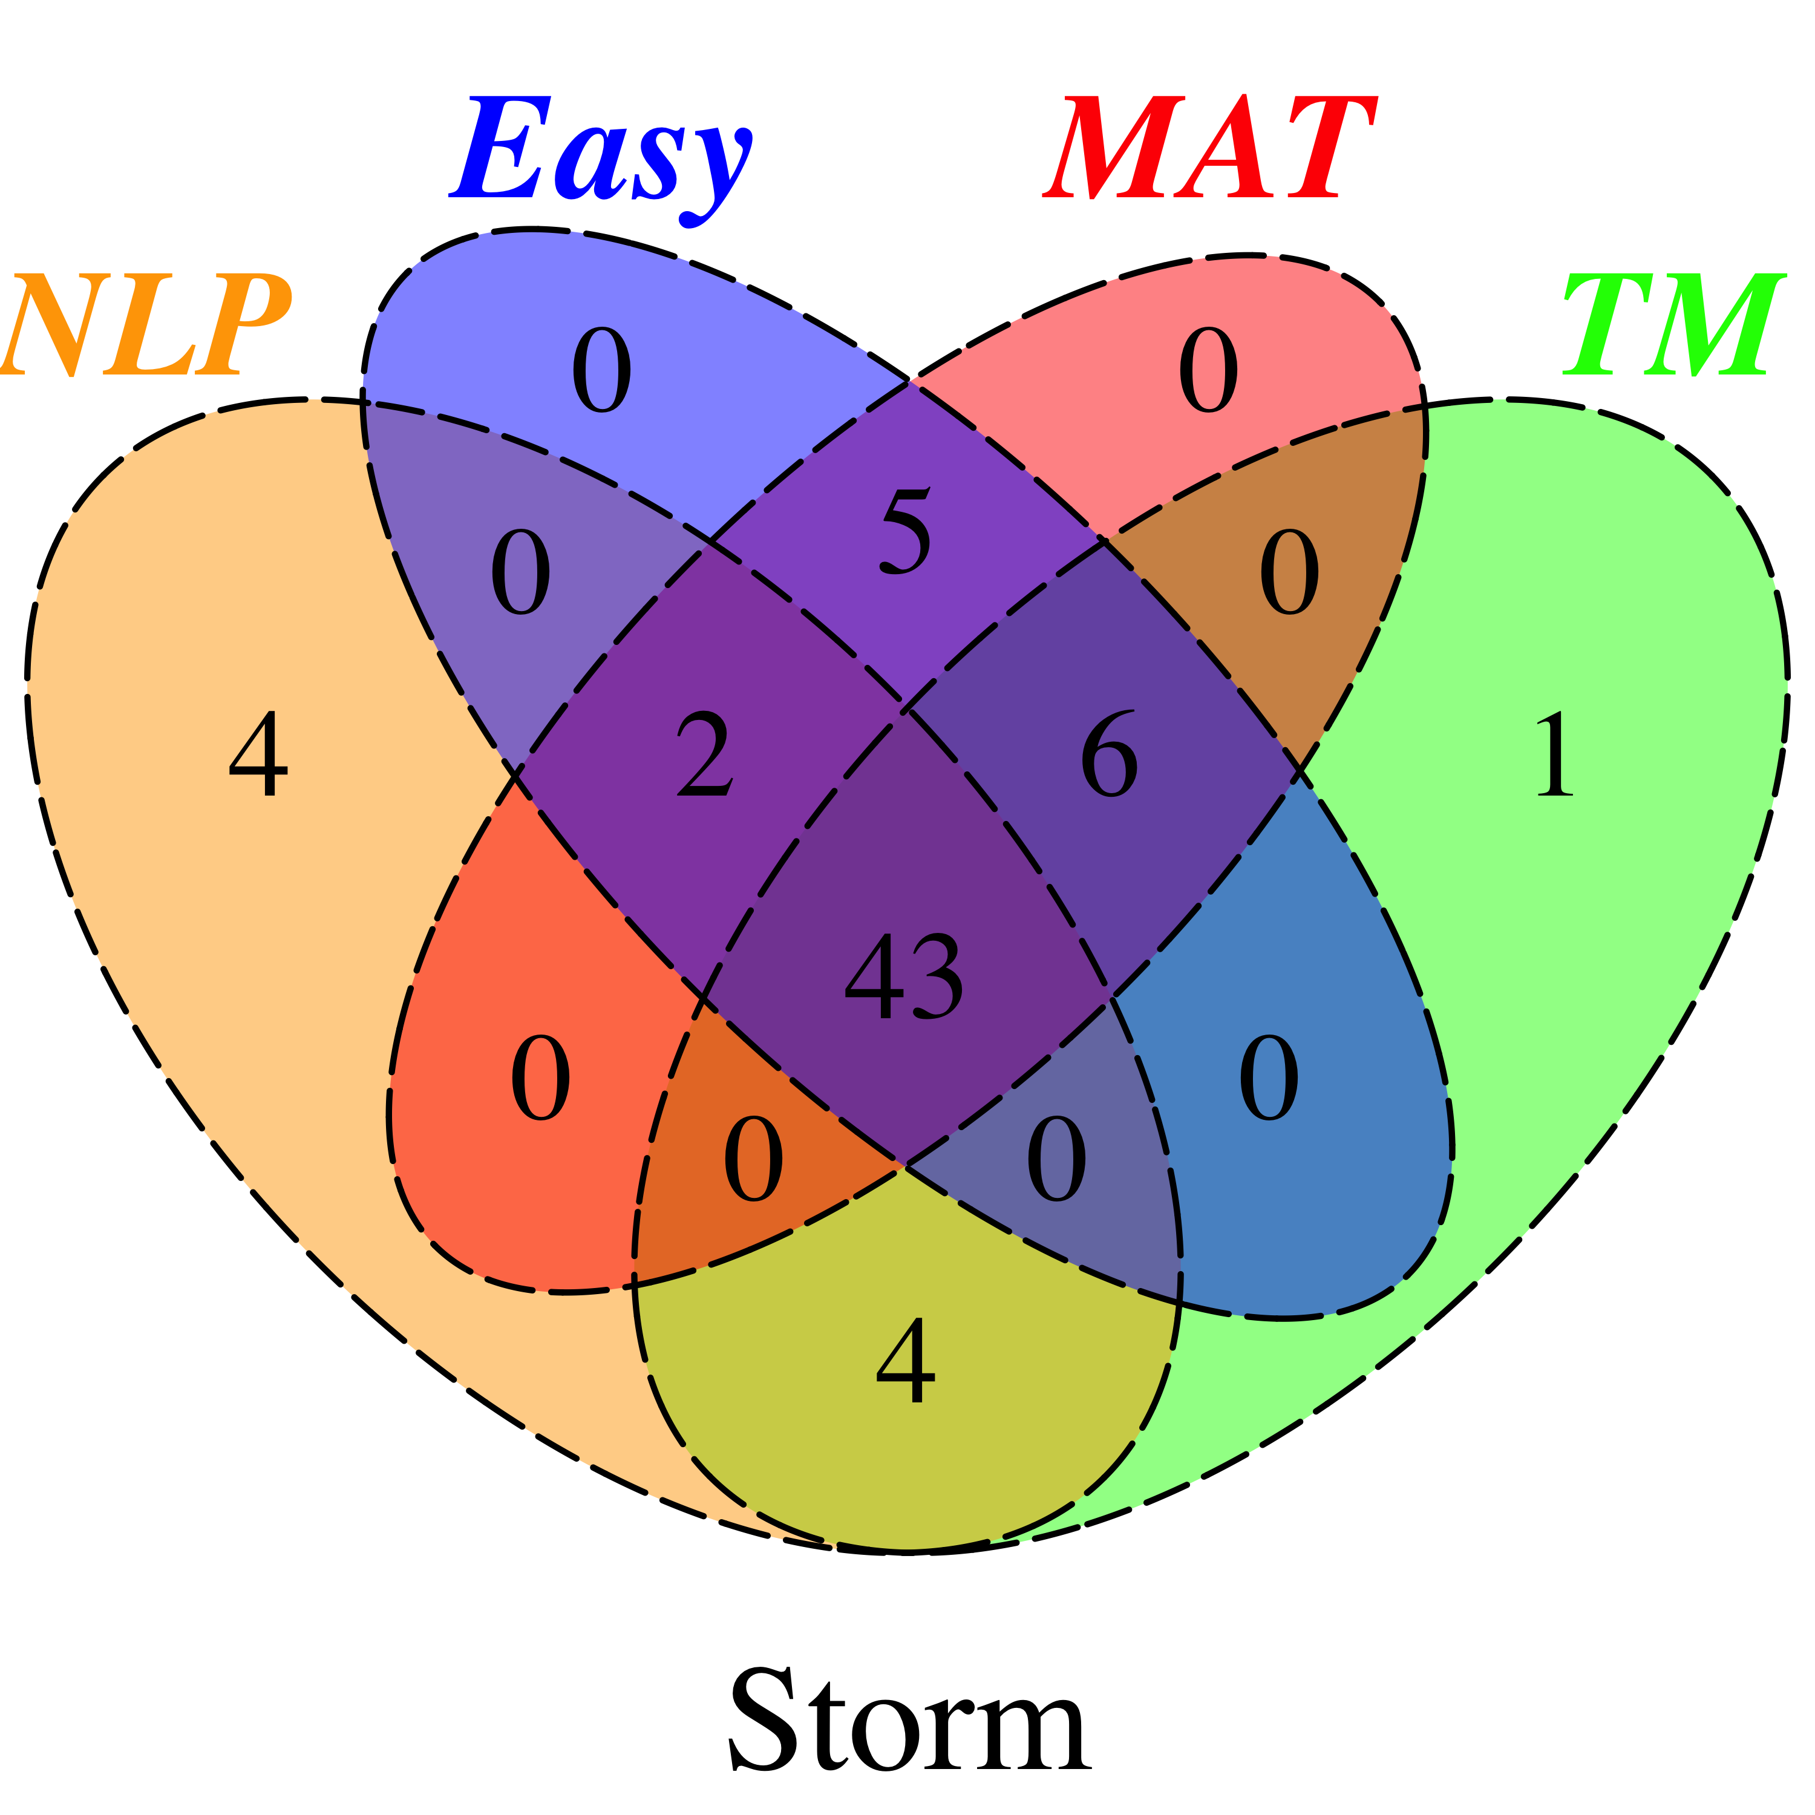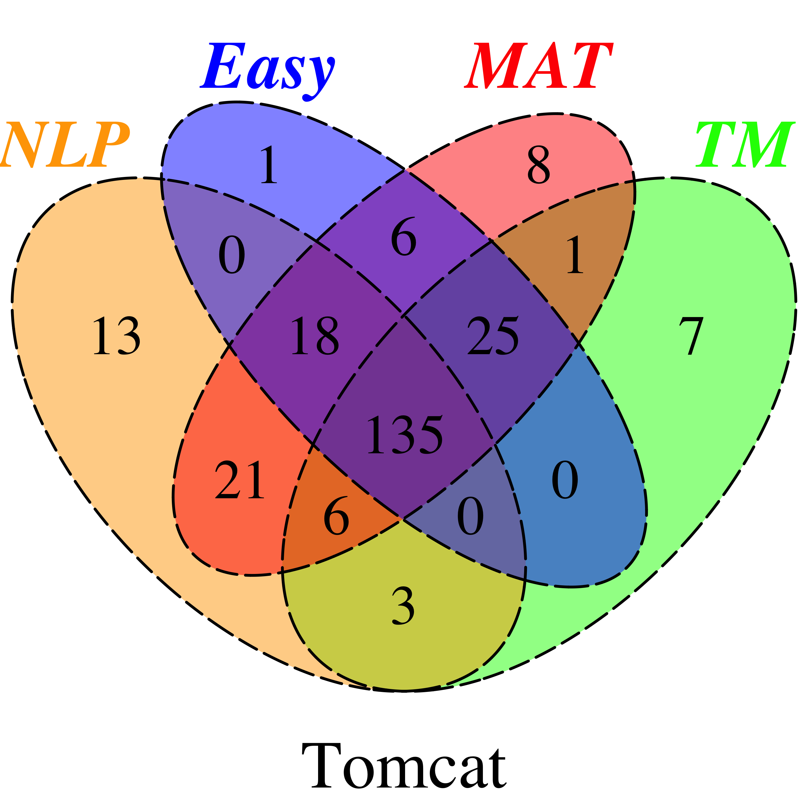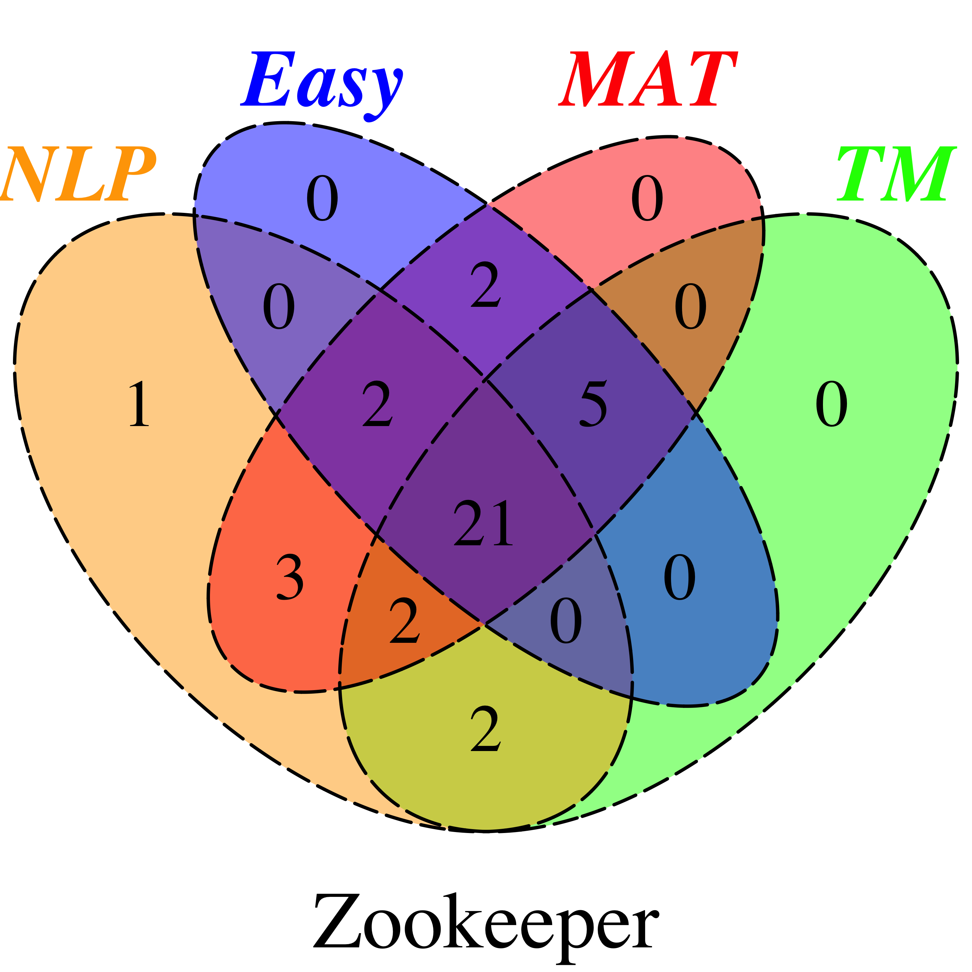

**Figure 5.** Set diagrams for the number of true positive instances classified by MAT and three supervised approaches (NLP, TM, and Easy) on 20 projects

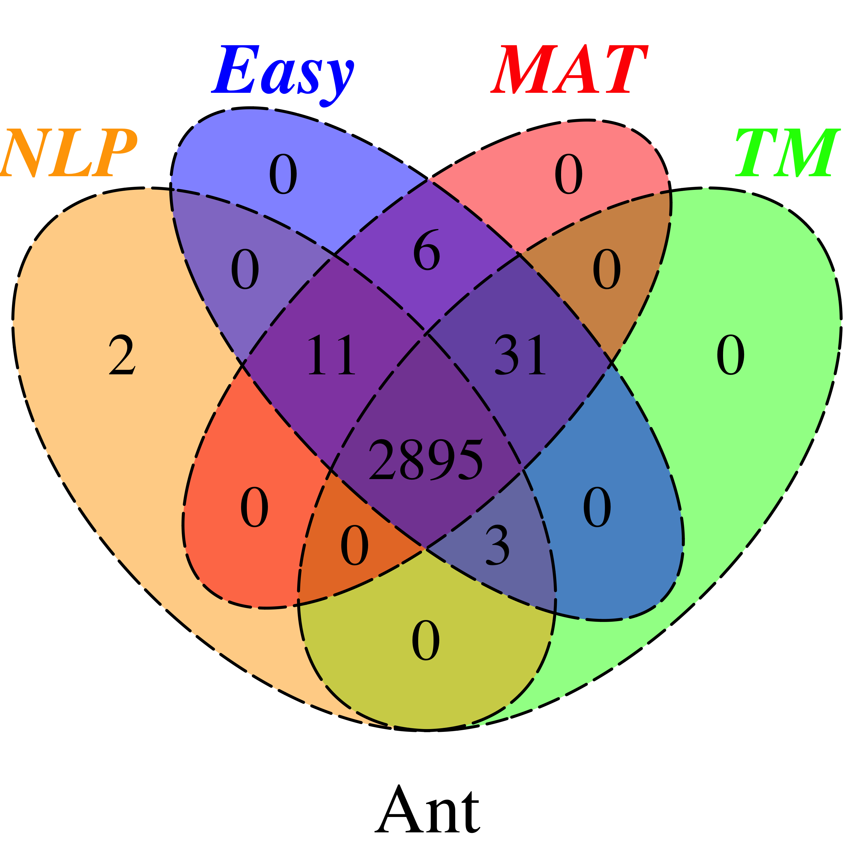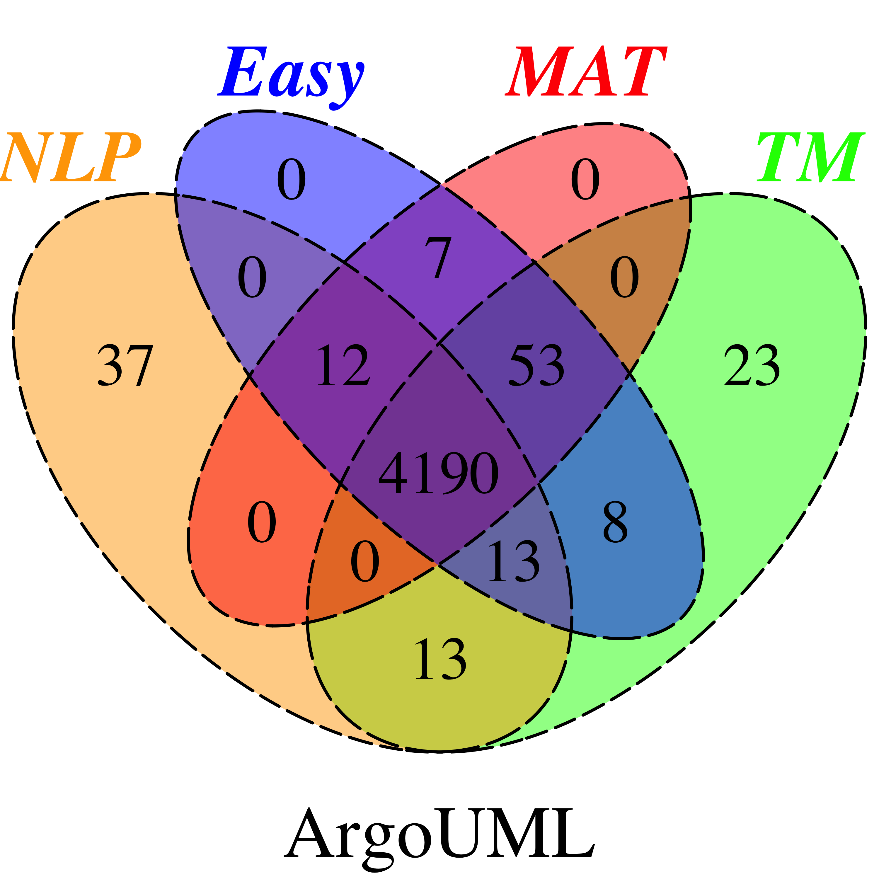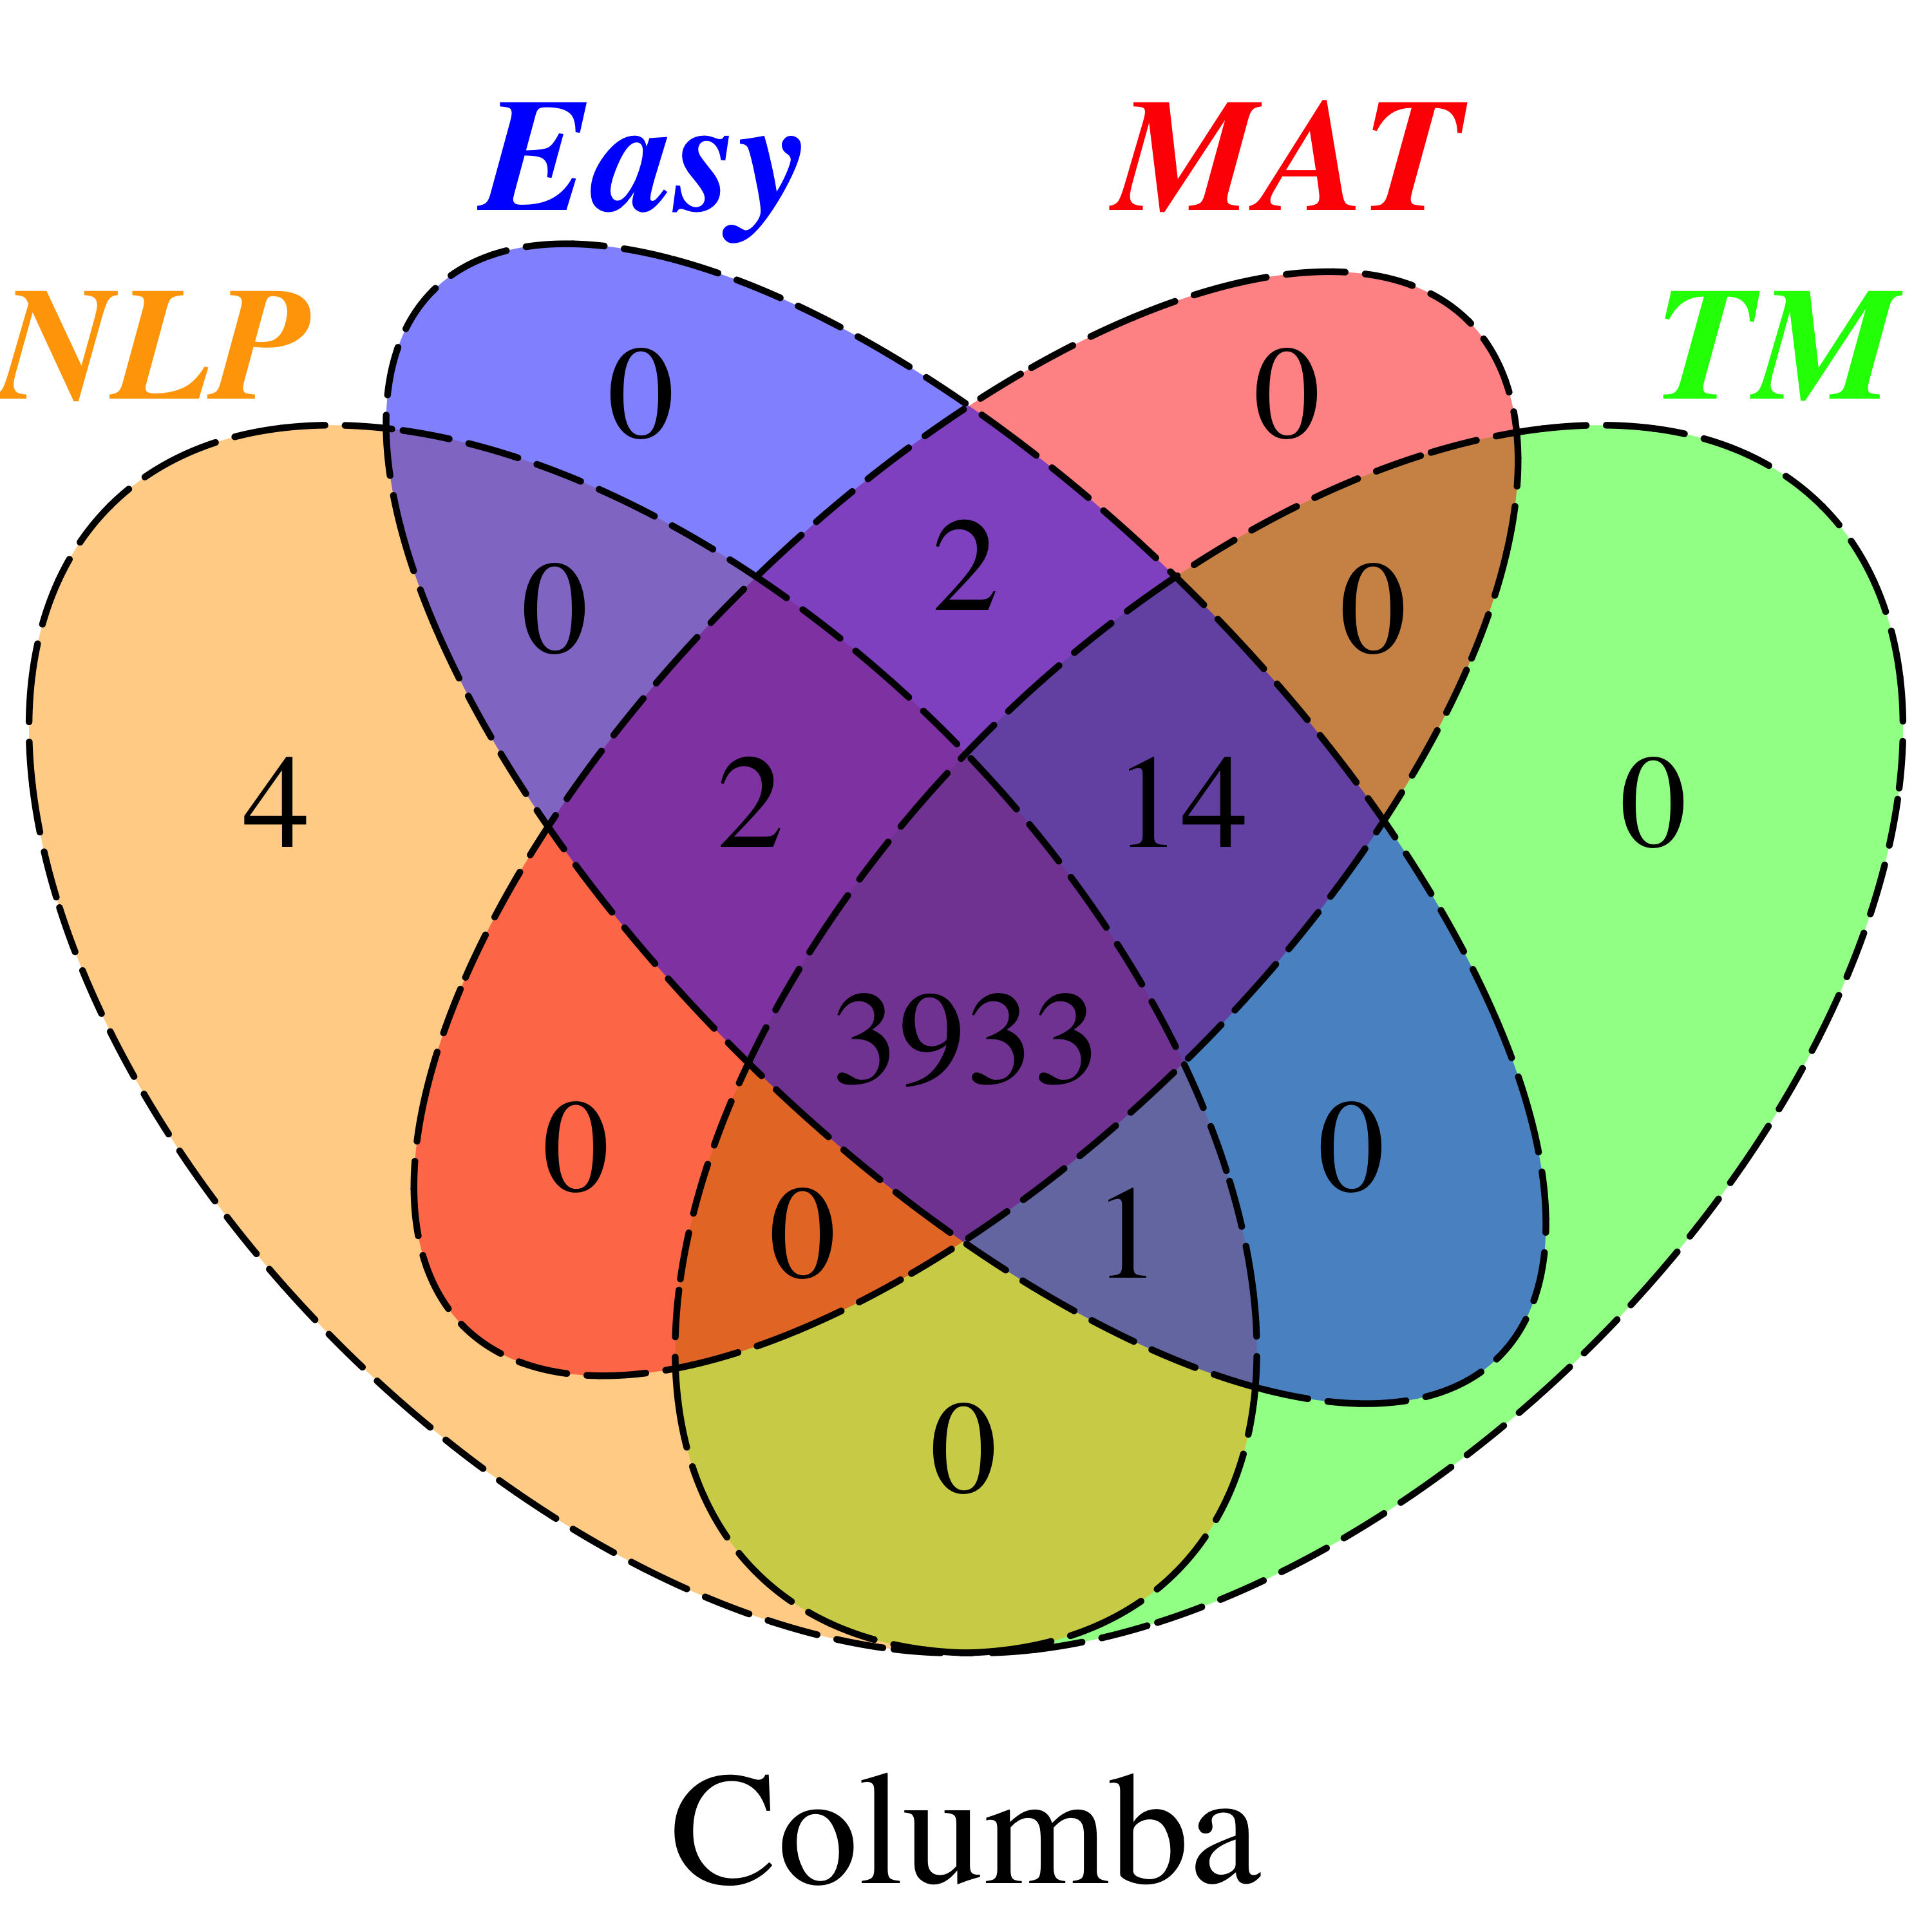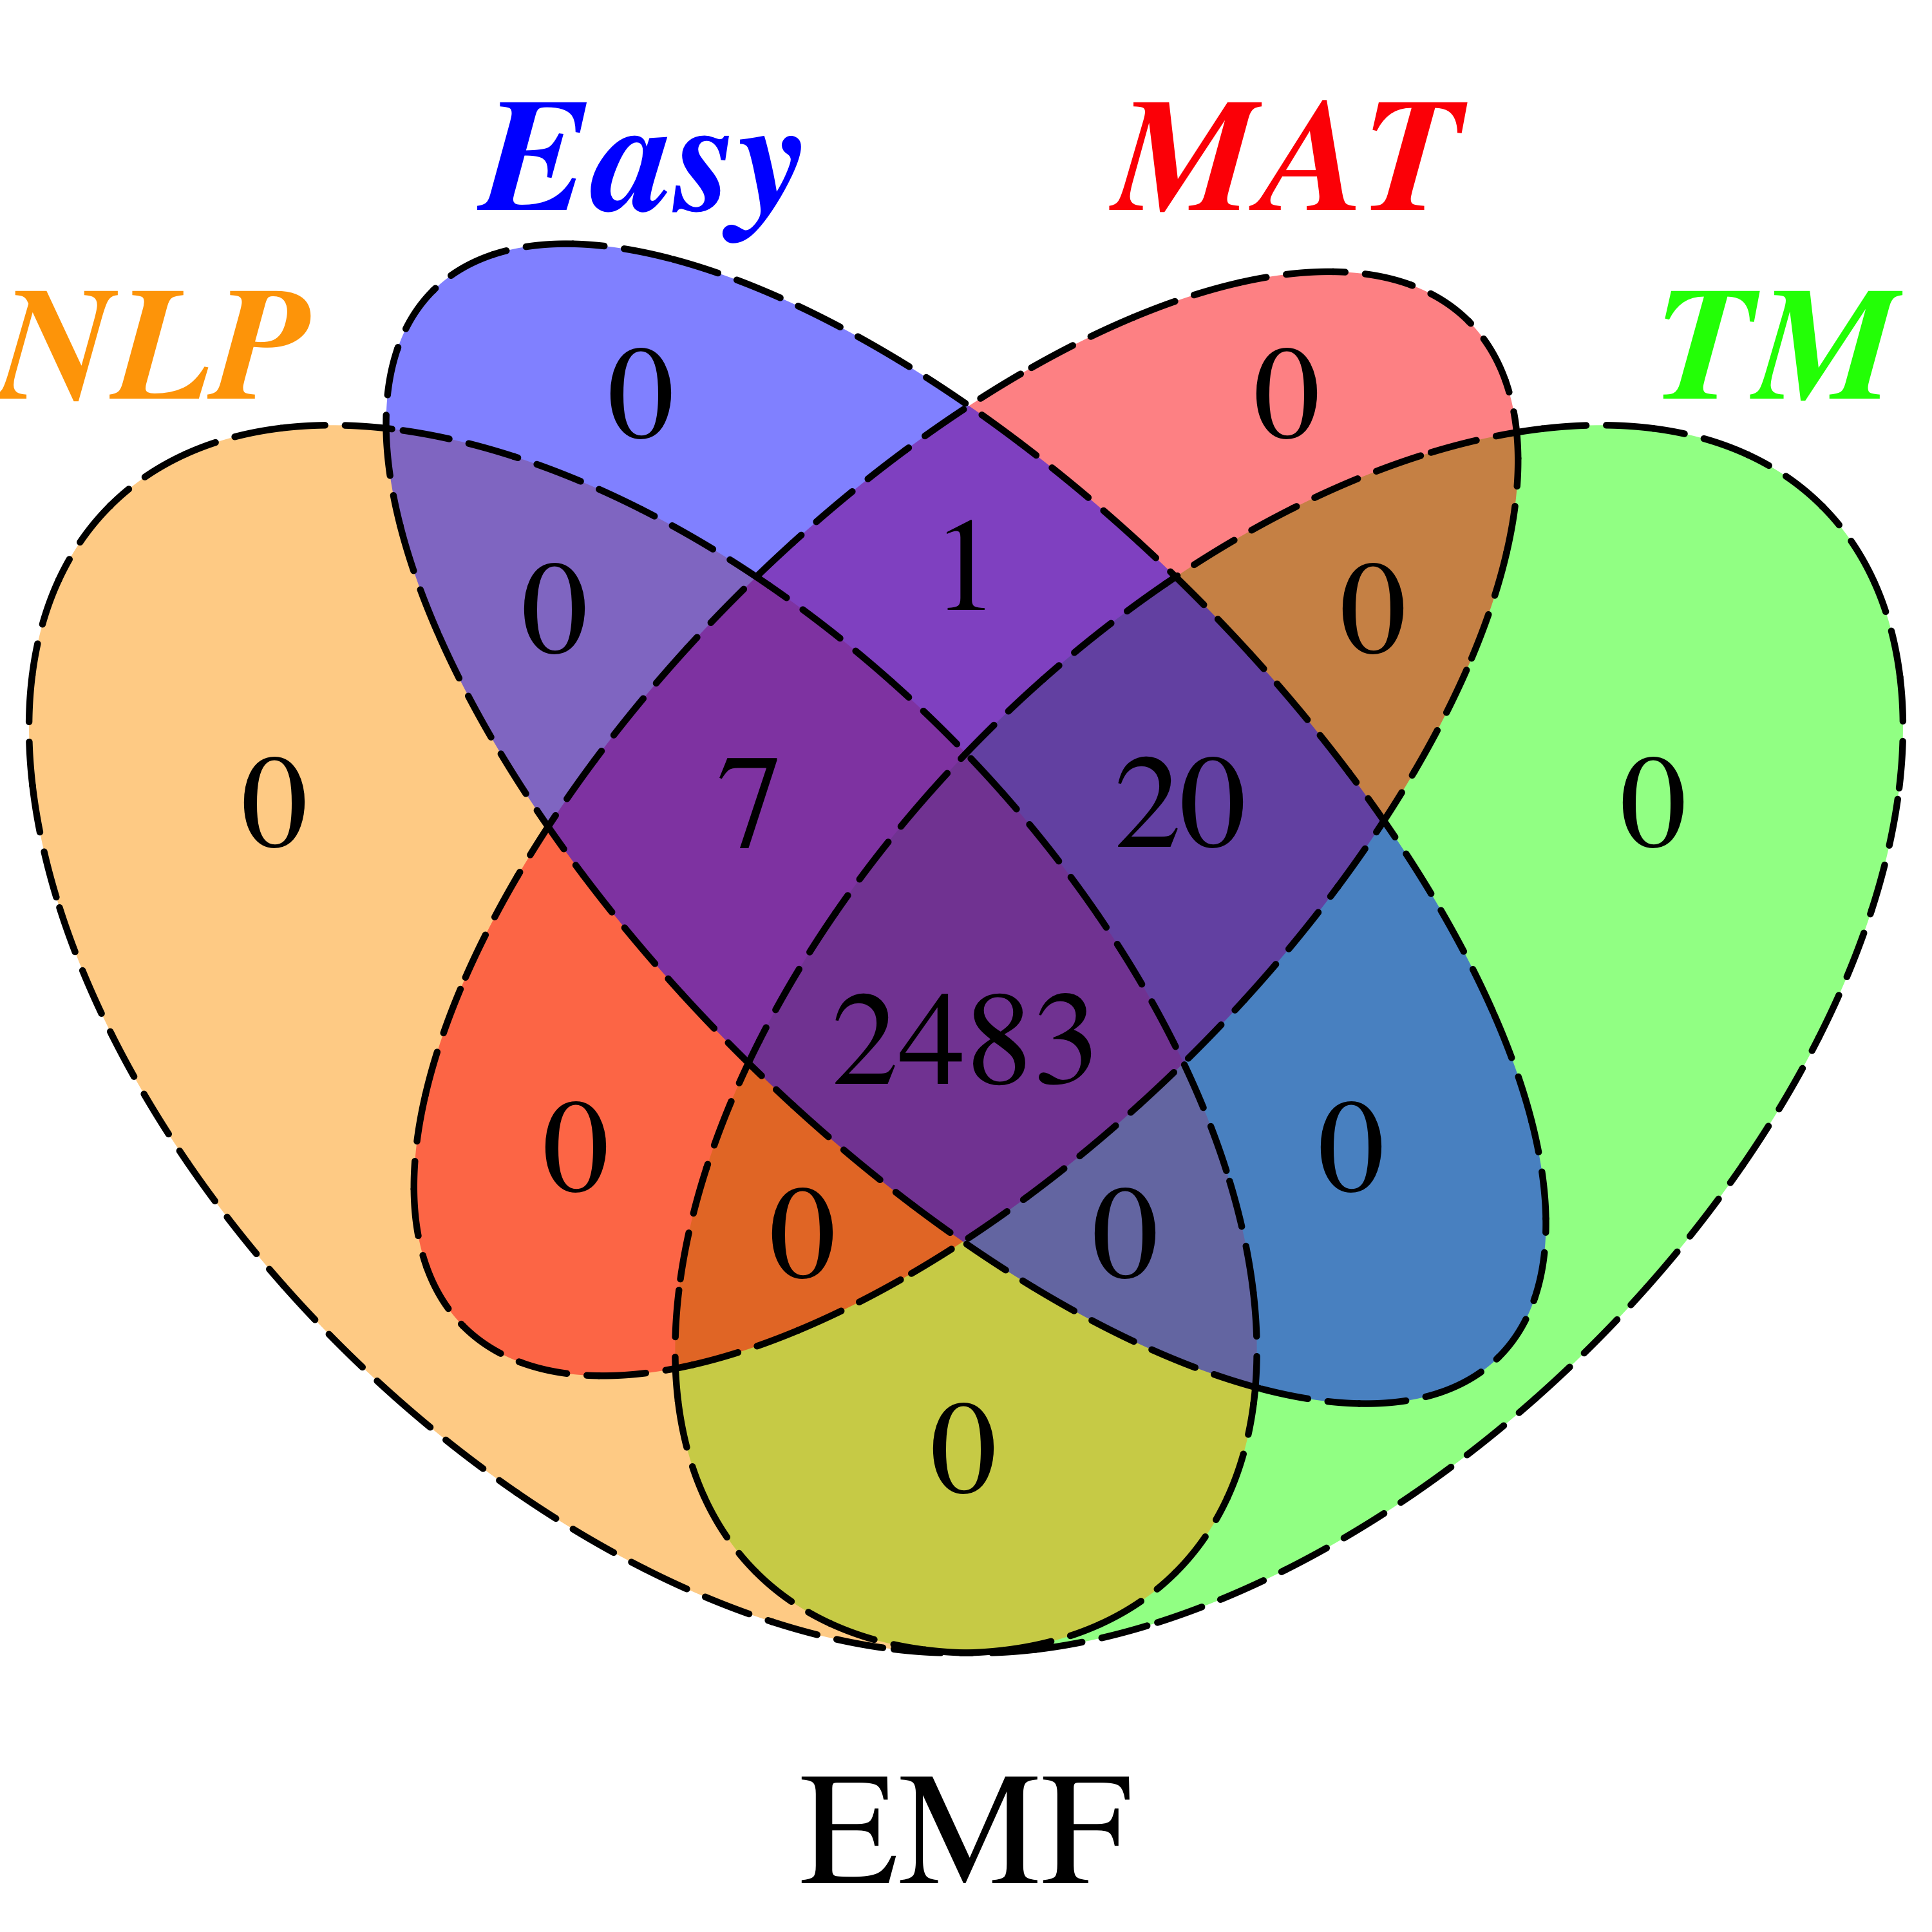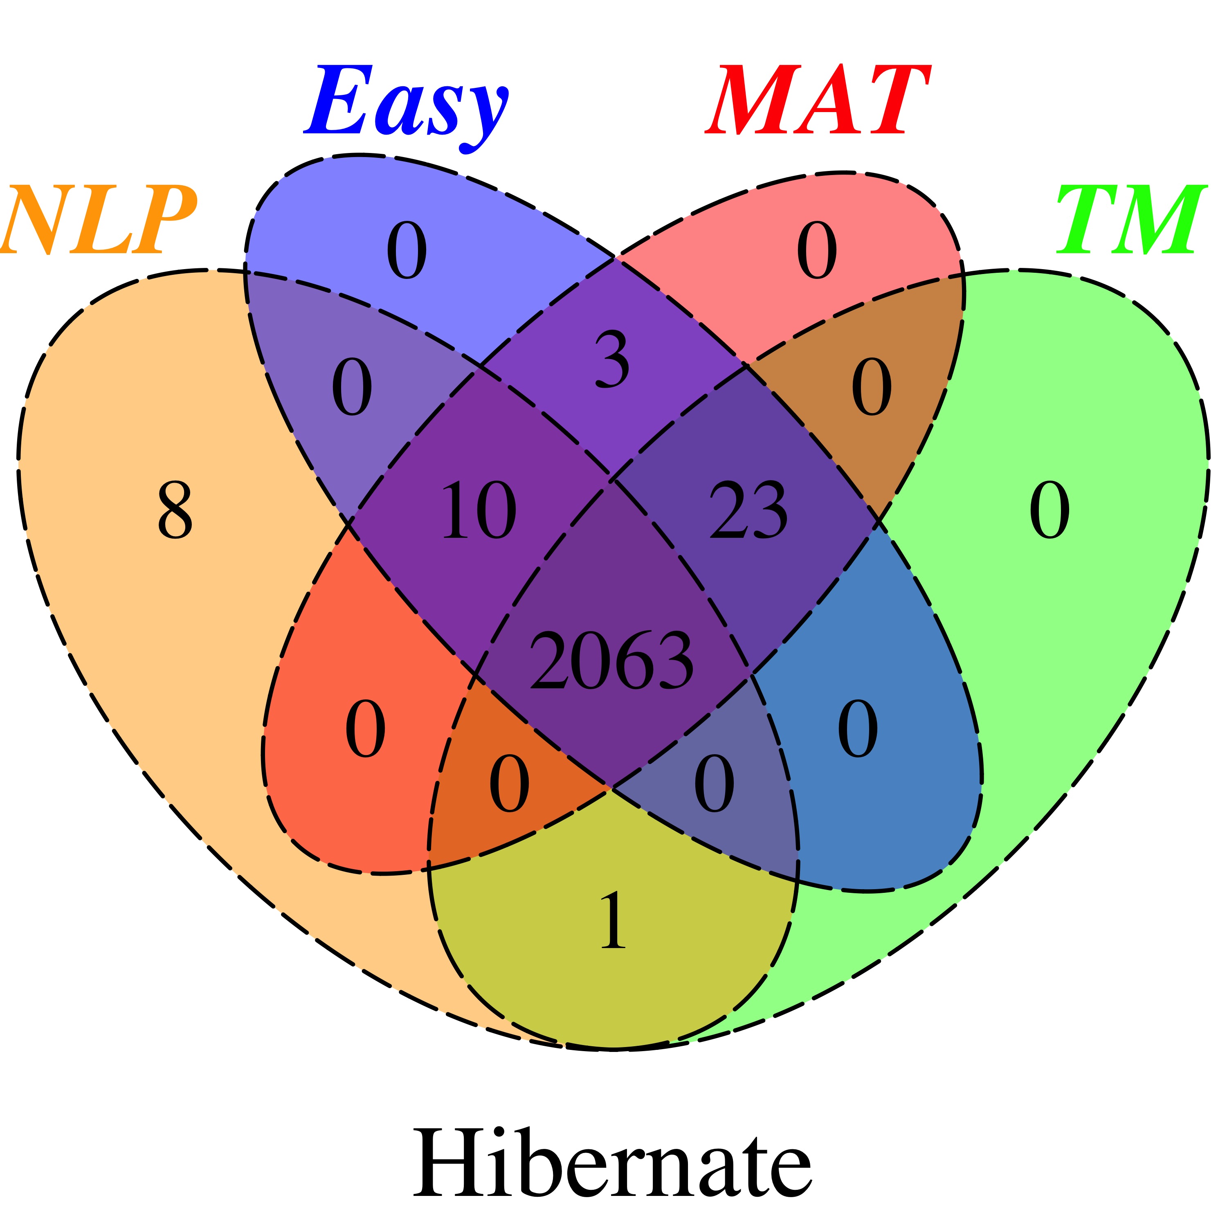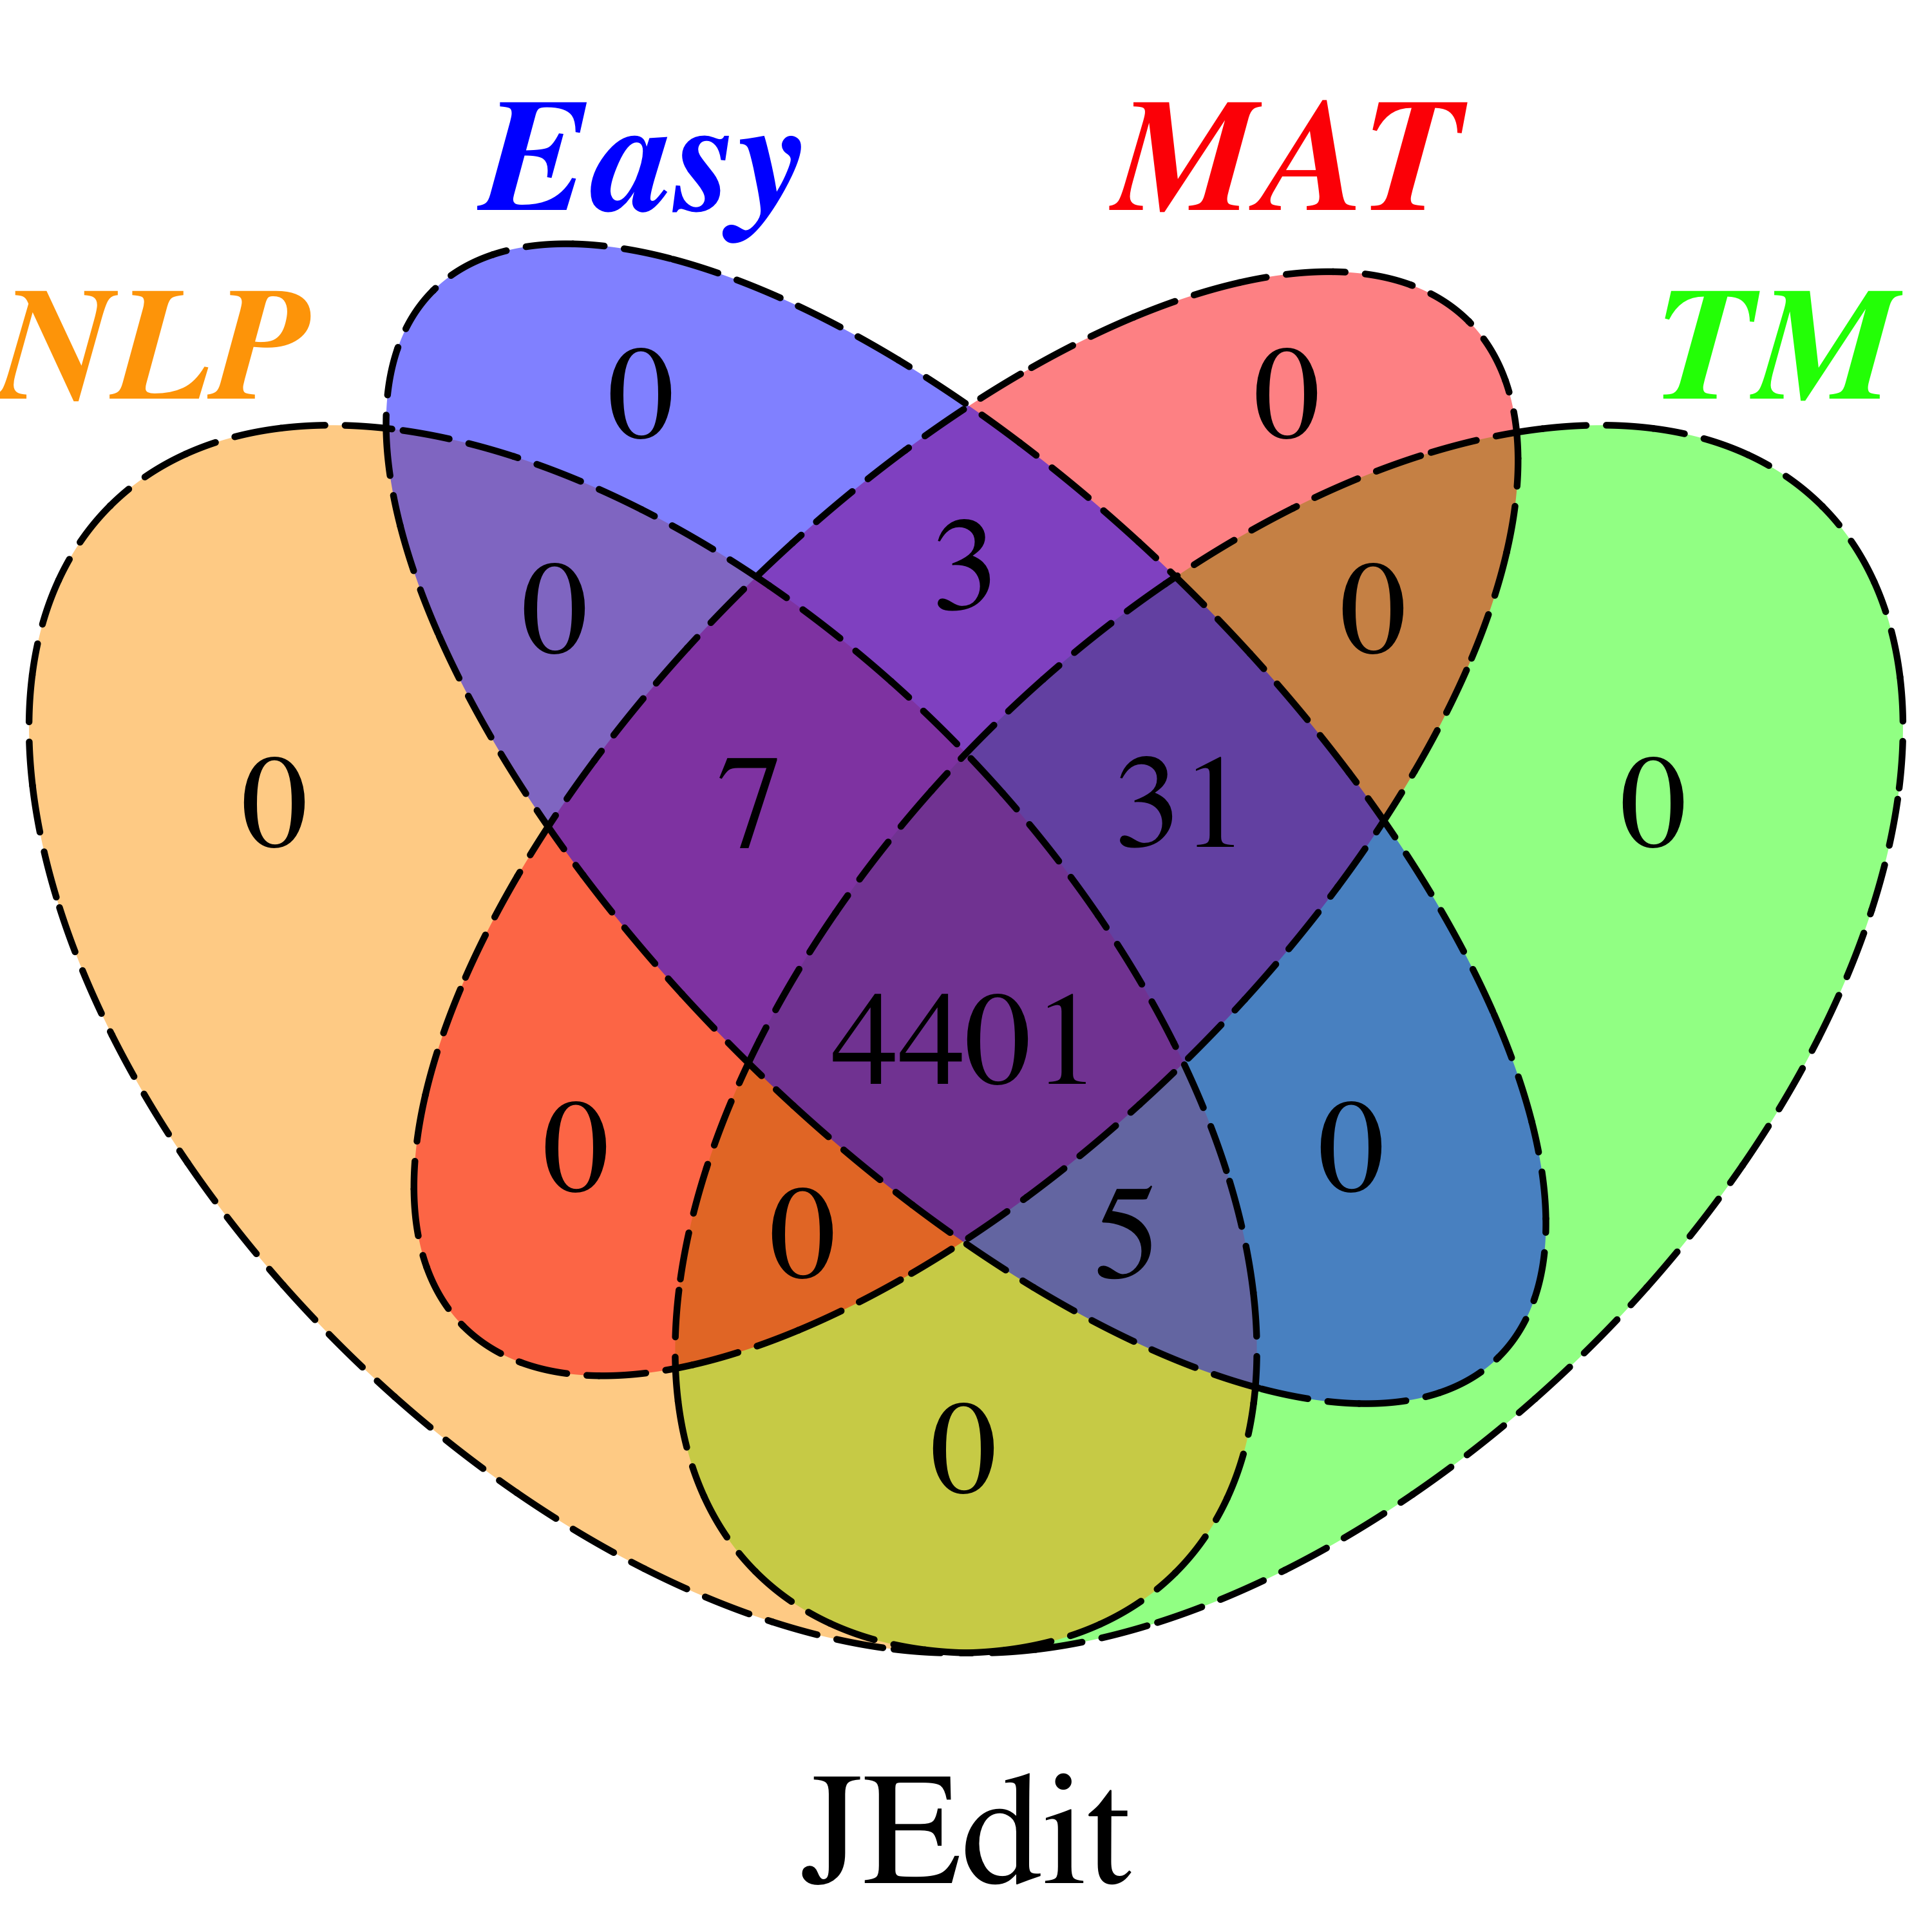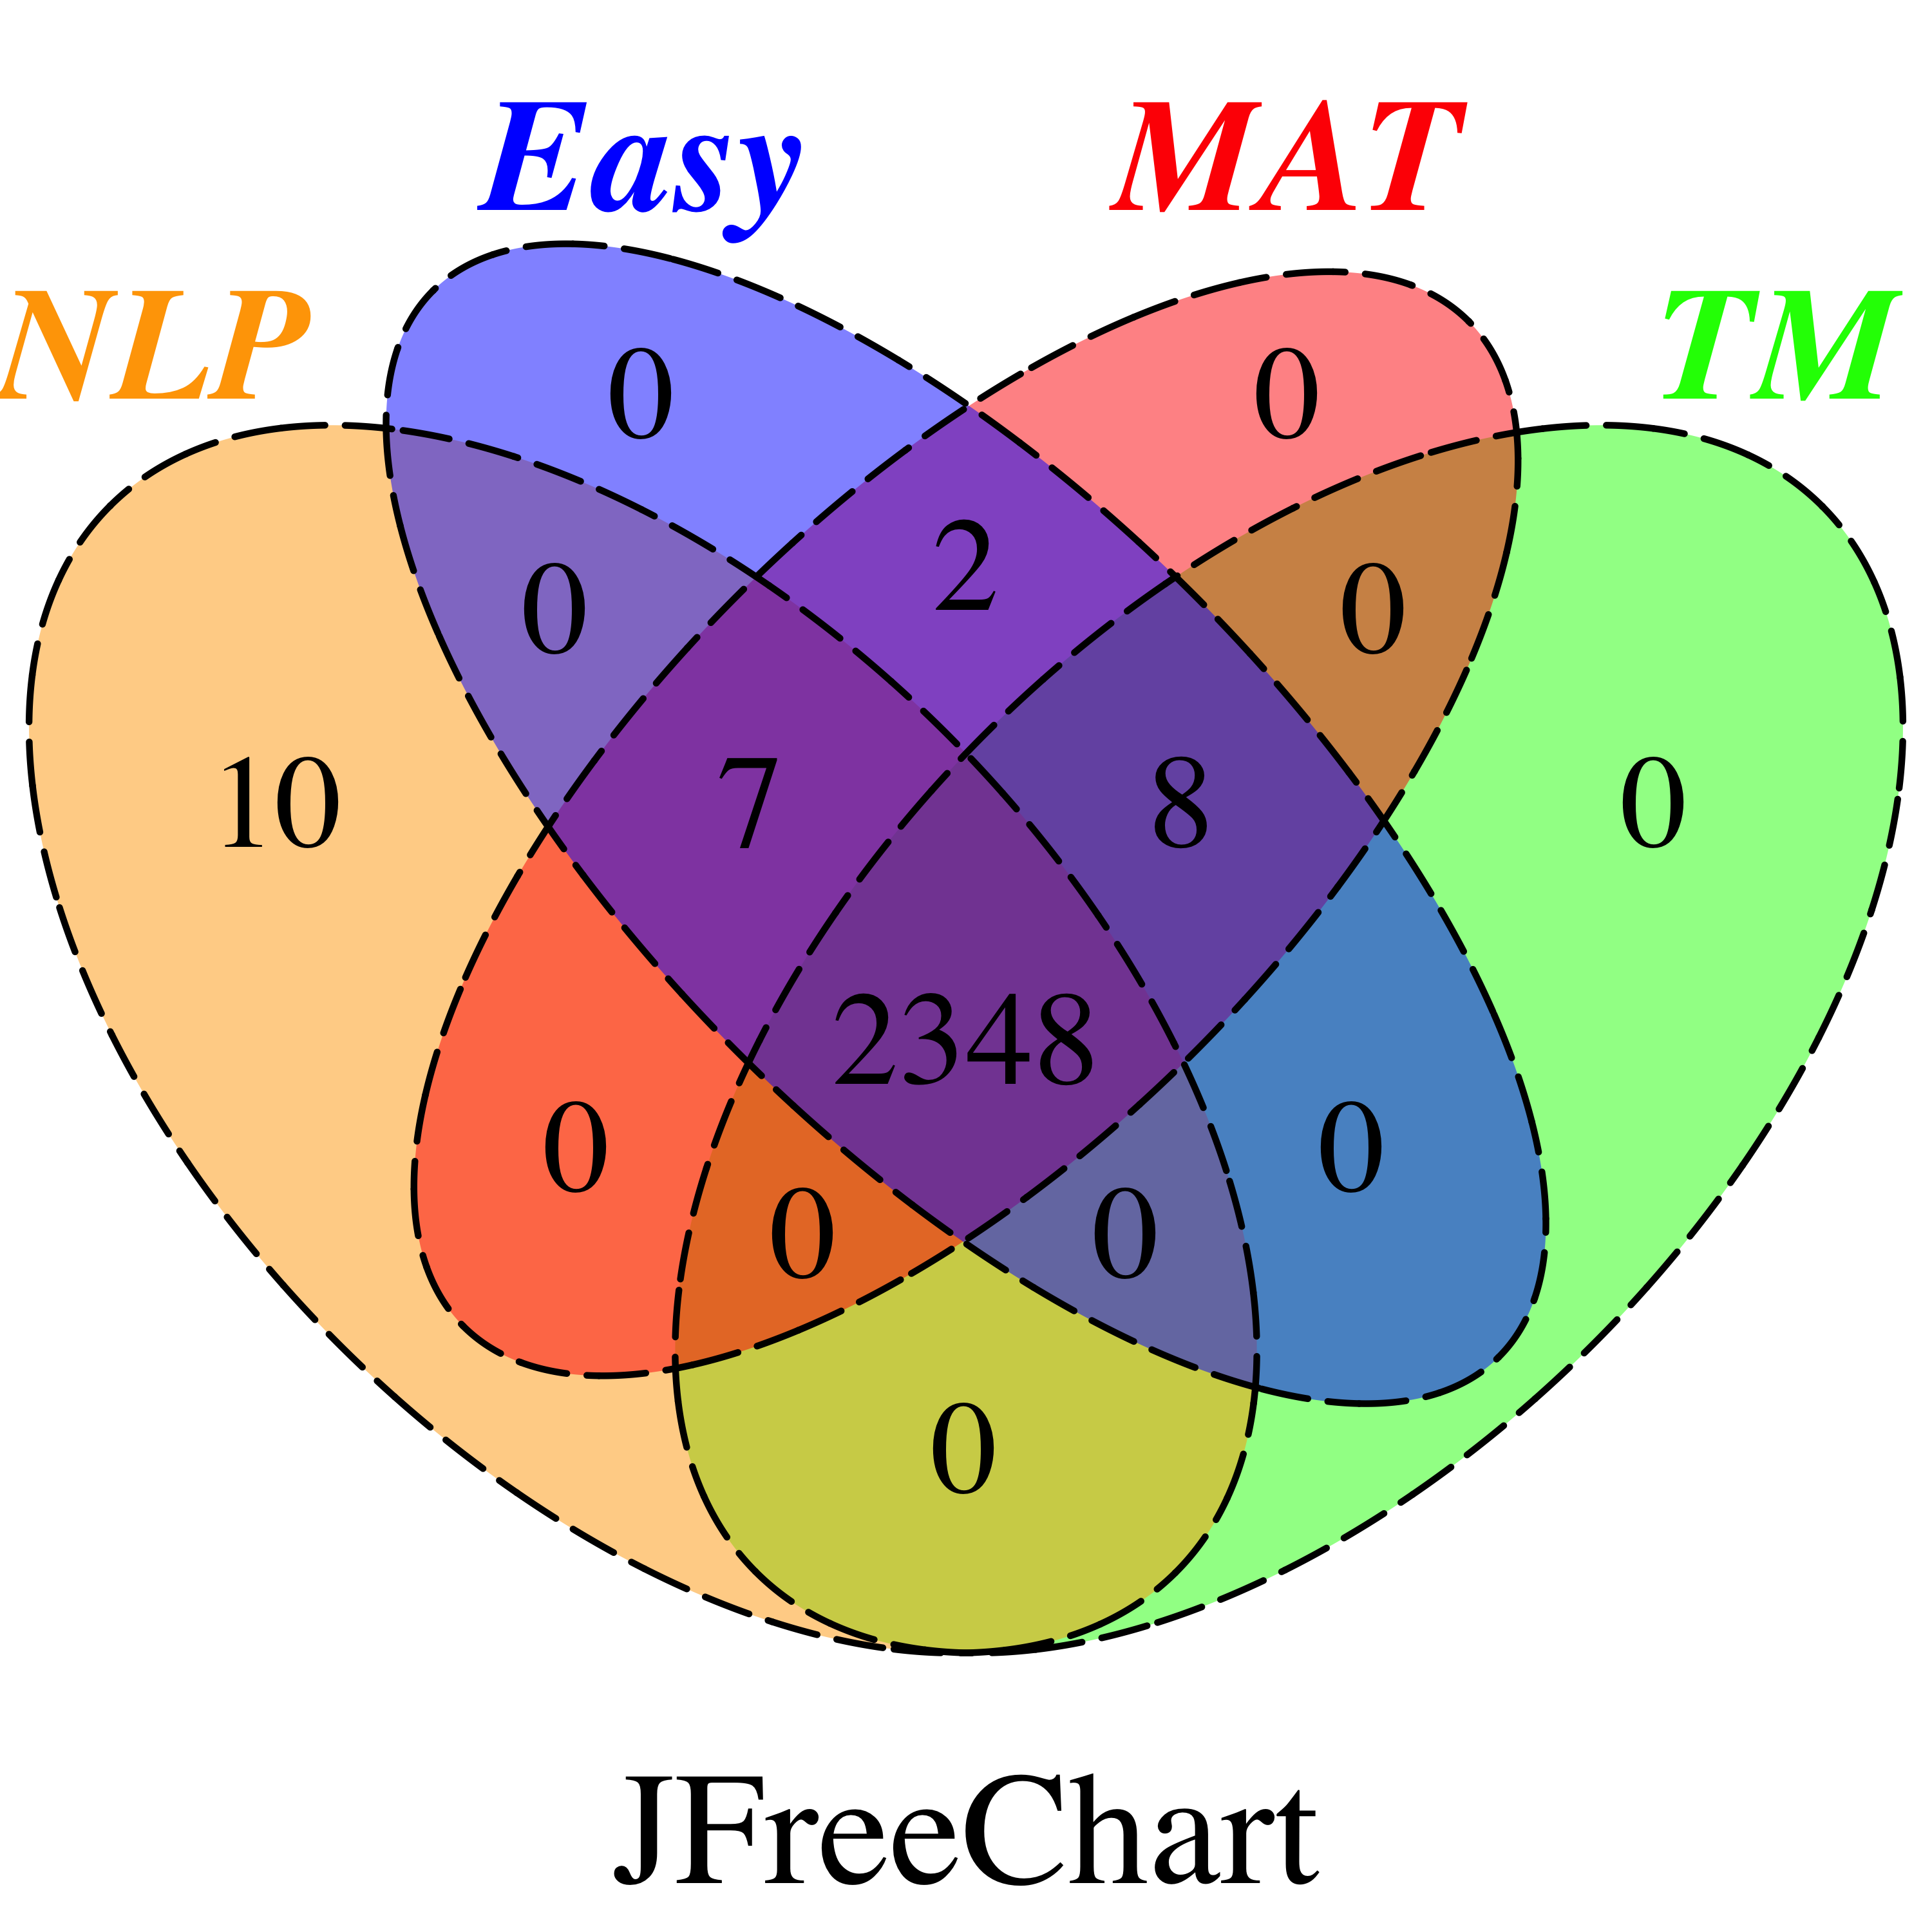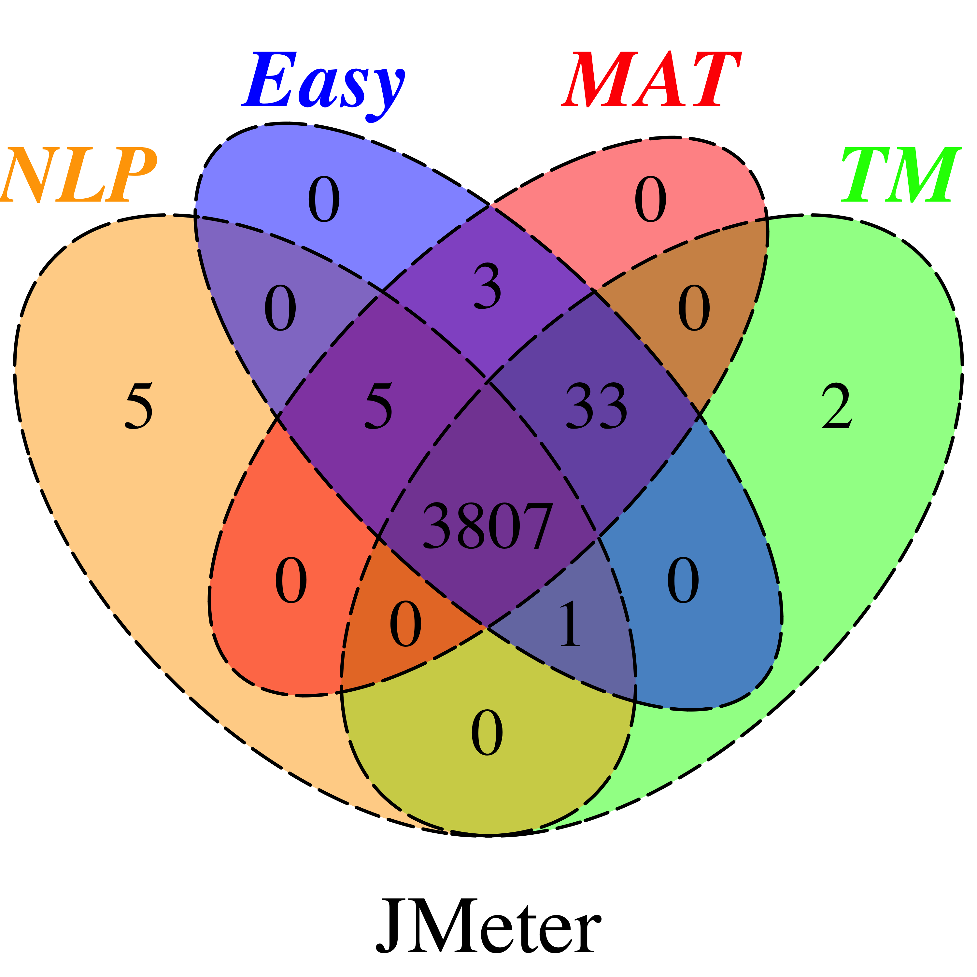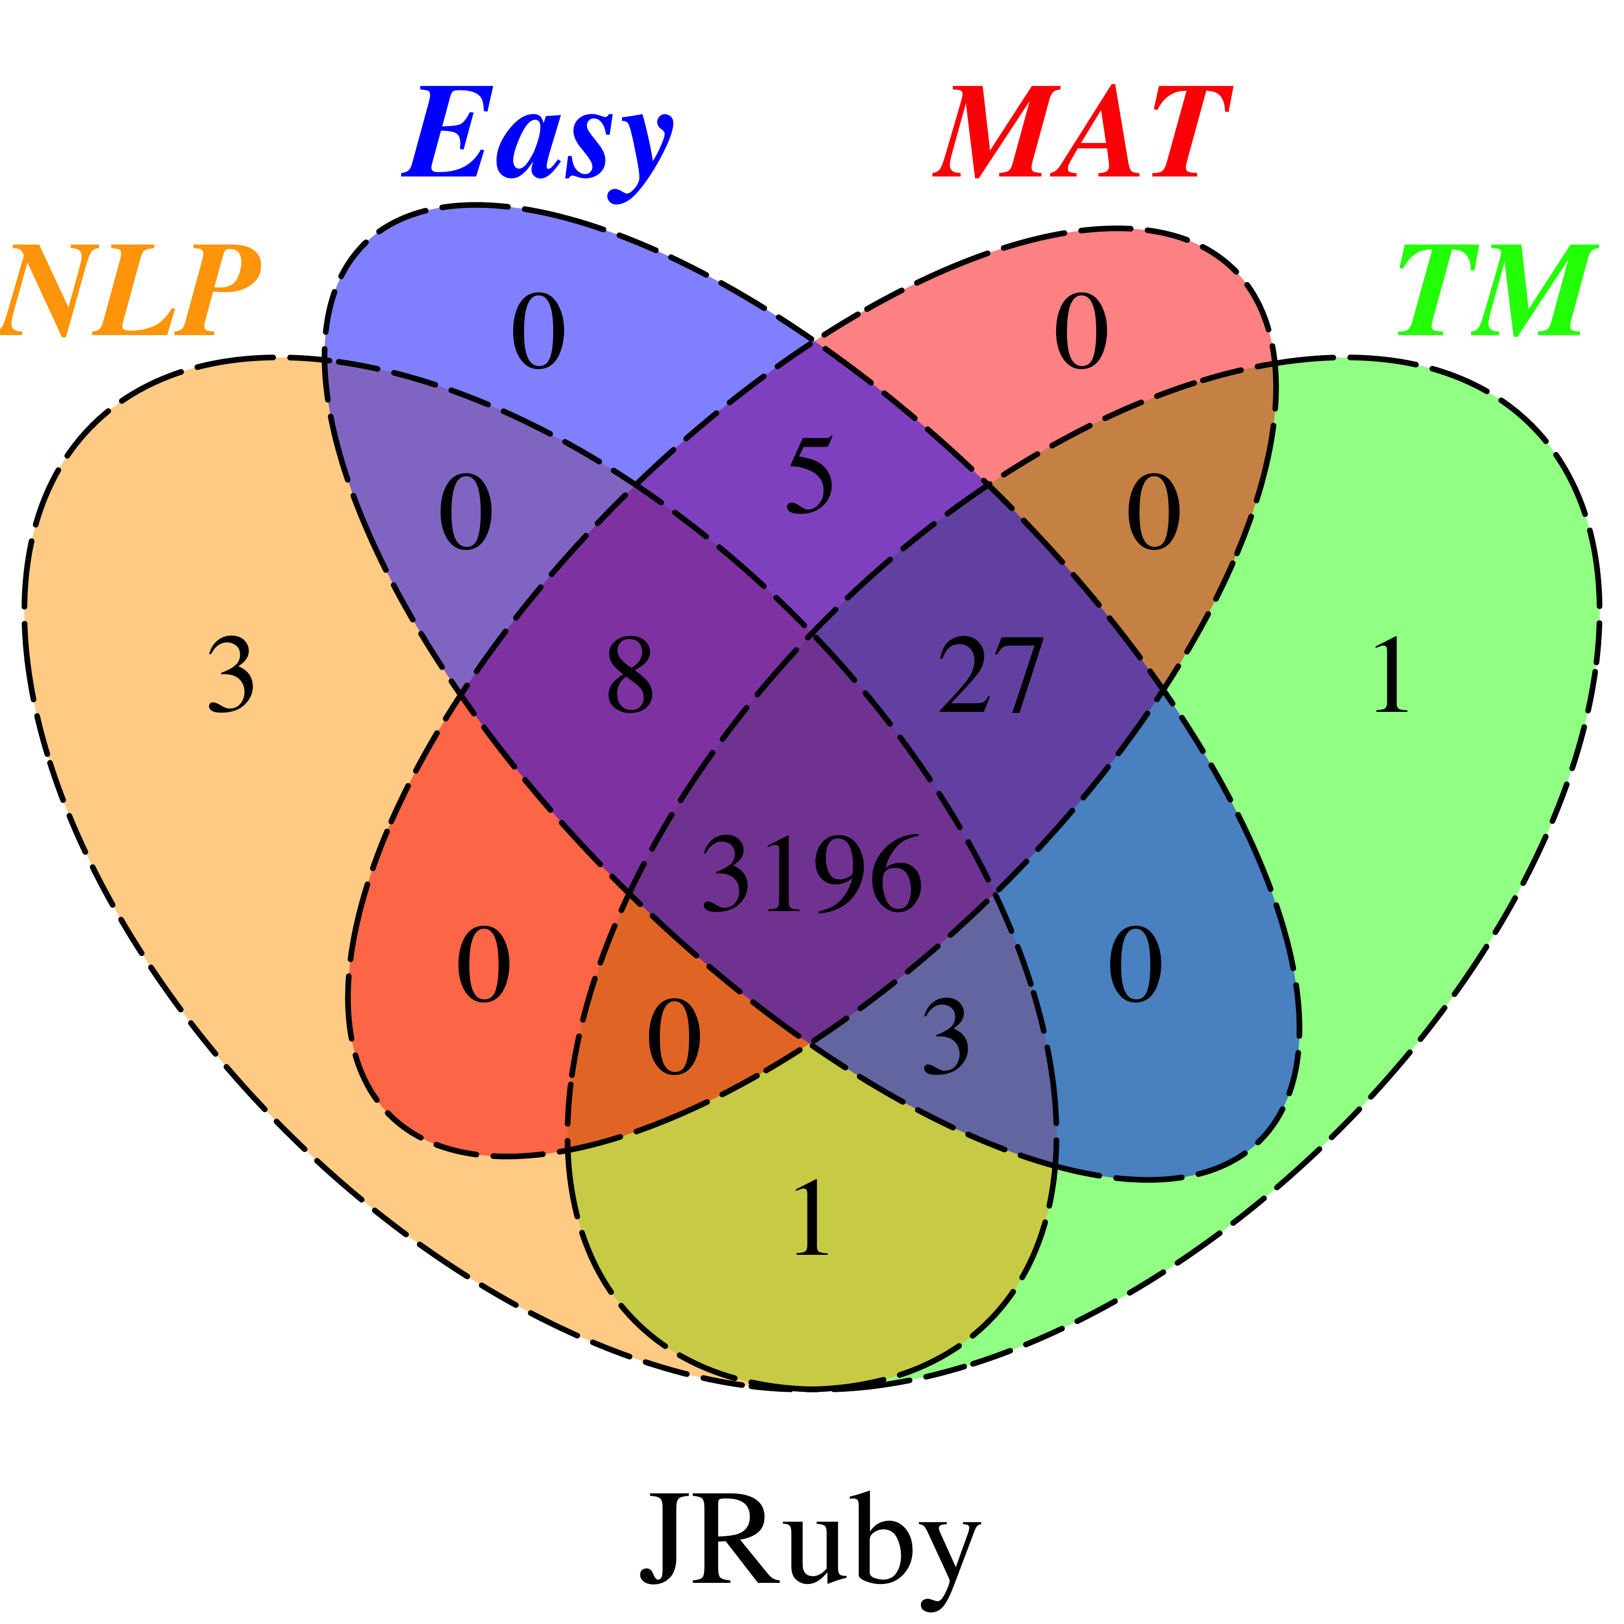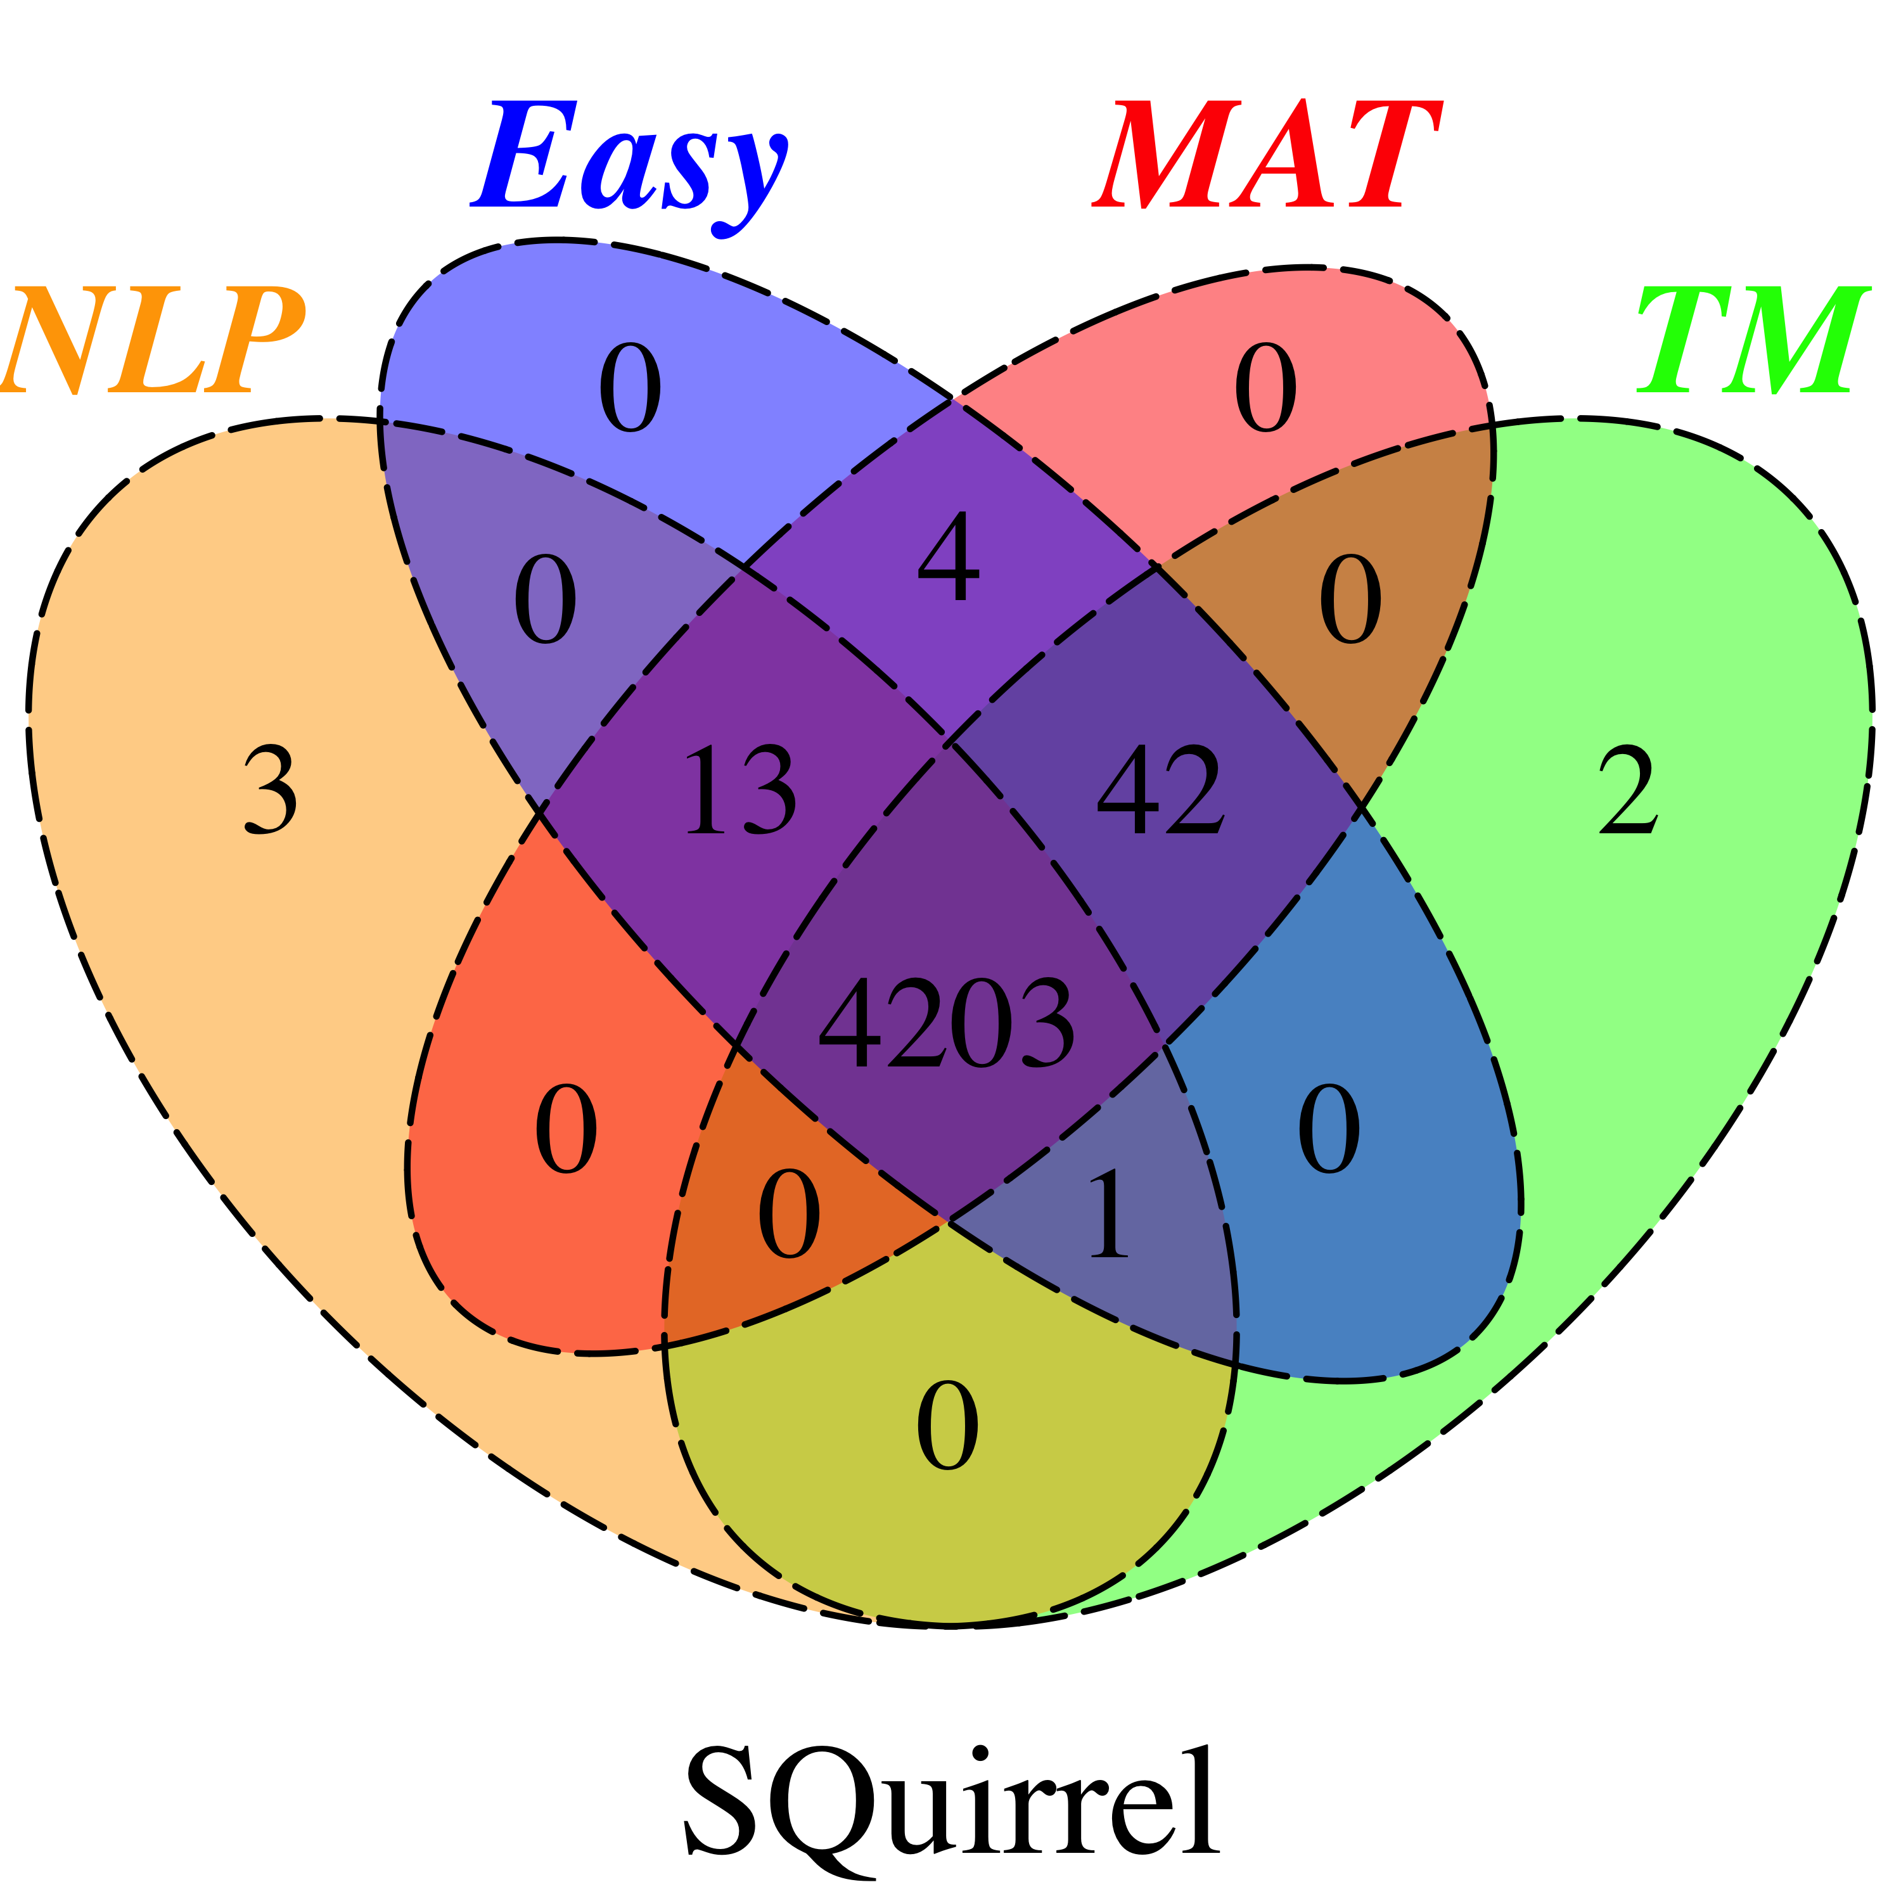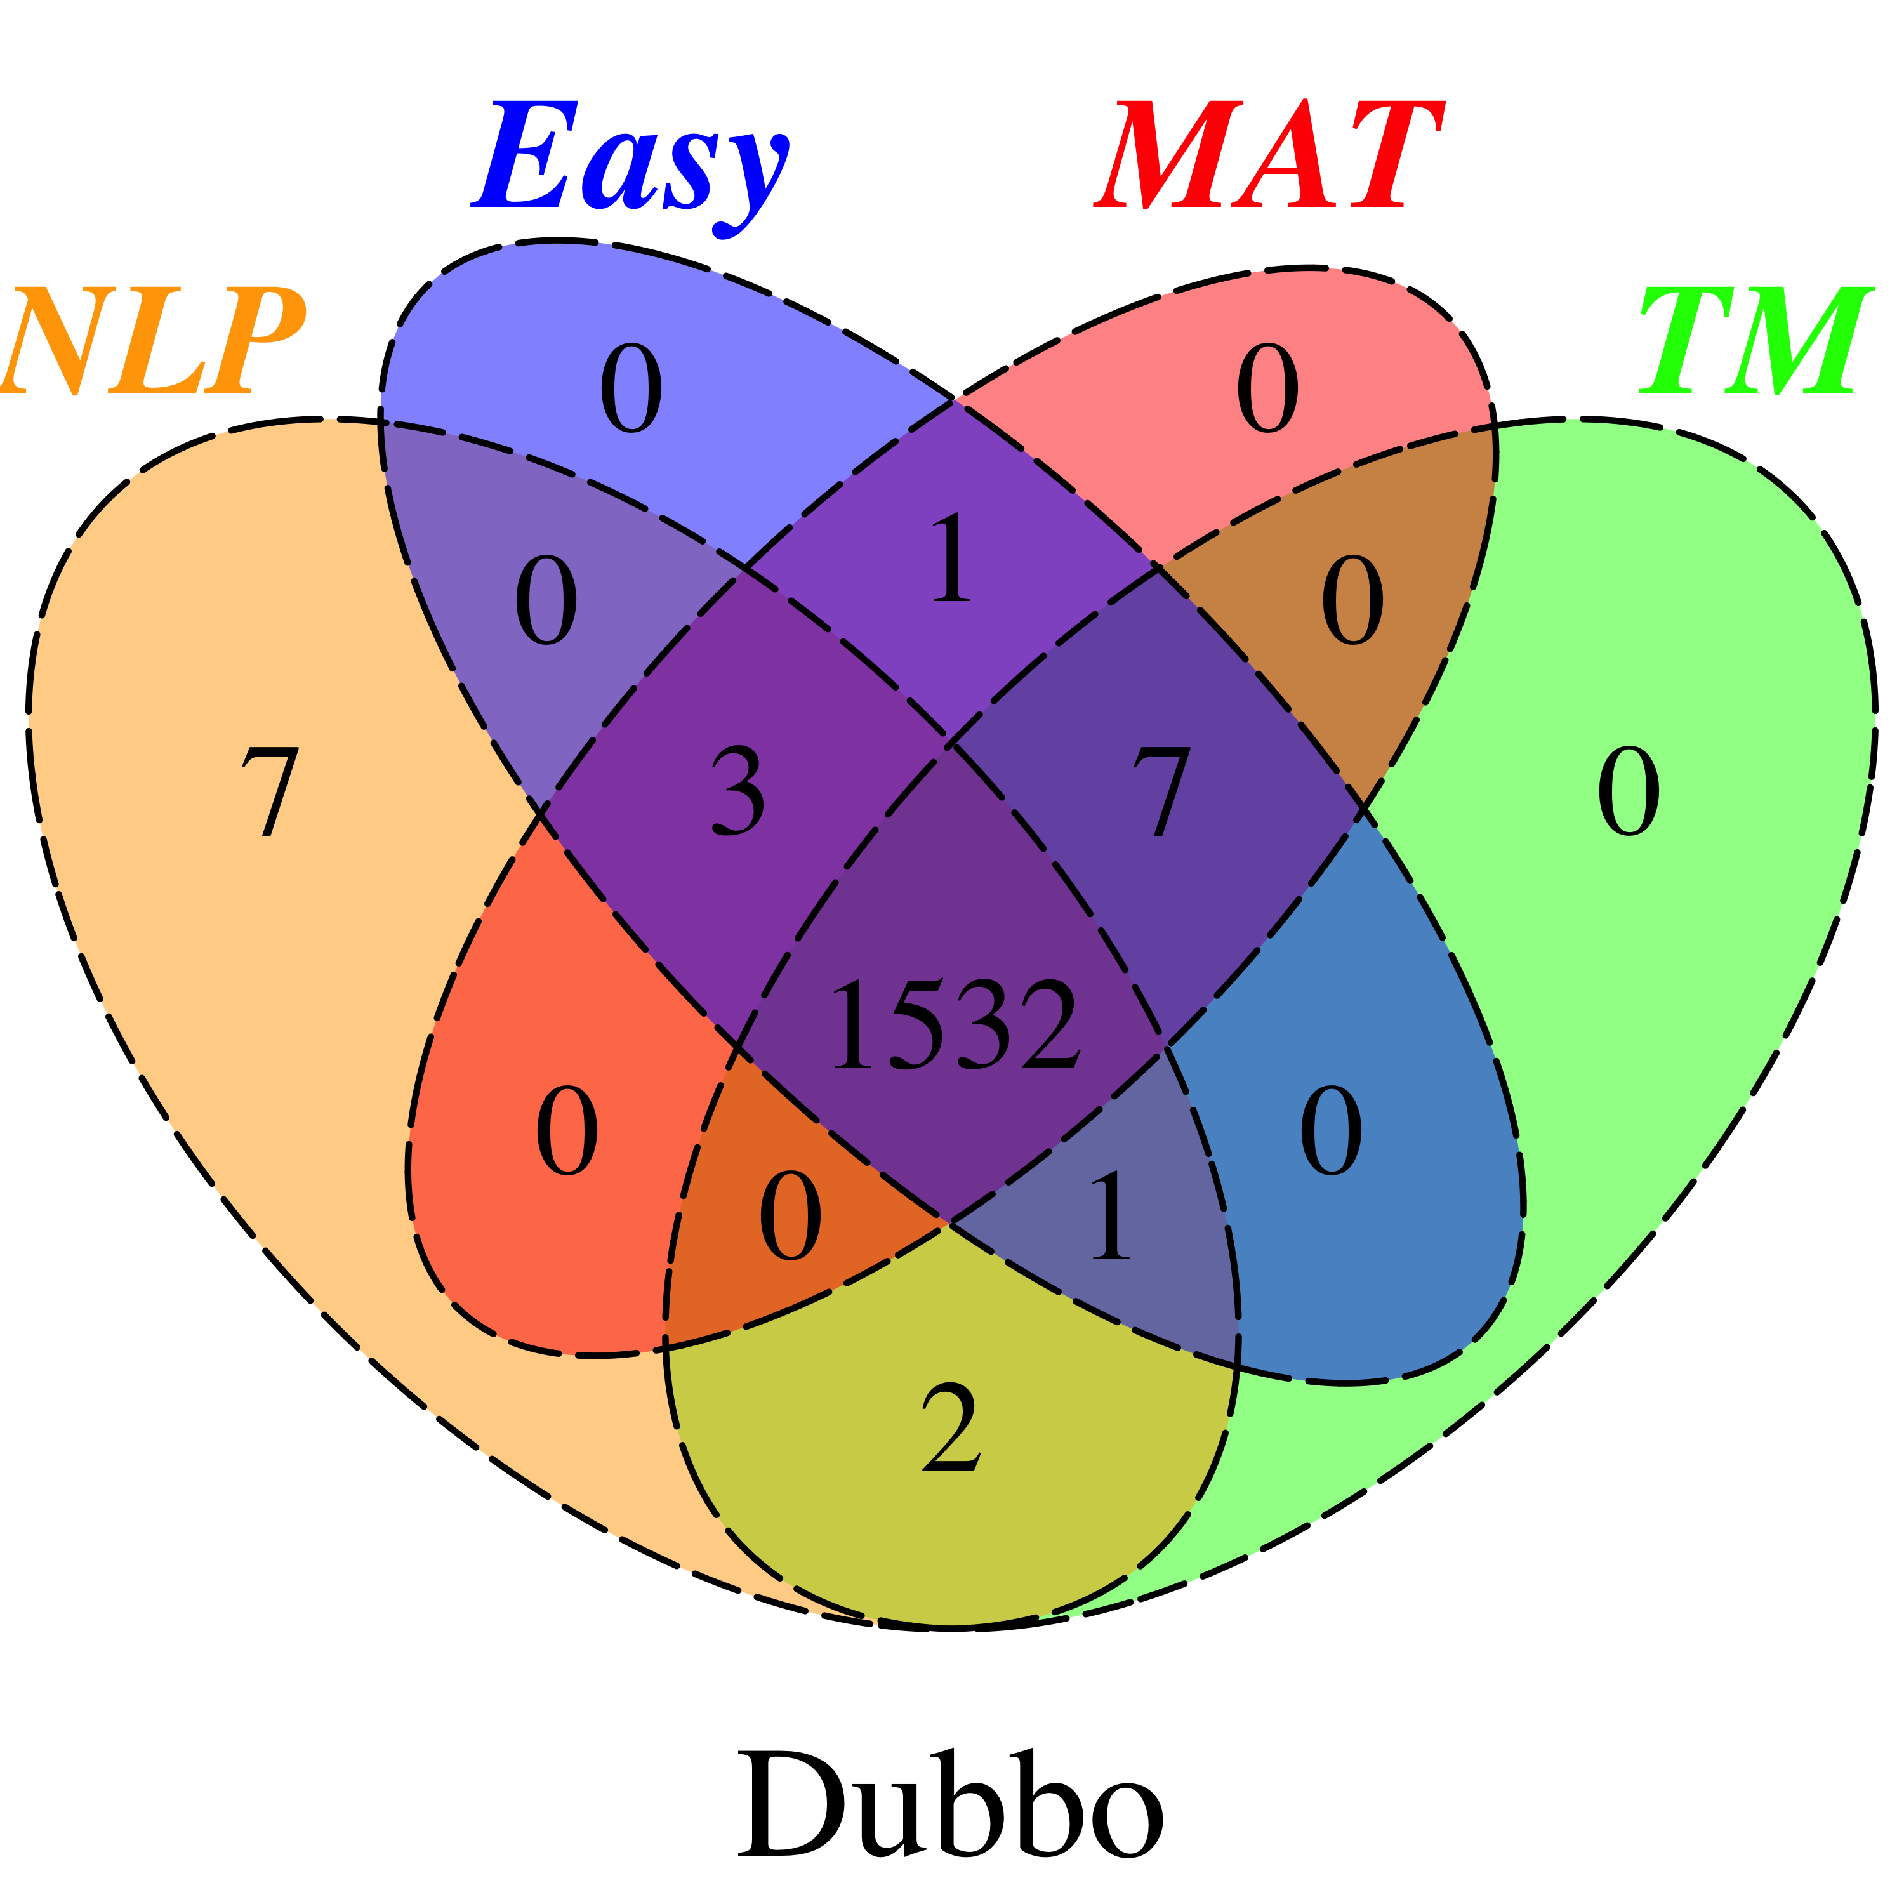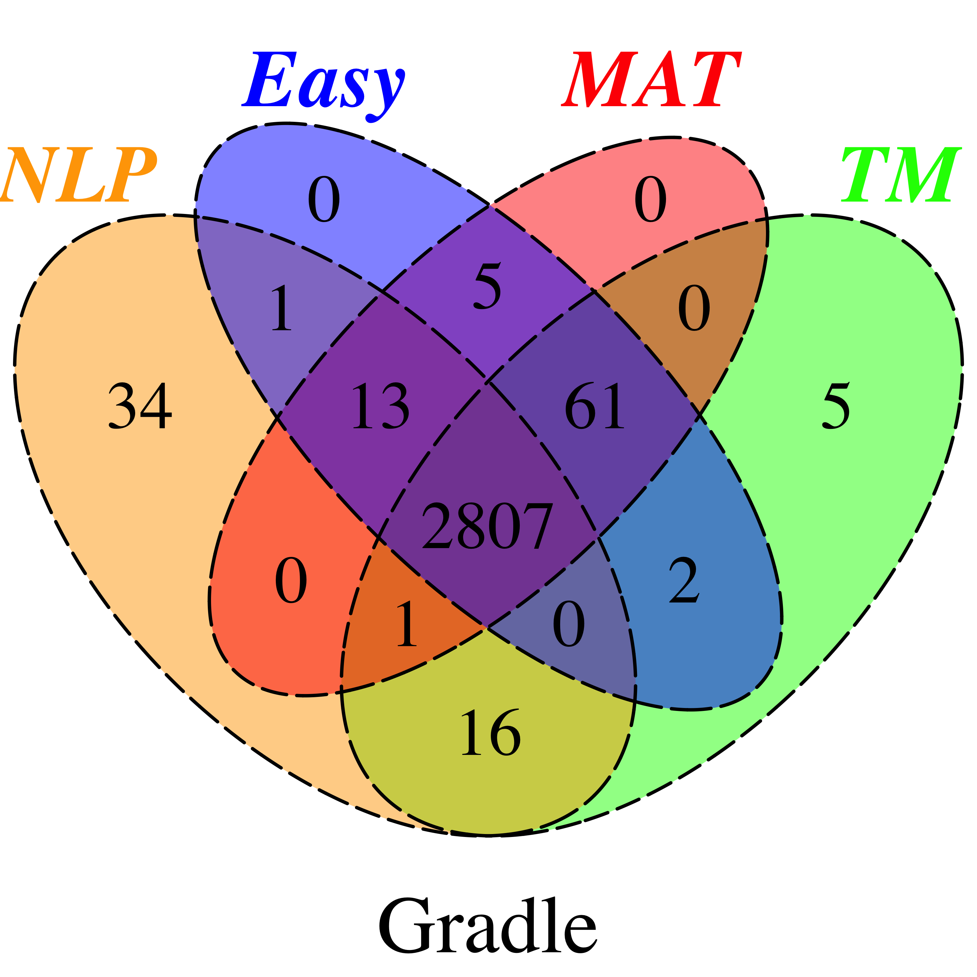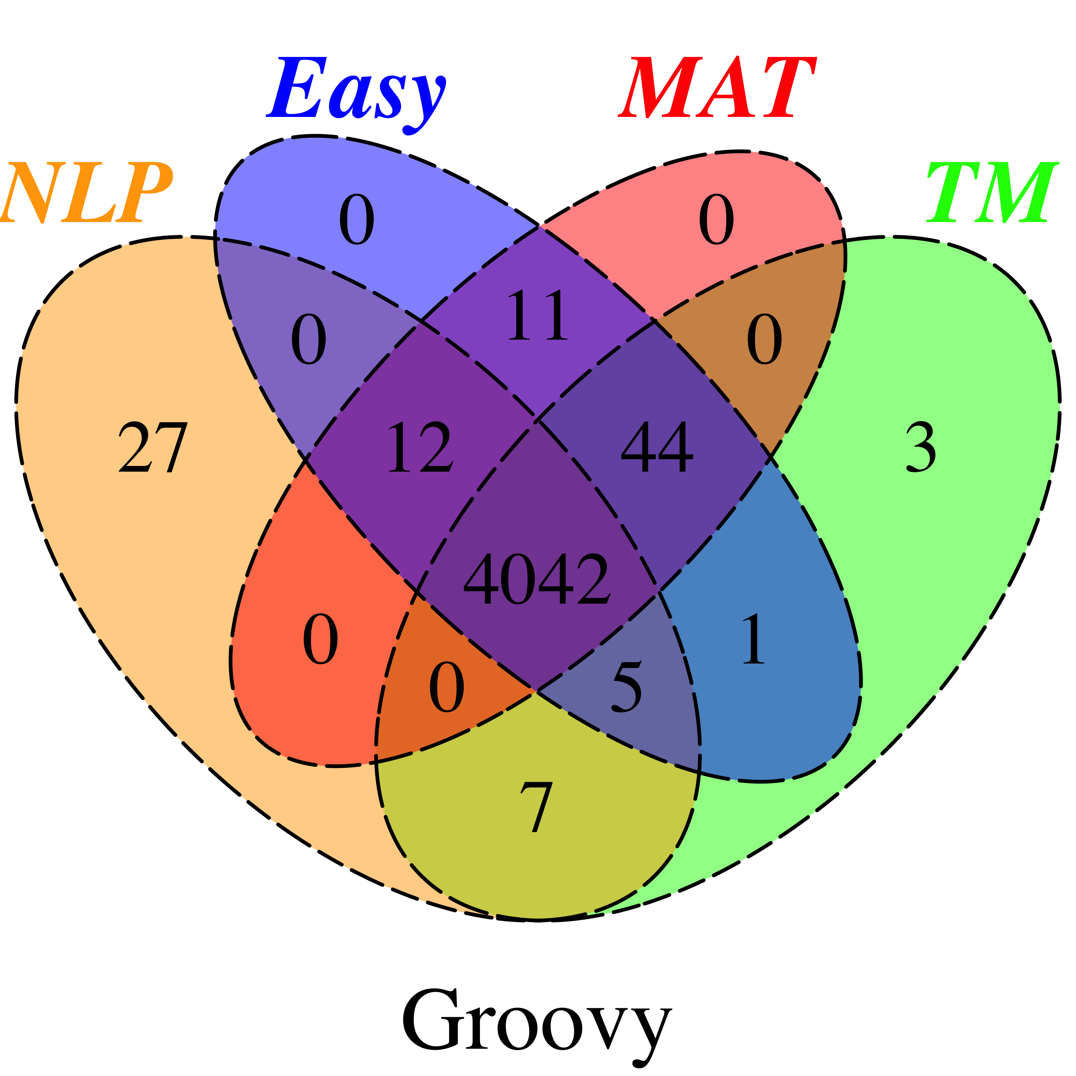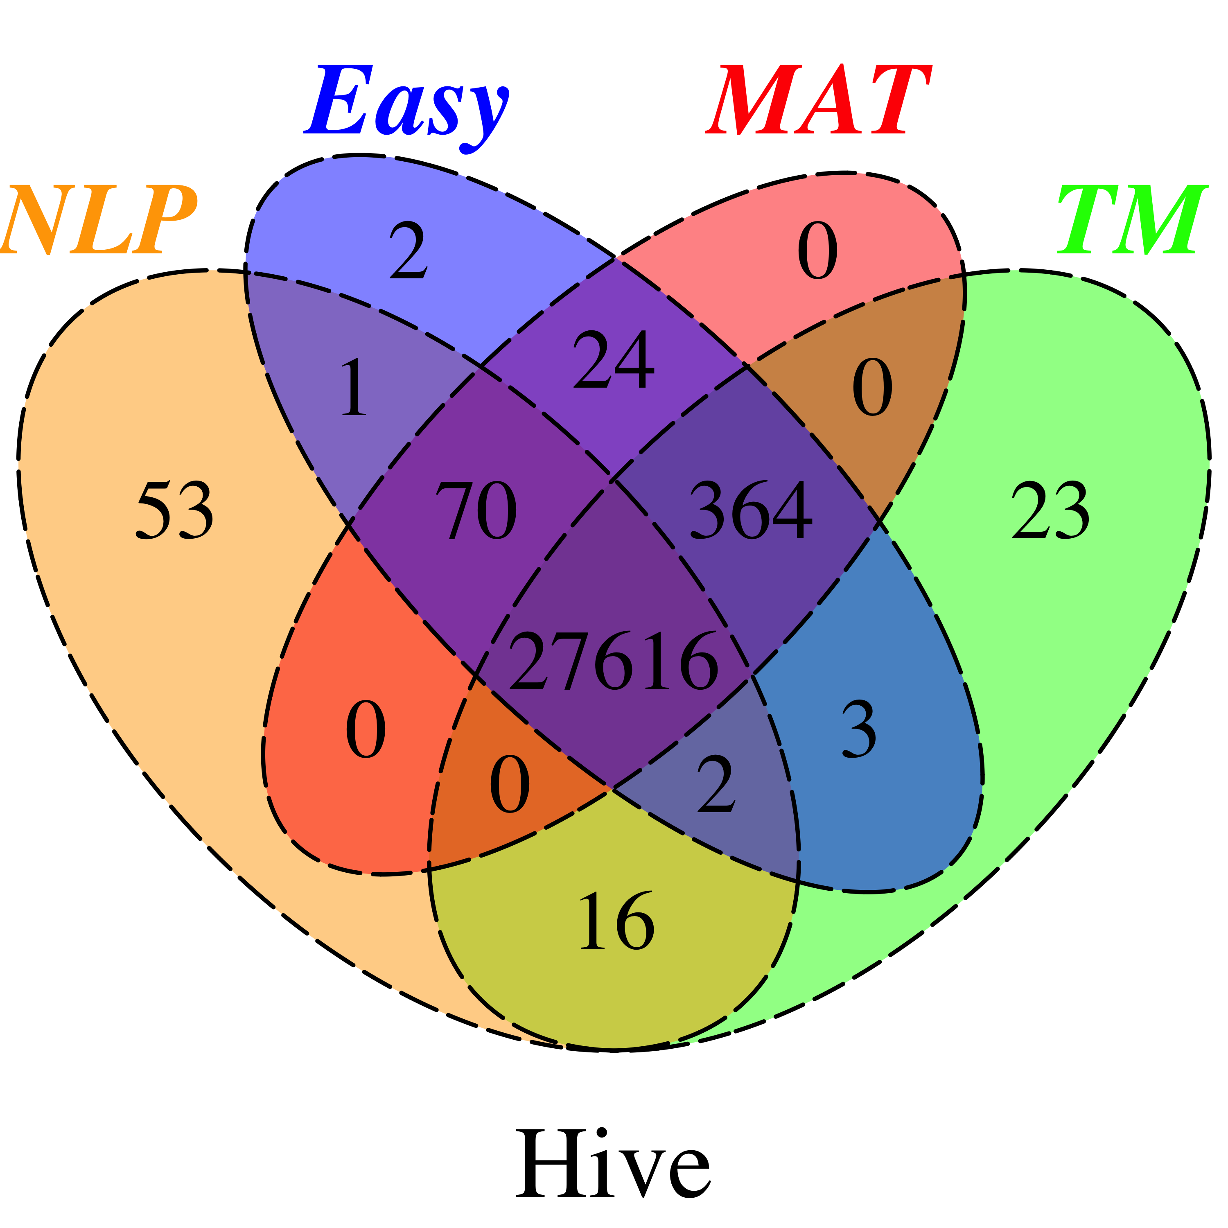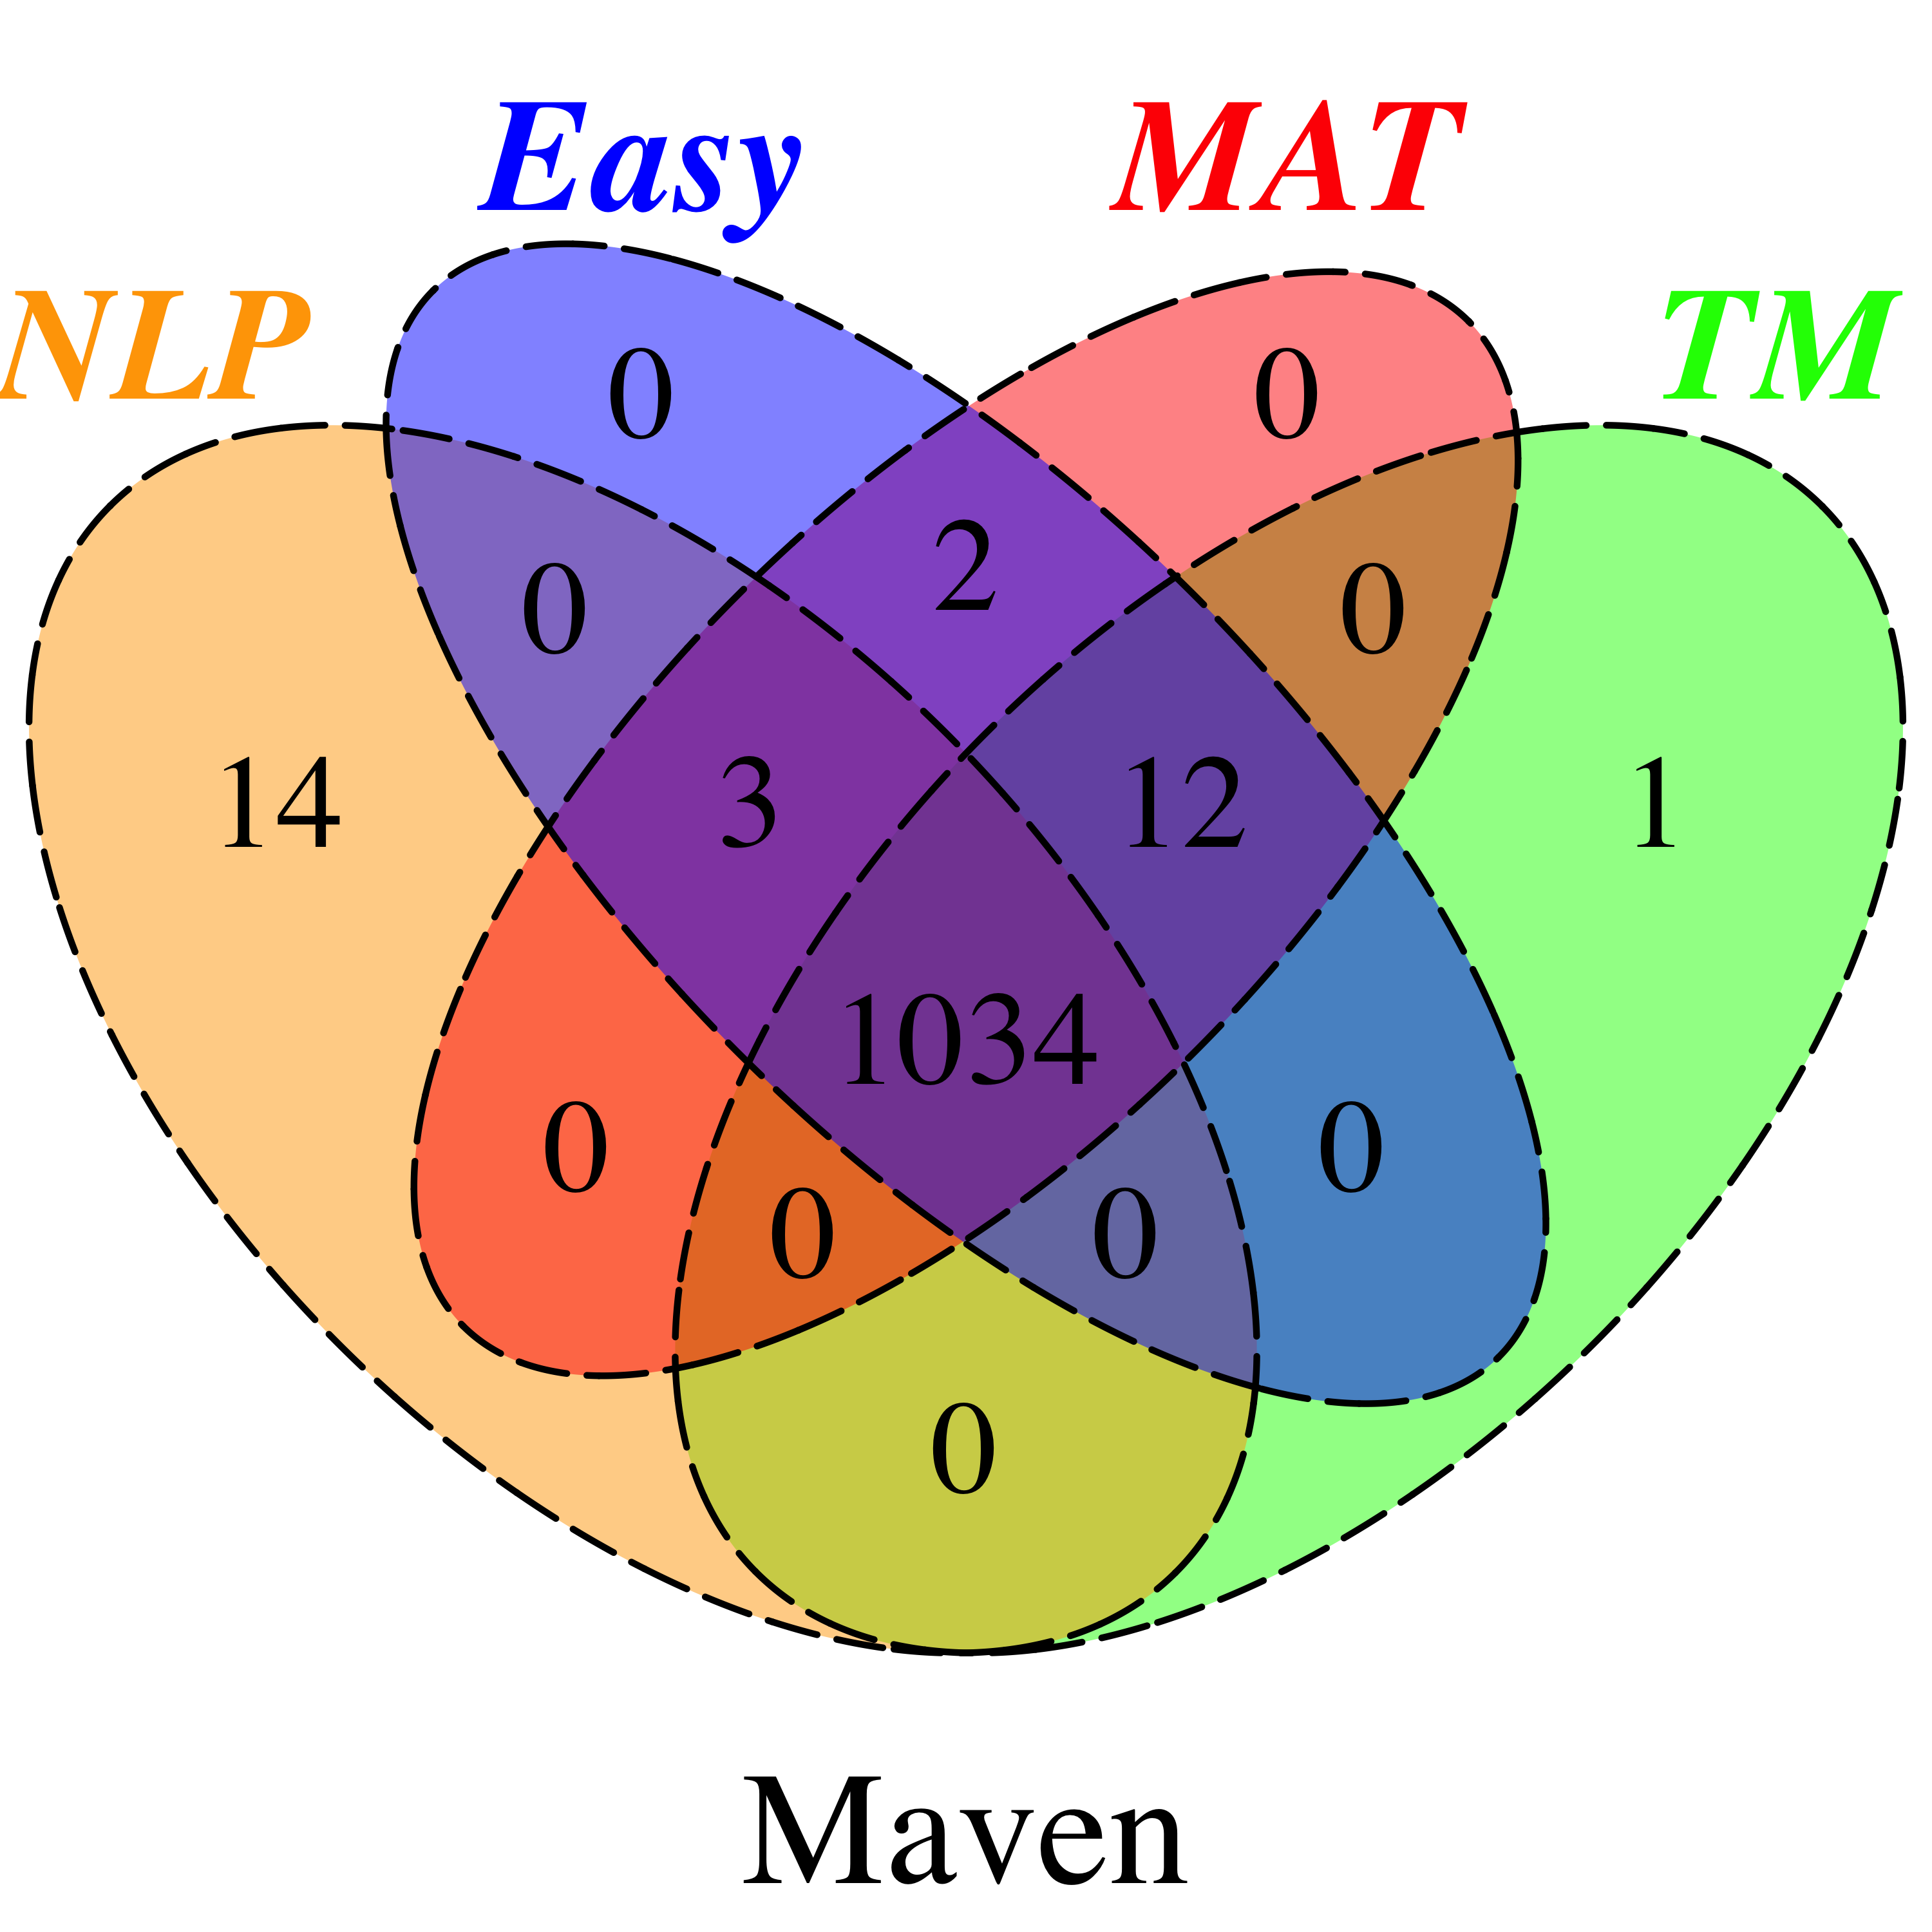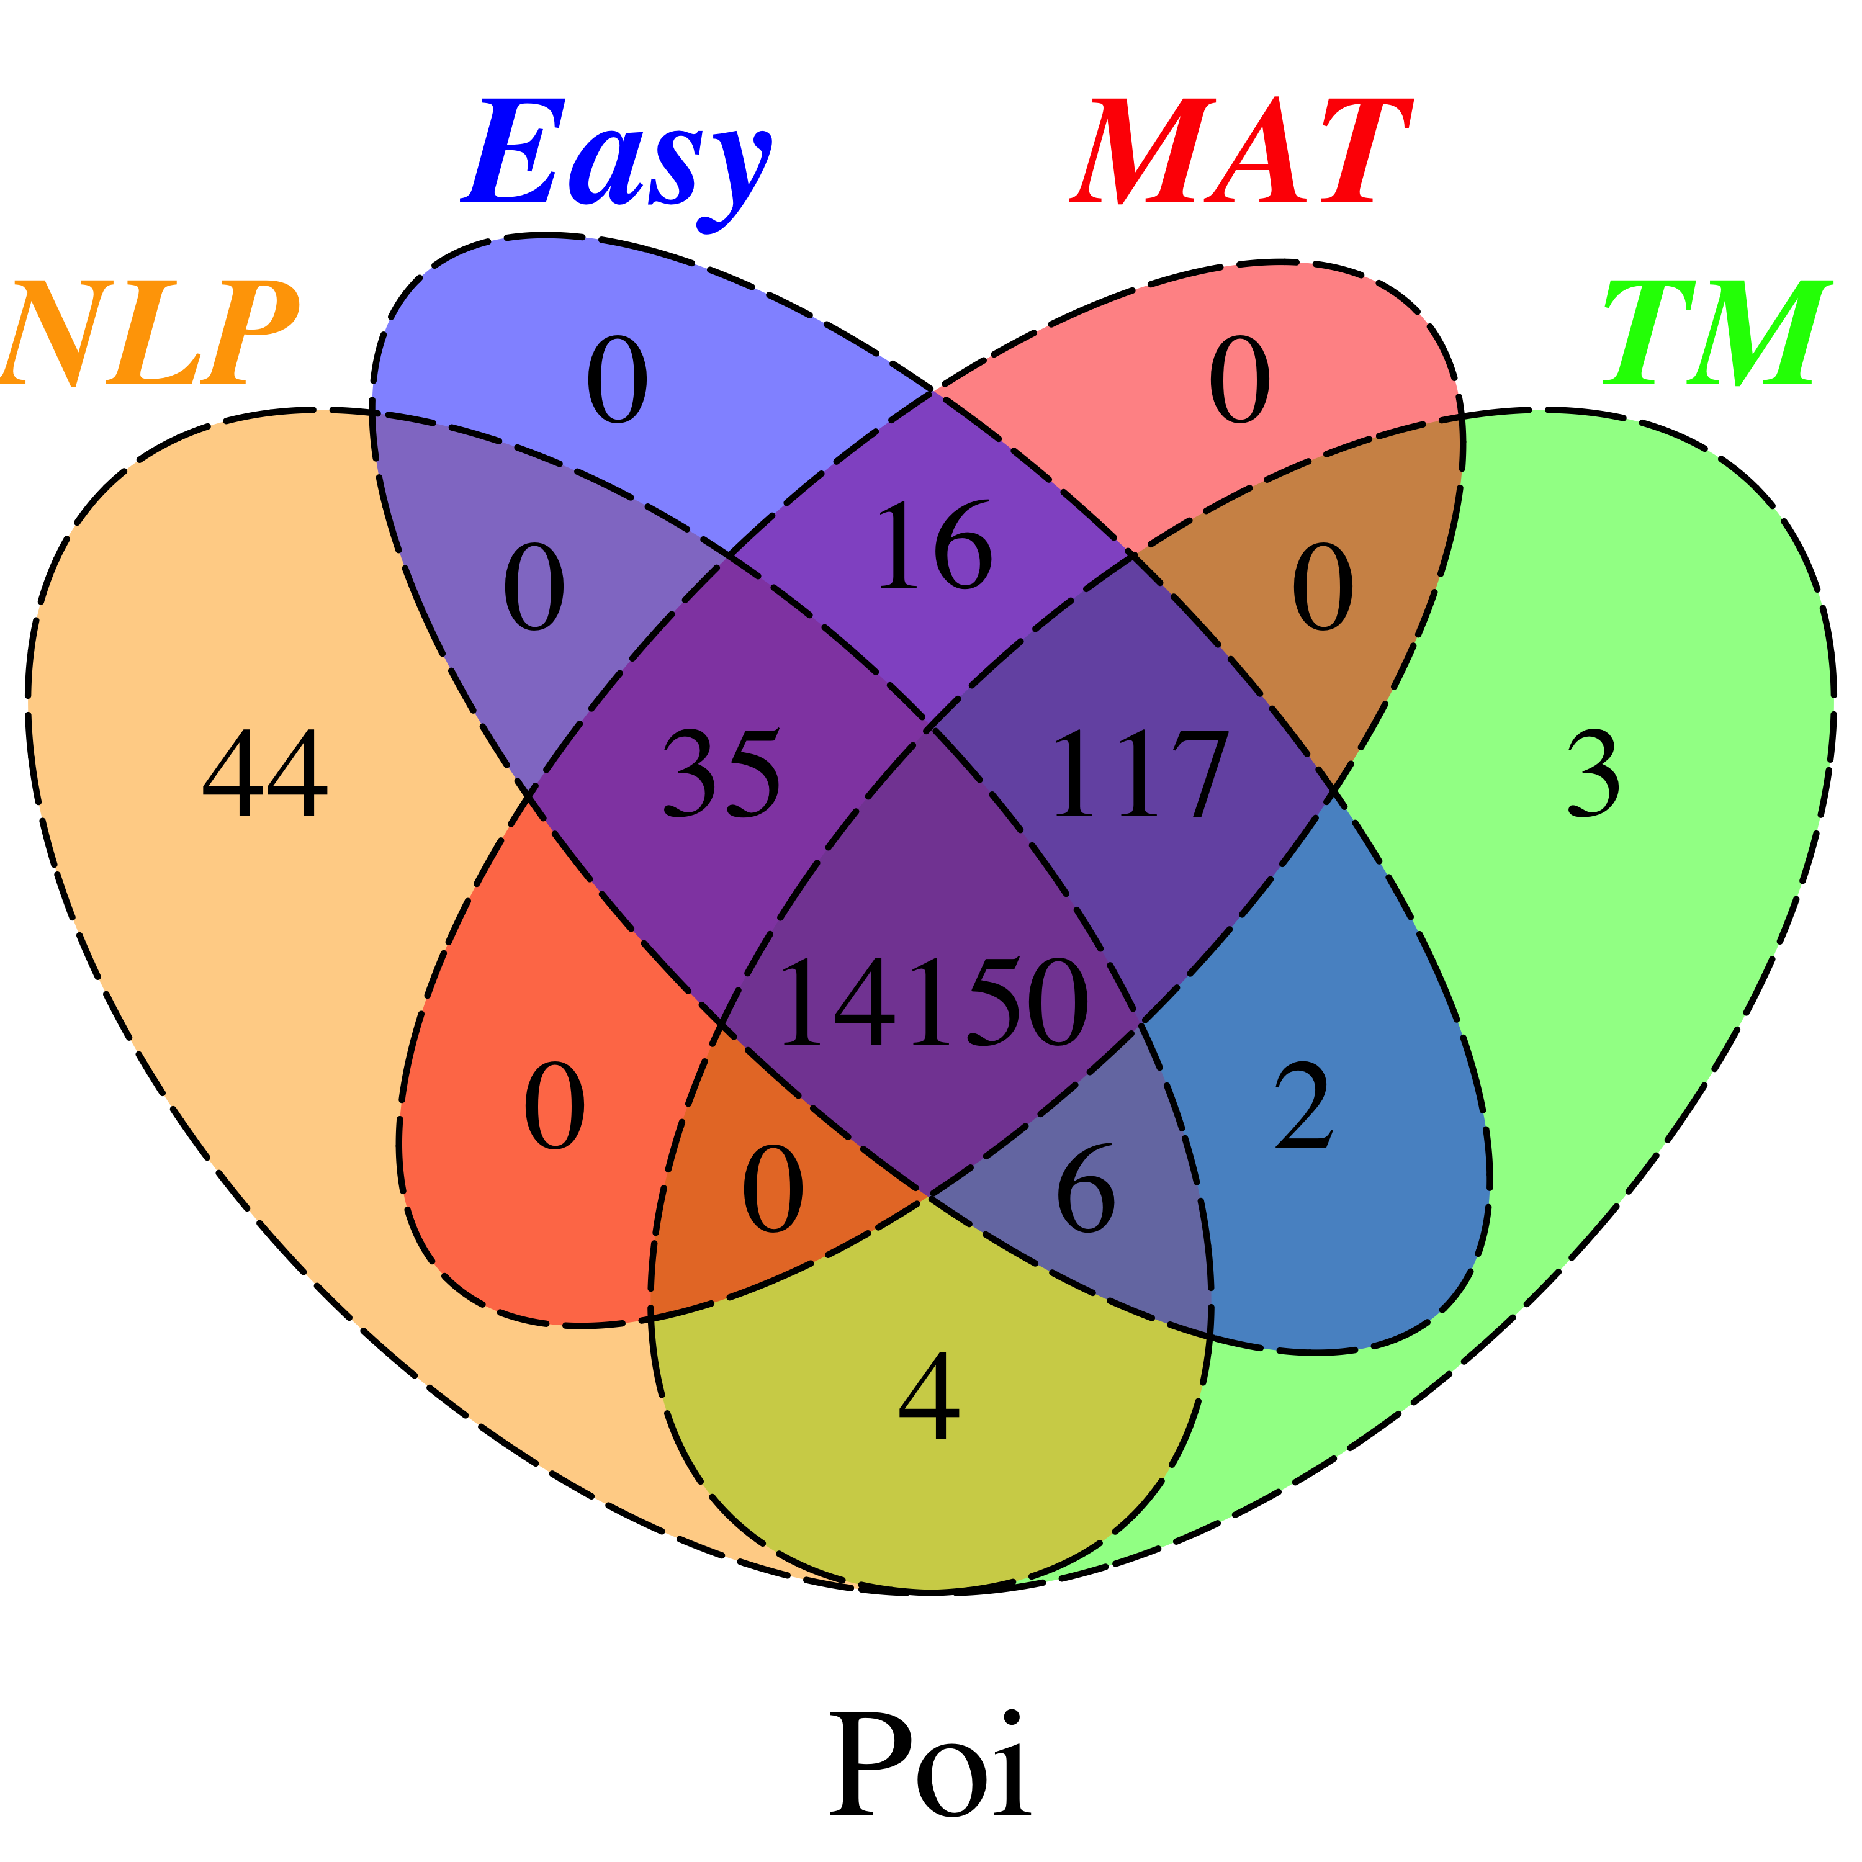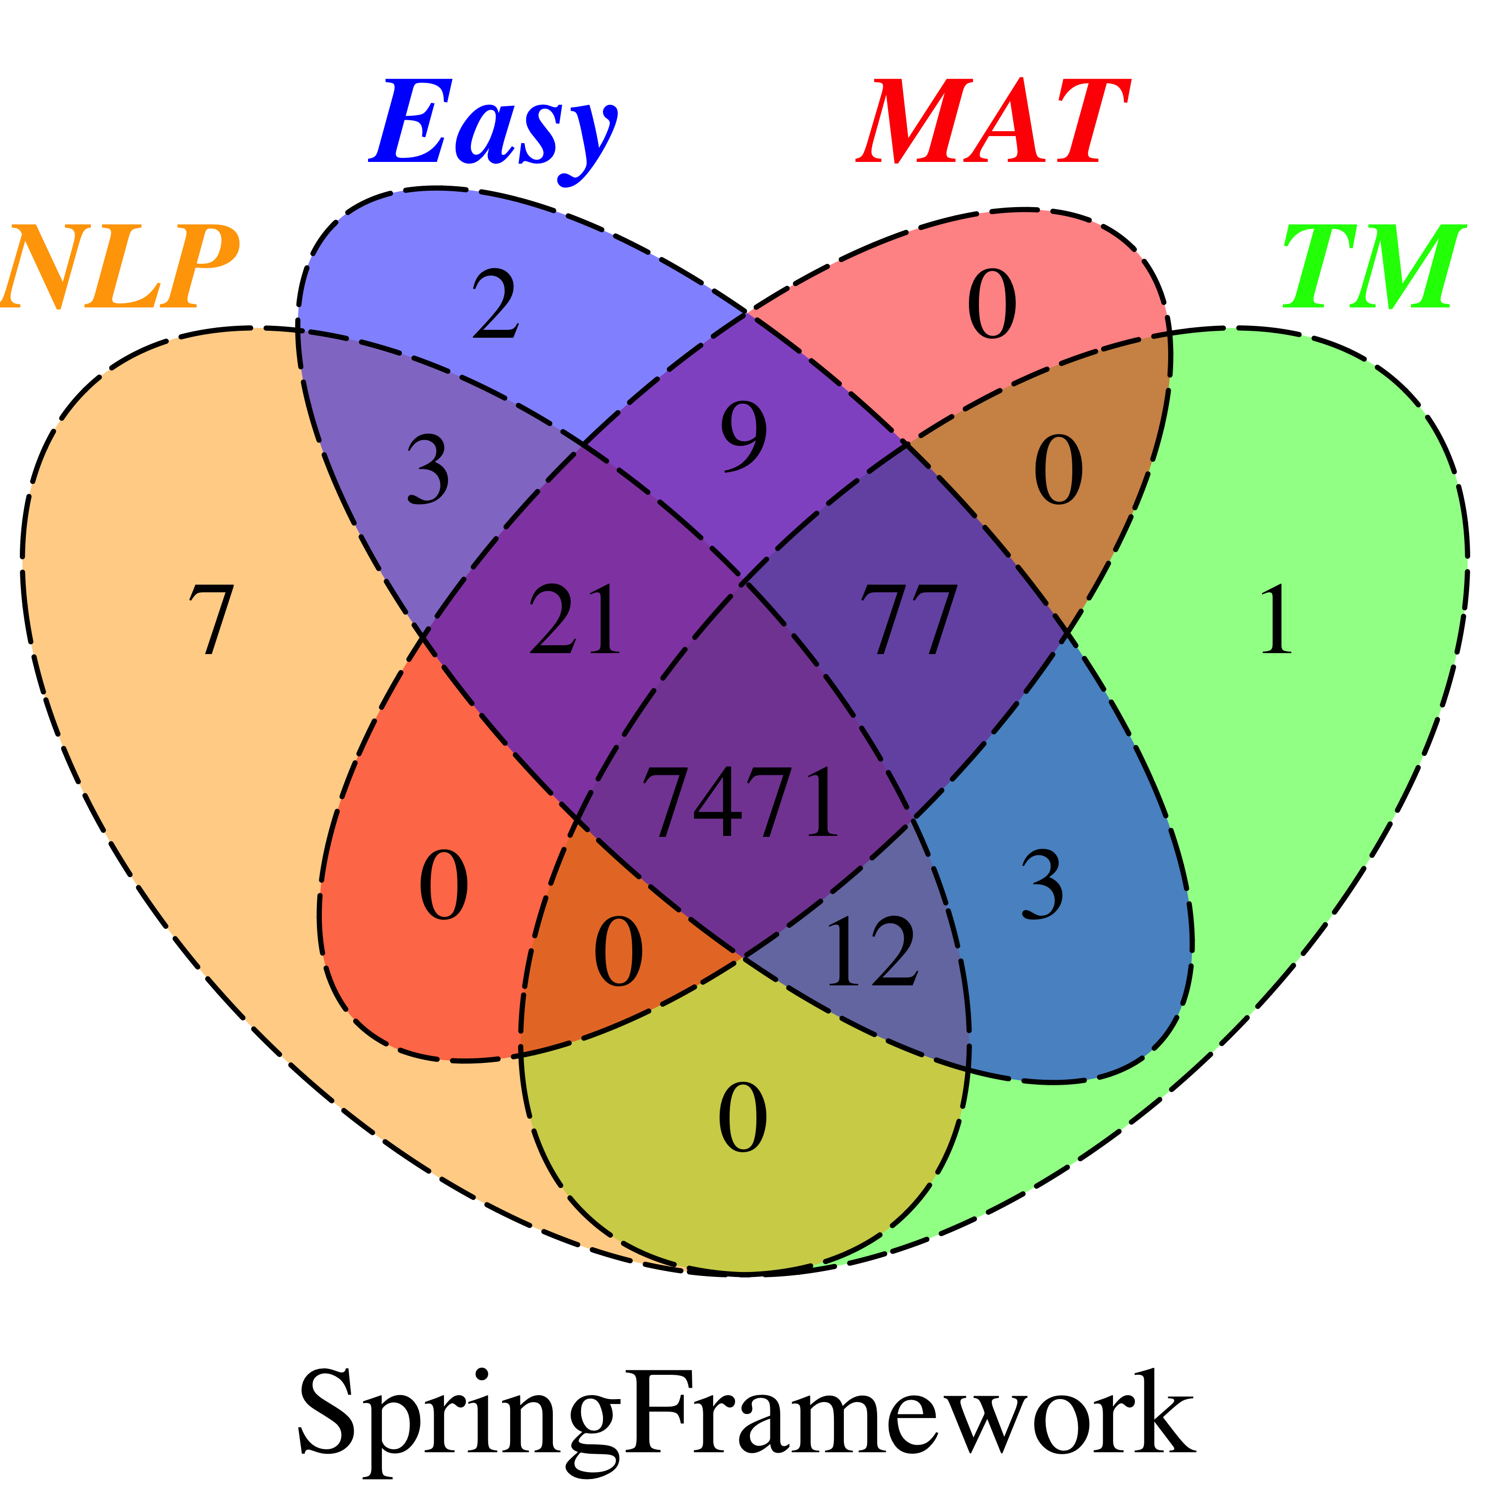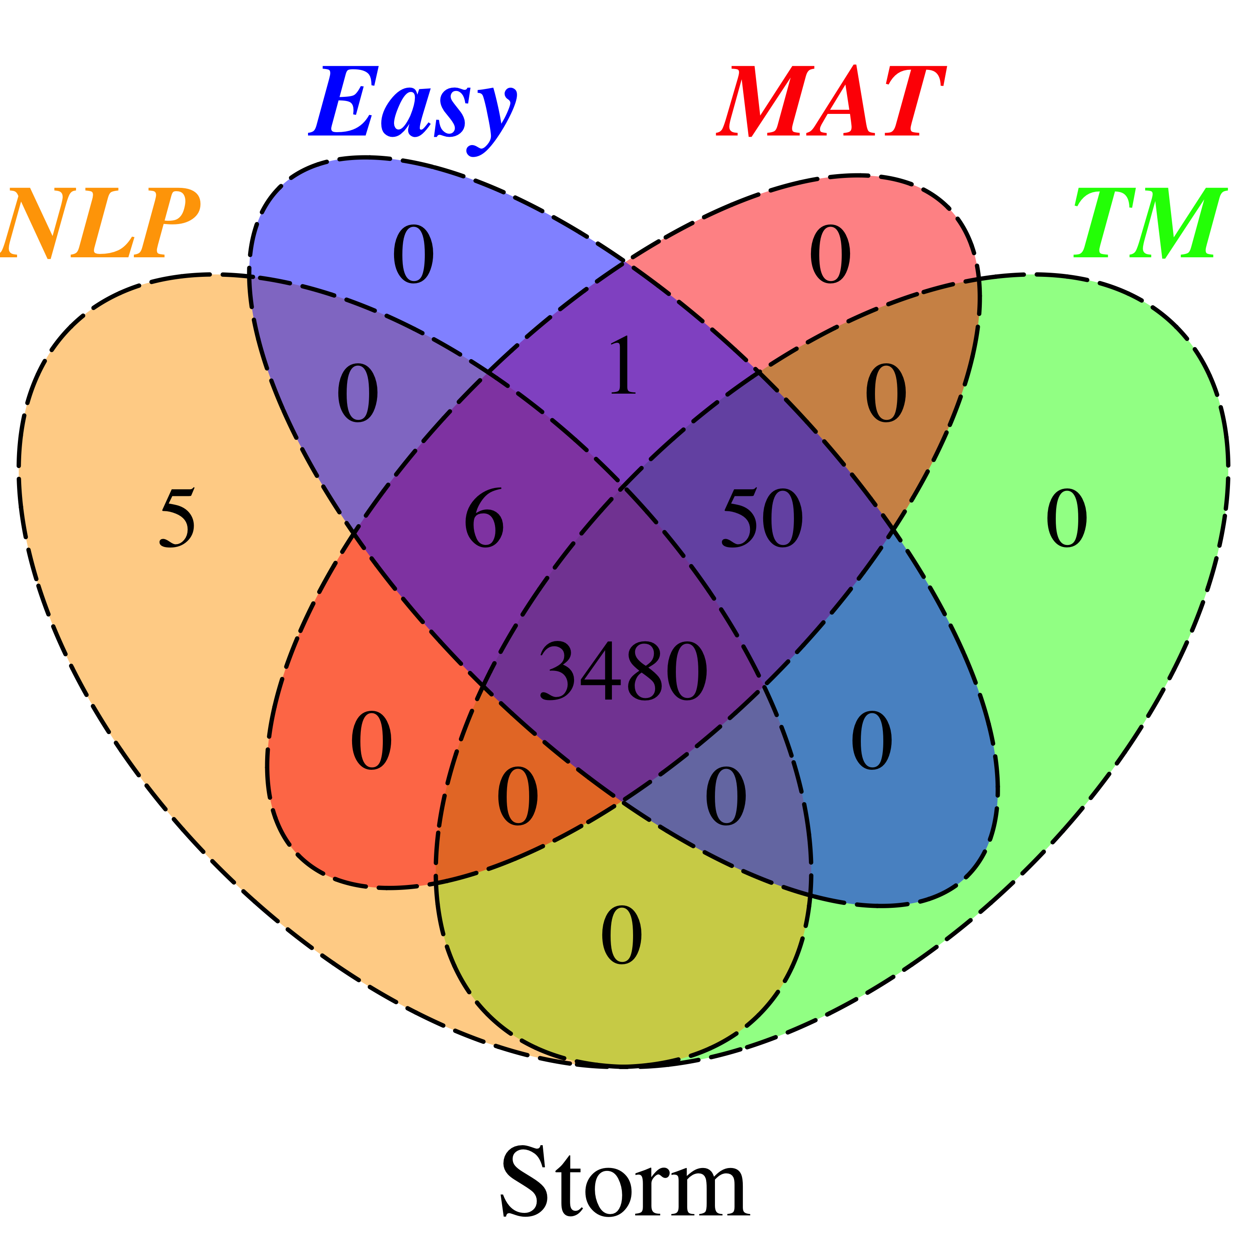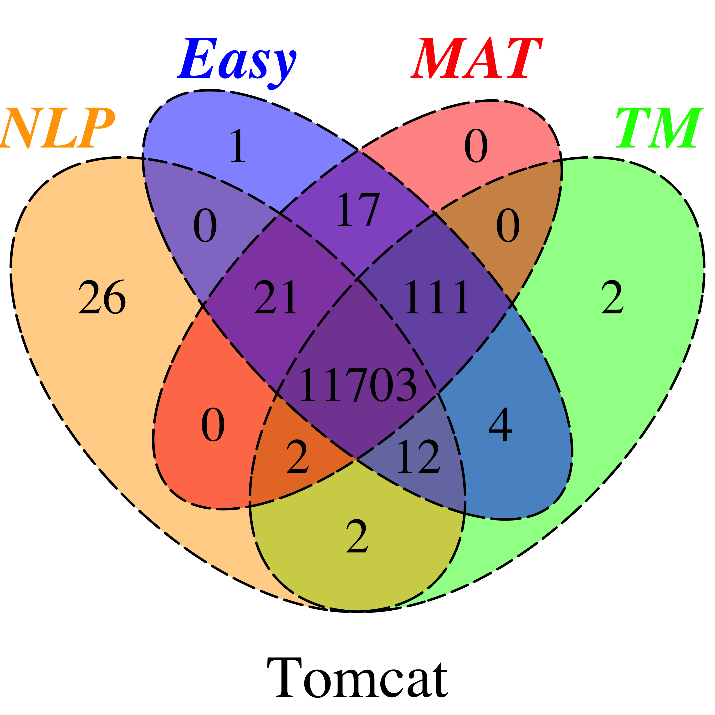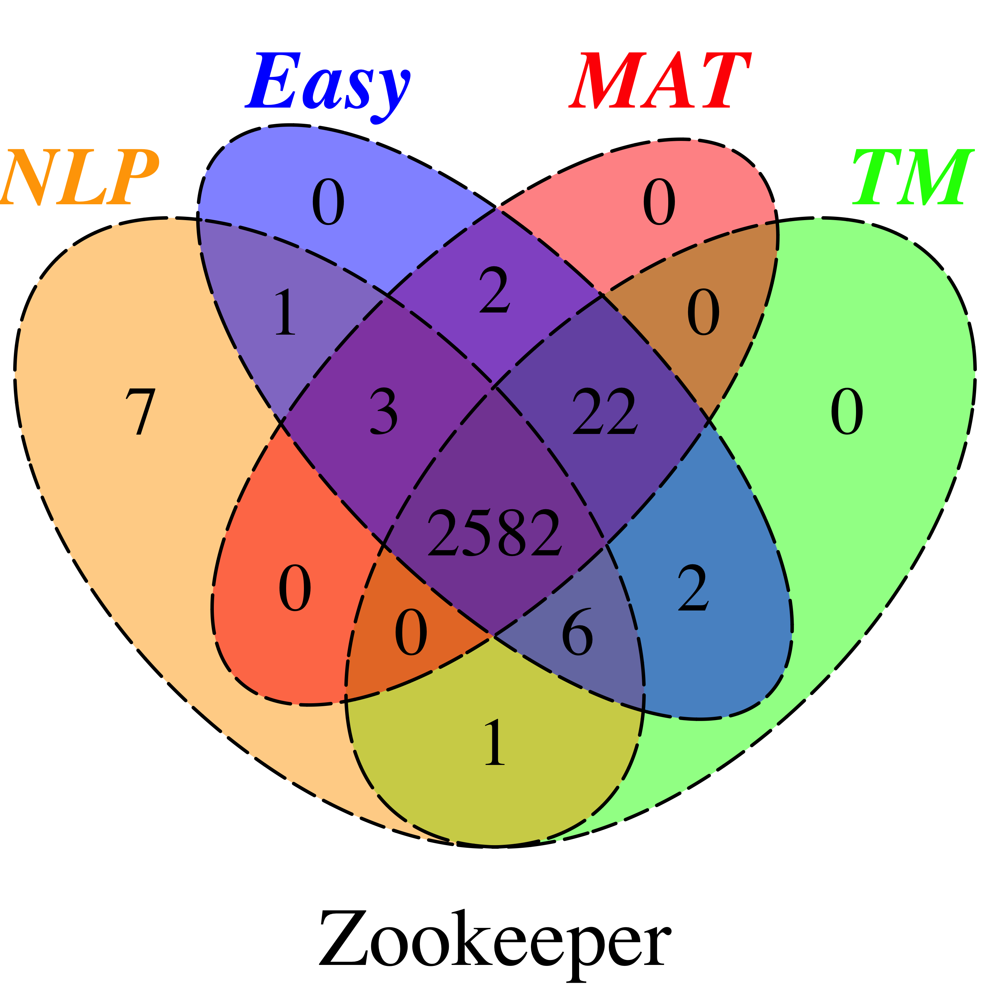

**Figure 6.** Set diagrams for the number of true negative instances classified by MAT and three supervised approaches (NLP, TM and Easy) in 20 projects